Guide to calculating the exceptions from the Australian location test
  - Venture Capital Programs

What is the foreign investment location test?
The location test applies when an Australian based early stage venture capital limited partnership (ESVCLP) or venture capital limited partnership (VCLP) invests in a company located outside of Australia. To ensure that Australian partnerships are supporting the Australian economy and businesses, s118-425(2) and s118-427(3) of the Income Tax Assessment Act 1997 (ITAA 1997) states that investee companies must be Australian residents at the time of investment and have more than 50 per cent of their employees and assets situated in Australia.
Note: If the investment is an initial investment, at least 50 per cent of investee company employees and assets must remain situated in Australia for 12 months under s118-425(2)(b)(ii) of the ITAA 1997.

Exceptions to the location test
Section 118-425(12A) of the ITAA 1997 allows partnerships to invest up to 20 per cent of their total committed capital into foreign companies.
The threshold is calculated by adding the value of a new investment to the cumulative value of all other investments which are revalued at the time of the new investment, divided by the total committed capital at the time of the new investment.

Definition of committed capital
Under s118-445 of the ITAA 1997, a partner’s committed capital in a partnership is the sum of the amounts that the partner may, under the partnership agreement establishing the partnership, become obliged to contribute to the partnership.
It does not matter whether:
- the partner contributes all of those amounts; or
- any amounts contributed are subsequently returned to the partner; or
- the contributions give rise to equity interests or debt interests in the partnership, or both.

Calculating the valuation of prior investments
The value of earlier investments at the time of a new investment may be different to their value at the time they were initially made. Only investments made that meet s118-425(2) as a result of s118-425(12A) at the time they were made, will count towards the 20 per cent foreign investment cap.
The Table 1 overleaf provides a structure to help with these calculations:

Table 1 | Example calculation table for foreign investment test
Investment number | Investee company name/ Country | Investment date | Committed capital at time of investment | Value of investment | Calculation of committed capital | Foreign investment threshold test
#
#

 | Total foreign investment

How to assess your foreign investment thresholds:
Using the calculation table:
- Fill table out with all foreign investments, ensuring that it records:
  - investee company’s name;
  - the date of the investment;
  - the partnership’s committed capital at the time of investment; and
  - value of the investment.

- For subsequent foreign investments, each prior investment needs to be revalued at the time of the new investment and added to the table.

- In a ‘total’ row, record:
  - The sum of the new investment and the revalued investments
  - Divide the total value of the investment by the total committed capital at the time of the new investment.
  - Convert to a percentage. The total proportion should remain under 20 per cent.

Example 1

Follow-on investment where a company relocates internationally
PinkPig Fund, LP’s committed capital is $10 million. 20 per cent of the partnership’s committed capital is $2 million. This means the partnership’s foreign investments must not exceed $2 million.
- When the partnership first invested $1 million in ‘Party Central (AU)’, the investee company was considered an Australian company. Therefore, the first investment is not restricted by the 20 per cent threshold.
- 12 months after the initial investment, ‘Party Central’ moved overseas and became a foreign investee company under the name ‘Party Central (USA)’. PinkPig Fund, LP continued to make a second investment of $1.5 million into the now foreign investee company.
- The initial investment, ‘Party Central (AU)’, had tripled in value at the time of the second investment, making the combined total of investments 1 and 2, $4,500,000. Although the total value of the partnership’s investments as a proportion of its committed capital equals 45 per cent, both investments are considered eligible as the first investment isn’t a foreign investment, and thus not included in the calculation of the threshold.
- The total value of the partnership’s foreign investments is $1.5 million, and only 15 per cent of the partnership’s committed capital.
Both investments made by the partnership are eligible investments.
The following table records every investment made by PinkPig Fund, LP (the partnership).
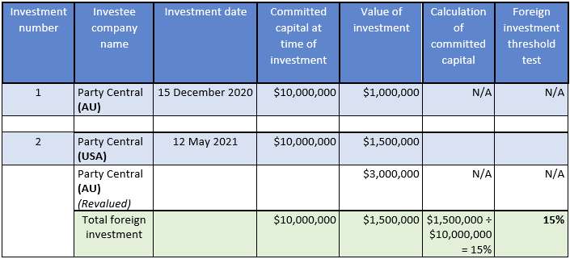Table 2 PinkPig Fund, LP Investments – First Foreign Investment
Note: There is only one foreign investment in PinkPig, LP’s portfolio

Example 2

Investing in an additional foreign company
As discussed in the previous example, investments 1 and 2 are eligible investments.
- After initially investing into ‘Party Central (AU)’ and ‘Party Central (USA)’, the partnership decided to make a second foreign investment. $700,000 was invested into ‘Clean Foodz Inc.’, a foreign investee company.
- At the time of this investment, the partnership’s committed capital was $11 million. 20 per cent of the partnership’s committed capital is $2.2 million. This means the partnership’s foreign investments must not exceed $2.2 million.
- As seen below, the ‘Party Central (USA) investment was revalued as $2 million at the time of investment 3. This brings the total value of foreign investments to $2.7 million and the partnership’s committed capital to 25 per cent.
- Therefore, the partnership’s investment into ‘Clean Foodz Inc.’ is ineligible, as it exceeds the 20 per cent threshold by 5 per cent.
The following table records every investment made by PinkPig Fund, LP (the partnership). Bold italic text denotes key changes.
Table 3 PinkPig Fund, LP Investments – Second Foreign Investment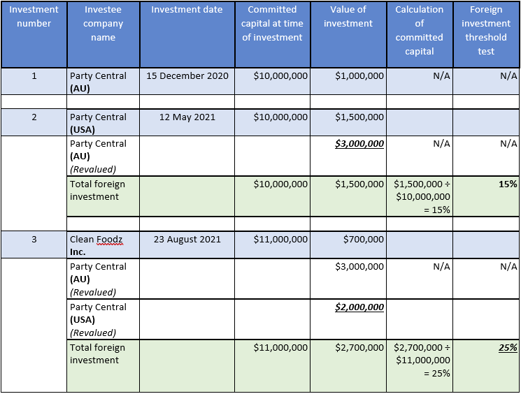
Note: Previous investments should always be revalued at the time of a new investment

Example 3

Multiple investments calculated cumulatively
At the time of Yeti Fund, LP’s final investment (Vegetation Table Inc.), its committed capital was $20 million. 20 per cent of the partnership’s committed capital is $4 million. This means the partnership’s foreign investments must not exceed $4 million.
- As seen below, investments 1 and 3 are eligible foreign investments because the total value of their investments (including the revalued investments) do not exceed the 20 per cent threshold.
- Investment 5, Vegetation Table Inc., exceeds this threshold, as the total value of investment is $4.2 million, ultimately $200,000 over the 20 per cent threshold of the partnership’s committed capital.
The following table records every investment made by Yeti Fund, LP (the partnership). Bold, italic and Underlined text denotes key changes.
Table 4 PinkPig Fund, LP Investments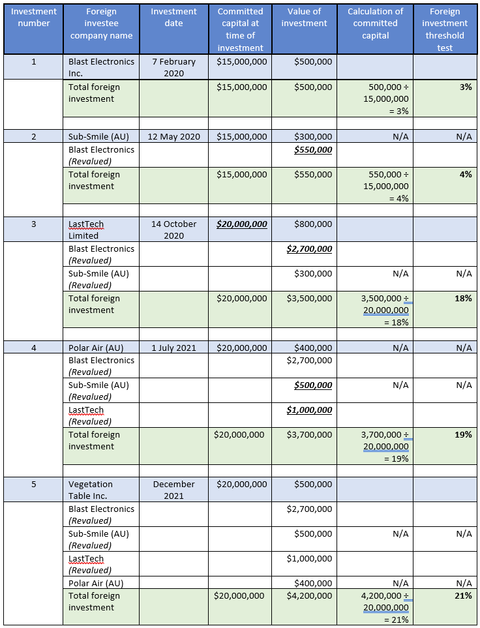
Note: The investment made into Vegetation Table Inc. is considered an ineligible investment, as the new and revalued investments push the partnership’s total investment value over the 20 per cent threshold by 1 per cent.

