Regional Jobs and Investment Packages  
  
Wide Bay Burnett Region  
Local Investment Plan

May 2017

Table of Contents

1 Foreword 3

2 Introduction 5

3 Regional overview and analysis 5

3.1 Location 5

3.2 Population 6

3.3 Competitive advantages: 6

3.4 Emerging opportunities 6

3.5 Future growth predictions and changes in employment 7

3.6 Population growth rates across the six local governments that make up WBB 7

3.7 Economy 8

3.8 Employed persons 9

3.9 Qualifications and skills 10

3.10 Priority projects 11

4 Investment sectors and strategic priorities 12

4.1 Investment Sector: Agriculture/ agribusiness 12

4.2 Investment Sector: Infrastructure 13

4.3 Investment Sector: Tourism 14

4.4 Investment Sector: Manufacturing 15

## Foreword

The Local Investment Plan will identify investment sectors and strategic priorities that create sustainable industries and jobs into the future. The plan provides an economic and strategic overview of the region based on an assessment of the region’s competitive advantages and potential areas of growth.

Funding under the programme will reflect the investment sectors and strategic priorities set out in the plan. Investment sectors reflect broad industry areas that can drive economic growth and create jobs in the region.

Strategic priorities are associated with each investment sector. These priorities target specific activities within the sector that can unlock new markets and create opportunities in the region.

All applications for Regional Jobs and Investment Packages (RJIP) funding in the region should align with one or more of the priorities outlined in the plan. The first RJIP merit criteria asks applicants to demonstrate the linkages between their project and the region’s plan.

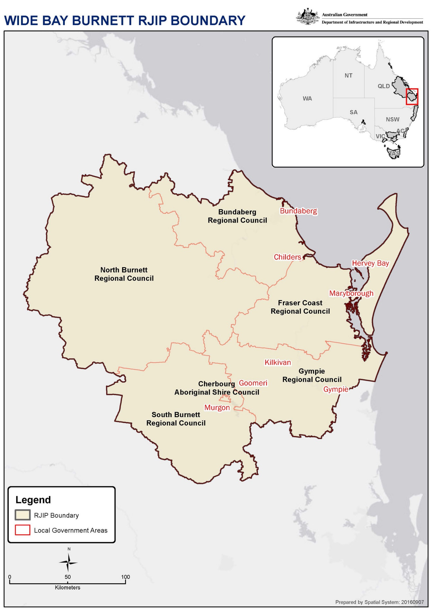

## Introduction

The Wide Bay Burnett (WBB) Local Planning Committee (LPC) has developed this plan based on the knowledge of members, consultation with relevant agencies and these existing documents:

* Wide Bay Burnett Economic Development Strategy 2014 -2019.
* WBBROC Positioning the Wide Bay Burnett for Future Growth 2016.
* Bundaberg Regional Council Development Strategy 2016.
* Fraser Coast Economic Development Strategy 2015-2020.
* Gympie Region Economic Development Strategy (2015-2019).
* South Burnett Economic Development Strategy (2015-2019).
* North Burnett Economic Development Strategy (2015-2019).
* North Burnett ‘Where Opportunity & Lifestyle Align’ Economic Development Plan 2014-2020.
* Wide Bay Burnett Regional Plan.
* Trade and Investment Qld, Wide Bay-Burnett Export Company Profiles, Food and Agribusiness sector Fraser Coast Region al Economic profile (current).
* Regional Development Australia WBB Regional Roadmap (2016-2019).
* State Govt Bio Futures 10-year Roadmap and action plan (released 2016).
* Lawrence Consultancy Services, Wide Bay-Burnett Regulated Economic Indicators (15-16).
* Department of Local Government and Planning, Wide Bay-Burnett Regional Plan, September 2011.
* Trade and Investment Qld, Wide Bay-Burnett Export Company Profiles, Food and Agribusiness sector (2016).
* Department of Agriculture and Fisheries, Foodmap analysis of the Australian food supply chain – July 2012.
* Bundaberg Fruit and Vegetable Growers, Production Horticulture in Bundaberg and the greater Wide Bay Region (15-16).
* Regional Development Australia Wide Bay-Burnett, Workforce Development Jobs and Skills Matching Study,2013.
* ABS Regional Population Growth 2017 (Cat. No. 3218.0).
* ABS 2011 Census, presented within the DIRD 2016 Yearbook.
* National Aged Care Data Clearing House, Population Projections, 2012 (base) to 2027.
* ABS, Population by Age and Sex, Regions of Australia, 2015 (Cat. No. 3235.0).
* Commonwealth Department of Employment, Small Area Labour Markets publication, March 2017.
* Department of Agriculture and Fisheries – Queensland Forest and Timber Industry: An overview – 2016.

## Regional overview and analysis

### Location

The Wide Bay-Burnett region stretches 48,600 sqkms from the fertile soils of the Burnett to the naturally-gifted Fraser Coast, three hours’ drive north of Brisbane. The region encompasses the local governments of Bundaberg, Fraser Coast, Cherbourg, Gympie, North Burnett, and South Burnett, and the major regional centres of Bundaberg, Gympie, Hervey Bay and Maryborough.

### Population

The population of the Wide Bay-Burnett in 2016 is 293,000, having grown by 11,800 over the past five years. Population growth has relied more proportionally on migration from other areas than from within Queensland.

With a vibrant tourism industry and growing human services sector, Wide Bay’s economy continues to build and diversify upon its traditional strengths in agriculture, tourism and manufacturing.

### Competitive advantages:

The Wide Bay-Burnett region’s competitive advantages include:

* Established tourist destinations and well maintained recreational facilities.
* Low cost of housing and cost of living.
* Lower wage and commercial land costs for businesses looking to relocate or establish.
* Presence of quality higher education institutions including three universities.
* Abundant natural resources.
* Convenient access to passenger rail and air travel for residents and businesses in coastal centres.
* Substantial human capital in terms of citizen skills, experiences, political access and volunteerism.
* Close proximity to markets and commercial activity in South East Queensland.
* Low cost of agricultural land, ideal climate, innovative and large scale growers, exporters and food manufacturers.
* Broad network of telecommunications, transport and energy infrastructure.
* Port and marina facilities for large and small vessels.

### Emerging opportunities

Emerging opportunities include:

* Maximising the region’s advantageous geographic location—the region is surrounded by growth in South East Queensland and Gladstone, and mineral and energy development in the Surat and emerging Galilee basins, which can provide opportunities for supplying labour, skills development and manufacturing and services supply chains.
* Infrastructure development—existing infrastructure corridors and opportunities for expansion of the Port of Bundaberg and connecting transport corridors will improve the region’s capacity to contribute to the state’s economy.
* Economic expansion—the region presents opportunities for additional industrial land allocations to attract substantial industrial development in the vicinity of Bundaberg and Maryborough.
* Expanding existing aviation and port areas and their supporting service industries—the Port of Bundaberg and operational airports of the region provide prospects for economic development and employment generation.

### Future growth predictions and changes in employment

Projections of economic activity for the Wide Bay-Burnett Region (2016 RDA Regional Road Map, Lawrence Consulting) shows that over the period to 2021, the regional economy will experience average real annual growth of 3.2% to a level of approximately $14.1 billion, whilst employment will increase by almost 11,000 jobs.

The quinary sector – which includes personal services, health, hospitality, arts and recreation – will experience the largest increase in employment, with over 4,800 additional jobs created.

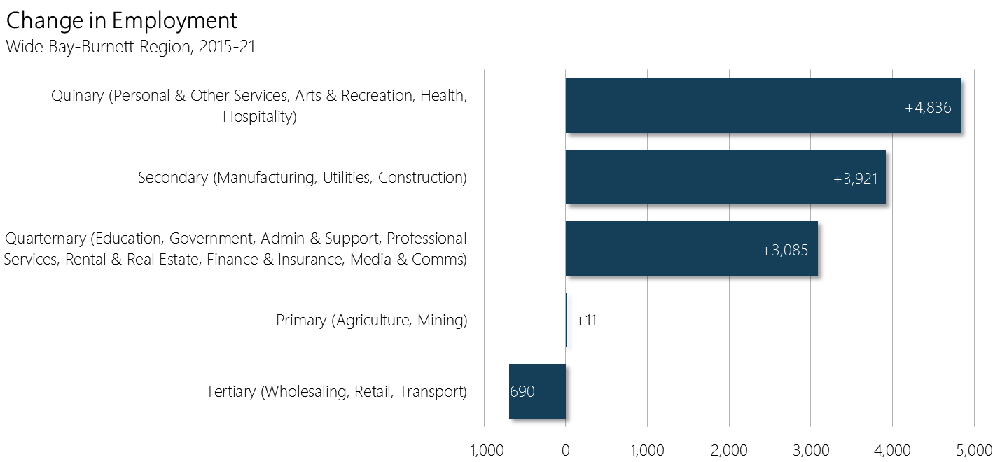

Lawrence Consulting report commissioned by Regional Development Australia Wide Bay Burnett 2016

### Population growth rates across the six local governments that make up WBB

Table 1 Estimated resident population

Estimated resident population by local government area

Source: ABS Regional Population Growth 2017 (Cat. No. 3218.0)

Note: Population estimates are final for 2011, but preliminary for 2016 (p)

### Economy

The Wide Bay Burnett boasts the largest population of any Queensland region outside the South East. This growth will fuel continued economic expansion in emerging industries, including aviation, transport equipment manufacturing, ecotourism, bio futures and high-value export agriculture.

The region accounts for 10 per cent of Queensland’s agricultural production. Significant agricultural activities include timber production and processing (softwood and hardwood) beef, pork and poultry production and processing, sugar cane production and processing, tree crops (especially macadamias and avocadoes), fruit and vegetable production (especially citrus and tomatoes) and seafood production and processing.

These agricultural industries will continue to be important for the Wide Bay Burnett region into the future with the worldwide demand for food expected to increase by 70% over the next 40 years. The region's ability to take advantage of the world demand requires an adoption of practices to increase productivity from the land currently under cultivation; maximise the land use for production of high demand, competitive and high value produce; use best practice for packaging/freight and water access/irrigation; and ultimately increase significantly the regions exports.

Manufacturing accounts for 8.9% of the region’s employment and is the third highest employment sector (behind health and social assistance and retail trade). The largest manufacturing segments are machinery and equipment, metal fabrication, food manufacturing and processing, aviation and marine.

Table 2 Highest employing industries

By Local government area

Table 3Second highest employing industries

By Local Government Area

Tourism continues to be a major industry, particularly in the coastal areas of Bundaberg and Fraser Coast. Opportunities exist to deepen the tourist sector appeal to promote sport and event tourism, agri-tourism, cultural and indigenous tourism, recreational fishing, beach and hinterland retreats, ecotourism activities (such as diving, cruises, whale watching, beach-combing, wilderness camping, and flora and fauna exploration at coastal and rainforest locations).

Significant opportunities exist for mining and energy with reserves of coking coal and minerals including bauxite, magnetite, illmenite, and molybdenum; and coal seam gas ready to be mined and extracted.

Increases in projected population upward of 400,000 over the next 20 years will underpin the strong residential construction sector. Industrial construction will provide local firms with opportunities as key economic driver sectors develop.

Major projects such as the development of the Port of Bundaberg, continued improvement of the major arterial of the Bruce Highway, enhanced communications and value-added agriculture are among transformational initiatives that will have far-reaching benefits.

The region faces significant challenges over the next 15-20 years due to an aging population and subsequent forecast declining workforce, along with the need to boost productivity by transitioning to higher value-adding industries.

### Employed persons

This indicator is based on the place of usual residence of the employed person and not the location of work.

Table 4 Employed persons

By Local Government Area

Source: ABS 2011 Census, presented within the DIRD 2016 Yearbook

Note: Persons aged 15 years and over. (a) Excludes Migratory – Offshore – Shipping regions.

Note: The Community Development Employment Project (CDEP) Scheme, an Indigenous employment program operational at the time of Census collections, can influence the employment measures including employment numbers, labour force participation and structural change estimates for regions with CDEP participation. This is due to both the changes to the CDEP Scheme since the 2006 Census count and differences in the collection methodologies over time (see ABS 2013, Australian Social Trends, Nov 2013, Cat. No. 4102.0 for details)

Wide Bay-Burnett needs to increase investment in talent and skills to position it to better meet future labour demands and increase workforce participation. It is well serviced by three university campuses, TAFE and a diversity of public and private schools, however educational attainment remains below state averages.

### Qualifications and skills

The proportion of people who have at least a certificate III qualification or who are employed in a skilled occupation provides an indication of the capacity of people in a region to capitalise on job opportunities.

Table 5 People with a Certificate III or above, or employed in a skilled occupation

By Local Government Area

Source: ABS 2011 Census, presented within the DIRD 2016 Yearbook

Note: persons aged 25-64 years; Occupation was coded to the Australian and New Zealand Standard Classification of Occupations (ANZSCO) First Edition; Skilled occupations include Managers, Professionals and Technicians and Trade Workers.

### Priority projects

Significant projects across the region either confirmed or planned include:

* Bundaberg Aviation and Aerospace Precinct.
* Rubyanna Wastewater Treatment Plant.
* Bundaberg Multi-Use Sports & Community Centre.
* Bruce Highway Upgrade.
* Hervey Bay and Maryborough CBD Urban Renewal Master Plan.
* Hervey Bay Medical Precinct Masterplan.
* Gympie Aquatic Recreation Centre.
* Fraser Coast Sports Precinct.
* Fraser Coast Innovation Hub.
* Avion Hervey Bay Airport Precinct.
* Port of Bundaberg marine/commercial and residential expansion.
* Urangan Harbour Masterplan.
* Mon Repos Turtle Centre, Bundaberg.
* HMAS Tobruk Dive Wreck.
* Fraser Coast Motorsport Complex.
* Gympie Rattler Historic Tourist Train.
* Gympie Coastal Connection Road.
* Gayndah Regional Irrigation Development Project, ISIS Mill.
* Bundaberg Port gas pipeline construction and Port State Development Area declaration.
* South Burnett Rail Project.
* Lady Bjelke-Petersen Community Hospital.
* Unlocking Unallocated State Land - for agriculture purposes.
* Renewable Energy Projects e.g. Large scale solar farms and biofuel opportunities.
* Wide Bay Minerals Province.

## Investment sectors and strategic priorities

### Investment Sector: Agriculture/ agribusiness

#### Evidence

* The region is considered Queensland’s food bowl growing significant quantities of state’s livestock, sugar, fruit, nuts, vegetables, timber, seafood and specialty crops.
* The region is home to iconic businesses including Nolan Meats, Bundaberg Sugar, Bundaberg Rum, Bundaberg Brewed Drinks, Peanut Company of Australia, Australian Macadamias, Auschille, Hyne Timber, Nestle, Ironbark Citrus, Swickers, Ocean King Prawns, Urangan Fisheries.
* Labour Force Survey data (ABS November 2015) shows the WBB accounts for 4.5% of total employment in Qld and 17% of all people employed in the agriculture, forestry and fishing sector.
* In 2014-2015, gross value of ag production in WBB was $1.1 billion, 10% of gross production across Queensland.
* In terms of gross value added, employment and business numbers, the Wide Bay Burnett region has a much greater reliance on agriculture (approx.. 13%) than Queensland (approx.. 3.4%).
* The most important commodities in the region based on gross value were cattle and calves ($379m), followed by sugarcane ($120m) and citrus ($120m).
* In 2014-2015 the WBB accounted for 74% ($56m) of the total value of Qld’s macadamia nut production (ABS 2015).
* Two-thirds of the state’s softwood plantation resources and processing facilities are situated in the Wide Bay Burnett.
* ABS data in 2013-2014 showed there were 4,113 farms across WB, 17% of all farm businesses in Qld.
* Queensland's commercial fisheries are a significant contributor to the national and state economies. The 1500 licensed commercial fishing boats contribute more than 10% of the nation´s seafood production in both quantity and value, in addition to the other valuable fish products such as bait and aquarium fish harvested under commercial harvest fishery licences.
* The fishing industry is based on scallops, prawns, spanner crabs, mackerel, mullet and reef fish. It is estimated to be worth about A$37 million with a competitive edge based on the export quality of the region’s fresh and frozen products. Current markets include local, interstate and export destinations predominantly in Asia and Europe.
* Urangan Fisheries Pty Ltd, is one of the longest standing seafood processors/exporters in Queensland for more than 25 years, employing an estimated 100 people. Urangan Fisheries has been professionally processing and exporting fresh and frozen seafood to Asia, United States of America and the European Union for over ten years.

#### Strategic priorities

* Expansion of existing agricultural and agribusiness enterprises.
* Value-add processing and expansion/growth of associated ag businesses.
* Expansion of freight and logistics/packaging and processing.
* Introduction and implementation of new technology/innovation to enhance productivity, variety and competitiveness.
* Increase domestic and international market expansion/exports.

Evidence

The WBB’s economic strength has traditionally been in agriculture and primary production. This will continue into the future with strong growth across most industry sectors in the past five years. Competitive advantages identified by all levels of government include relatively low cost of agricultural land, ideal climate, innovative and large scale growers, exporters and food manufacturers. Proximity to large population bases of south-east Qld assist in growth of new demand and new markets.

The policy objective of the Commonwealth Government is to double agricultural production.

Refer to documents and statistics in section 3.

### Investment Sector: Infrastructure

#### Evidence

* Value-adding investment in infrastructure is crucial to meeting global demand. The efficiency of the supply chain from the farm-gate to the ultimate consumer is a major issue for Wide Bay Burnett farmers.
* Adoption of new technologies and associated industry infrastructure is required to remain competitive.
* Water security for agricultural and orchard production is a high priority to increase production to meet demand.
* Strengthening the freight network will support additional economic growth and potential expansion of the Port of Bundaberg and other niche and local industries. The quality and availability of infrastructure to secure the long-term viability of port operations requires planning and investment.

#### Strategic priorities

* Investment in economic-enabling infrastructure.
* Infrastructure to enhance development at the Port of Bundaberg.
* Infrastructure to improve supply chain efficiency across major industries.
* Investment in infrastructure that introduces new technology or innovation to existing industry.
* Investment in new infrastructure or relocation of infrastructure to WBB.
* Repurpose existing infrastructure.

Evidence

* With capacity and transport congestion issues at both the Port of Gladstone and Port of Brisbane, the Port of Bundaberg can play a more significant role in regional freight movements (imports and exports) as infrastructure improvement and commodity growth continues.
* There are several mothballed major infrastructure assets across the region including the former South Burnett Meat Works that could be repurposed for value-add industry.
* Recent significant expansions in livestock abattoirs has resulted in new economic opportunities including $20m cold store infrastructure of Nolan meats, Gympie and a $20m upgrade of the Swickers Bacon Factory, Kingaroy.
* Previous primary production groups that traditionally collected and marketed primary products are now investigating value-adding, including the peanut, navy bean and sugar/confectionary industries.
* Increased demand for domestic and export markets has created interest from packaging companies interested in establishing factories/investing in the WBB.

### Investment Sector: Tourism

#### Evidence

* Creating a more diverse tourism offering is critical for the WBB to remain relevant and competitive tourism destinations for domestic and international visitors.
* With the region’s geographic proximity to the southern Great Barrier Reef and iconic World-Heritage listed Fraser Island within the protected waters of the Great Sandy Marine Park, it is the ideal destination for the expansion of tourism product.
* The tourism sector and is the second largest export earner in Queensland - after coal. Approximately 40% of this tourism industry activity is based outside South East Queensland. The international and domestic tourist markets now account for 1.3 million visitors to Queensland with annual expenditure of $1.9 billion.
* The Tourism Satellite Account (TSA) published by Tourism Research Australia (TRA) indicates that in 2013–14, the tourism industry directly contributed $10.7 billion to Queensland’s economy and directly employed 130,900 people.
* In the 2009–10 period, $444 million was spent by visitors in the Fraser Coast region alone. To the year ended June 2013 tourism contributed 9.5% to the Gross Regional Product or $779 million in economic output to the Bundaberg North Burnett economy.
* According to Lawrence Consulting, tourism supports 6,548 jobs in the Bundaberg North Burnett region. This is approximately 15% of total employment within the Bundaberg region.
* On average 463,000 visitors travelled to Bundaberg and 93,000 visited the North Burnett – a total of 556,000 visitors.
* On average they stay 3.4 nights in Bundaberg and 2.9 in the North Burnett.
* On average the total spend per year in Bundaberg is $196,000,000 and $33,000,000 for North Burnett.
* It is also the mainland access point to World Heritage listed Fraser Island, and supports a variety of domestic and internationally renowned tourism industries, including wine and culinary tourism, ecotourism, sport and recreation tourism, and agri-tourism opportunities.
* There are also opportunities to tap into the growing Asia-Pacific market, particularly attracting visitors from India and China.
* Tourism is both a major economic activity and lifestyle driver for the Fraser Coast Region, and visitor expenditure impacts a number of key regional economic sectors. The visitor economy injects $360 million of direct overnight expenditure into the destination’s economy which contributes to nearly $648 million of direct and indirect expenditure across the sectors including transport, accommodation, food services and retail trade. It also contributes to securing 6,015 jobs (direct and indirect) for the Region.

#### Strategic priorities

* Widen and deepen the tourist sector and expand the range of tourism experiences available.
* Investment in key tourism precincts.
* Target sports and events tourism, culinary tourism, Interstate Fly/Drive Visitors (NSW/ Vic), Visiting Friends and Relatives (VFR), Drive Tourism, Long Stay Visitors (seniors, grey nomads), Niche markets (marine, natural and cultural heritage, agri-tourism, health and wellbeing), nature-based tourism (including fishing), travel for a Purpose (education).
* Attract more overseas tourists, particularly developing Asian middle-class.
* Improve accommodation quality and variety to appeal to and attract wider demographic.
* Improve regional connectivity to increase length of stay and visitor spend.

Evidence

* The 2016 International Visitor Survey, produced by Tourism Research Australia, showed 41,000 international visitors travelled to Bundaberg, while 147,000 international visitors travelled to the Fraser Coast.
* International visitors spent $35 million while in Bundaberg with an average spend per person of $859.
* On the Fraser Coast, international visitors spent $40 million with an average spend per person of $271.
* According to the forecasts, our largest inbound source market is set to change, with strong visitor growth seeing China overtake New Zealand in 2017–18 – two years earlier than previously forecast. China is expected to contribute 43 per cent of total growth in visitor numbers from 2014–15 to 2024–25 and 60 per cent of growth in expenditure.
* 45 cents in every tourism dollar is spent in regional Australia.
* Other markets expected to experience solid growth over the next few years are Indonesia, Malaysia, Hong Kong, Japan and South Korea, along with our traditional markets of New Zealand and the USA. Sporting events scheduled in 2017–18 will also see an increase in arrivals from the UK, Australia’s third-largest inbound market.

### Investment Sector: Manufacturing

#### Evidence

* Qld Govt has set a target for Queensland to become a recognised leader, nationally and internationally, by 2026, for its advanced manufacturing technologies, products, systems and services.
* The biomedical and life sciences sector is a highly knowledge-intensive segment of the Queensland economy. In 2011-12, there were more than 6000 full time employees in the therapeutic medicines and devices segment which is a proxy for the ‘biomedical component’ of the broader life sciences.
* The Australian Government has committed $14 million over four years to the mining equipment, technology and services ([METS](http://www.statedevelopment.qld.gov.au/mining-equipment-technology-and-services/industry-development/mining-equipment-technology-and-services.html)) sector and this is further supported by an additional $6 million over four years from the Queensland Government. Queensland's METS sector's gross revenue is worth more than $21 billion to the state.
* Manufacturing accounts for 8.9% of the WBB region’s employment and is the third highest employment sector in the region. The largest segments are machinery and equipment, metal fabrication, food manufacturing and processing, aviation and marine.
* The Queensland forest and timber industry has an estimated annual turnover of around $3.2 billion and directly employs around 10,000 people. The industry is defined by three main sectors – forestry, including forest-growing activities, forest harvesting (logging) and forestry support services, wood product manufacturing—including sawmilling, wood chipping, timber resawing and dressing activities, and production of plywood, veneer, panel boards, laminated timber products, doors, structural frames, roof trusses, wooden containers, engineered wood products, pallets and packing cases, pulp and paper manufacturing—including production of pulp, paper, paperboard, recycled paper products, converted paper products, corrugated paperboard, paper bags, paper stationery and sanitary paper products.
* The key centres of forest and timber industry activity in Queensland are the Gympie, Fraser Coast, South Burnett, North Burnett and Maranoa local government areas. The forest and timber industry in the Gympie local government area employs 572 people (3.55% of local employment). In the Fraser Coast local government area, 516 people are employed by the industry (1.75% of local employment). The industry in the South Burnett local government area employs 126 people (1.38% of local employment). In the North Burnett local government area, 57 people are employed by the industry (1.34% of local employment).
* Changes in product demands, design and offerings are being driven by rapid expansion of the Chinese and Indian economies, as well as the rise of the Asian middle class.
* Jabiru Aircraft supply aircraft and aircraft kits, propellers, wheels, brakes and control system components to domestic and international markets. Microair Avionics designs and manufactures aircraft radios, intercoms, radar transponders, altitude encoders and other electronic products for the aviation industry. Seabird Aviation operates out of Hervey Bay Airport supplying global demand.
* Pacific Gold Macadamias in Bundaberg exports throughout America, Asia, Japan, Europe and Middle Eastern markets. They are owned by the largest producer of macadamia nuts in the world.

#### Strategic priorities

* Broaden and strengthen the region’s manufacturing industry through investment.
* Support investment in expansion of existing manufacturing businesses.
* Invest in new manufacturing technologies and innovation to make local manufacturing more efficient and competitive.
* Attract suitable manufacturing and value-add businesses to the WBB to assist supply chain optimization and local value-adding.
* Increase productivity and international competitiveness by focusing on performance measurement, sustainable business practices, new technical skills training, design-led product development and global supply chain participation.

Evidence

* As a historically agricultural area, the region has an established supply chain which includes significant infrastructure including water, sugar mills and meat processing works. Recently, macadamia and high value processing plants and other specialist equipment have been added through strong investment.
* WBB accounts for 10 per cent of Queensland’s agricultural production. Significant agricultural activities include timber production and processing (softwood and hardwood) beef, pork and poultry production and processing, sugar cane production and processing, tree crops (especially macadamias and avocadoes), fruit and vegetable production (especially citrus and tomatoes) and seafood production and processing.
* Iconic manufacturers include Downers, Laminex Industries and Hyne Timber.
* Downer is a leading provider of services to customers in markets including: Transport Services; Technology and Communications Services; Utilities Services; Engineering, Construction and Maintenance (EC&M); Mining; and Rail. The Maryborough Maintenance Centre is not only an important part of the local economy, but generates $80 million a year for the Queensland economy.
* Laminex Gympie Plant is the centre of laminated building board operations for the world's biggest maker of medium density fibreboard and a major regional employer.
* Hyne Timber is Queensland’s largest producer of sawn timber products, a leader in preservative treatments and an iconic supplier to the Australian construction industry. Operating from 11 sites throughout the Eastern Seaboard, Hyne Timber is a leader in technology implementation, product development and quality control with a world class manufacturing capacity and environmental standards.
* Swickers, based in Kingaroy, has been in operation for over 50 years. This state of the art facility processes fresh pork for sale all around Australia. Swickers is the only Export Accredited pig abattoir in Queensland. A new slaughter floor. A new slaughter is under construction to the pork processing facility which will increase capacity to 30,000 head per week. It is the largest private employer in the South Burnett region.
* Refer to documents and statistics in section 3.