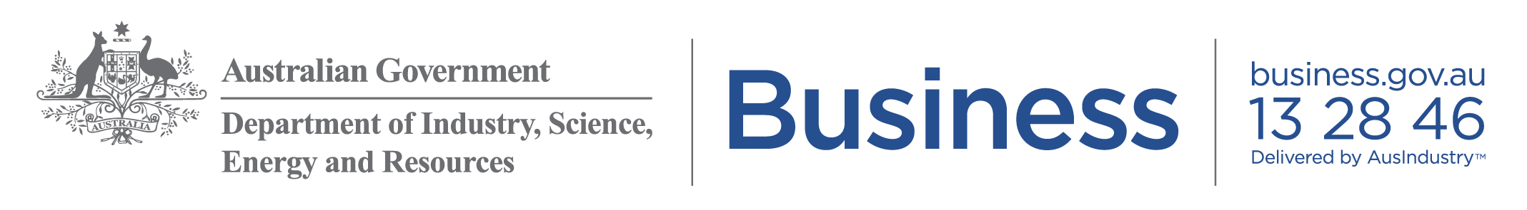

Marketing kit for small business advisers

Key resources for small businesses
Copy and paste these articles into your website, blog or newsletter and the posts to your social media accounts to share the latest news relevant to small businesses.

Newsletter/Website content

Free Small Business Advice
This year has brought about change in many unexpected ways. To assist you with these changes, you can now access your first service offering from the Australian Small Business Advisory Service (ASBAS) program for free.

Get help to use digital tools to save you time and money, and grow your business in areas such as:
- How digital tools can help small business
- Websites and selling online
- Social media and digital
- Small business software
- Online privacy and cyber security
ASBAS services are available across all metropolitan and regional areas for sole traders and small businesses with less than 20 full-time (or equivalent) employees.
Services are offered one-to-one to provide tailored support or through group workshops or webinars.
For more information on ASBAS and to find your local provider visit: www.business.gov.au/asbas

Social Media Content

Facebook Post
Looking for small business advice? You can now access your first service offering from the Australian Small Business Advisory Service (ASBAS) program for free. ASBAS provides low cost, high-quality small business advice from qualified experts. Get help to use digital tools to save you time and money, and grow your business.
To find out more and to find your local provider visit www.business.gov.au/asbas

Twitter
Due to high demand the #ASBAS program is being expanded to provide small businesses with advice on how to use digital tools to save you time and money, and grow your business.
Find out more at www.business.gov.au/asbas #ASBAS #smallbusiness

LinkedIn
Looking for small business advice?
You can now access your first service offering from the Australian Small Business Advisory Service (ASBAS) program for free. ASBAS provides low cost, high-quality small business advice from qualified experts. Get help to use digital tools to save you time and money, and grow your business.
ASBAS services are available across all metropolitan and regional areas for sole traders and small businesses with less than 20 full-time (or equivalent) employees.
Services are offered one-to-one to provide tailored support or through group workshops or webinars.
For more information on ASBAS and to find your local provider visit: www.business.gov.au/asbas
Optional image to accompany the posts below

Images
The following images to support your article are included below and are available to download from https://tinyurl.com/y3mny6a7 .

