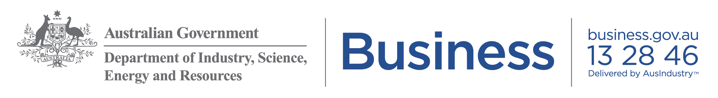

Marketing kit for small business advisers

Key resources for small businesses
Copy and paste this article into your website, blog or newsletter to share the mental health, financial and business advisory support available to small businesses.

Support for small business owners during coronavirus

Business advice
You may be running your business in ways you’ve never had to before. There is a range of support to help you adapt to these changes.
- A national three step plan will guide states and territories on relaxing coronavirus restrictions. Check your state or territory information for local advice. Safe Work Australia has industry specific guidance to help you operate your business safely.
- You can access low cost, high quality business advice from the Australian Small Business Advisory Services (ASBAS) Digital Solutions program. You can get help to take your business online, boost cash flow, manage your staff and much more.
- You can access a range of expertise and advice on business.gov.au as well as free online tools and resources to help you review your finances, market your business and look after your customers.
- As part of the Small Business Digital Champions Project 15 industry associations are providing business advice to their members. Members can talk to their industry association about how to access this support.

Financial support
The Australian Government has established an economic stimulus package to support you through coronavirus.
- The latest information about the Government’s assistance for business is available on business.gov.au.
- You can call the Government’s Coronavirus business support line on 13 28 46 between 8am - 8pm across Australia, seven days a week, for advice on the financial support available to you.
- You may be eligible for support from your state or territory government. You can find grants or online events delivered by your state or territory on business.gov.au.
- The Australian Tax Office offers a range of support and assistance to businesses and individuals. You can contact the ATO Emergency Support Infoline on 1800 806 218.
- For financial counselling, including advice on managing debt, contact the free and confidential National Debt Helpline by calling 1800 007 007. You can also visit MoneySmart for advice to help you manage your finances.

Mental health and wellbeing
Pressure on cash flow, looking after staff and uncertainty about the future can have an impact on your wellbeing. It’s important that you ask for help when you need it - this is not only good for your mental health but good for your business too.
- Beyond Blue’s dedicated website has advice and strategies to help you manage your wellbeing during coronavirus. You can also speak to the trained counsellors at the Coronavirus Mental Wellbeing Support Service 24/7. You can call them on 1800 512 348.
- My Business Health provides practical advice on how to keep your business afloat and maintain your wellbeing.
- Head to Health brings together over 500 apps, online programs and phone services across Australia to support you.
- business.gov.au offers guidance on how to access telehealth and mental health support.
- The Ahead for Business app is specifically designed for small business owners and provides useful tips to help you balance work and life, track your goals and manage how you’re feeling.

Images
The following images to support your article are available to download from: https://business.gov.au/risk-management/emergency-management/coronavirus-information-and-support-for-business/supporting-small-businesses-during-coronavirus

Mental health | Financial support | Business advice

