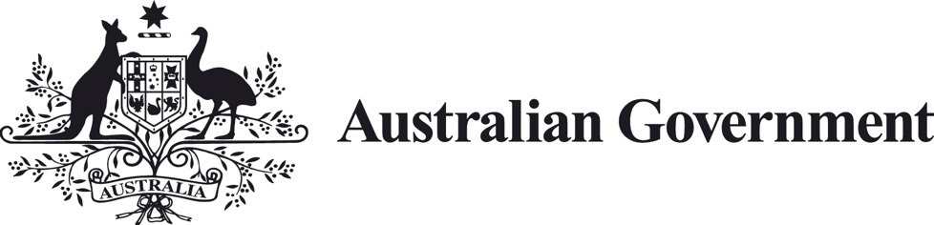

Business Research and Innovation Initiative
Fact Sheet – Challenge 3
Improving information matching and exchange for security, property, transport and liquor and gaming industries

Challenge summary
The Department of the Prime Minister and Cabinet is seeking innovative solutions to improve information matching and exchange between jurisdictions for
the Automatic Mutual Recognition of Occupational Registrations (AMR) scheme.
Specifically, we are seeking solutions that address information sharing barriers for the security, property, transport and liquor and gaming industries.
While different sectors face similar information sharing challenges, in some cases there are sector-specific challenges. Solutions could focus on certain components of this challenge or specific sectors.
To apply now, visit business.gov.au/BRII.

Potential themes
Advanced technology, advanced hardware and software, data automation, E-Systems, legal, regulatory, assurance, certification.

Overview of challenge
AMR came into effect on 1 July 2021 in New South Wales, Victoria, the Australian Capital Territory and the Northern Territory, and will progressively commence in other states.
AMR applies to a limited number of occupations initially and will include more occupations as Australia transitions to the scheme.
AMR makes it easier for workers who need to be licenced or registered for their job to work elsewhere in Australia.

AMR removes the need for a worker to pay and apply for a new licence or registration when working in another state or territory, saving them time and money.
AMR also enables state and territory regulators to continue compliance activity in an efficient and effective manner. This results in a greater need for real-time exchange of regulatory information between jurisdictions.
The goal of this challenge is to address the following AMR information matching and exchange issues.
How we might reduce the time and resources required to:
- verify information about a worker’s occupational registration or licence from another jurisdiction
- access the information reasonably required from another state regulator
- notify all other regulators of relevant disciplinary action, and
- notify all other regulators of the renewal, expiry, suspension and/or cancellation of a licence.
How can we ensure consistency in information shared across jurisdictions?
Current information sharing between jurisdictions can be manual and email-based due to database limitations.

More secure, efficient provision of information between regulators would reduce the time and costs spent on manual processes, allowing regulators to direct resources to compliance, enforcement and managing risks to the community.

This challenge seeks to explore the potential to verify, access and/or provide information connectivity between jurisdictions with disparate systems.

Solution requirements

Functional requirements

Enable state and territory regulators to more efficiently verify, access and/or provide information about a worker’s occupational registration or licence to relevant interstate regulators.

- This information is potentially held in multiple systems within and across jurisdictions.

Be consistent with the information-sharing provisions in the Mutual Recognition Act 1992 and any relevant state or territory legislation.

Take account of current regulator systems and processes, any agreed data interoperability standards or models, and interim solutions being developed to administer AMR.
Be capable of adapting to evolving regulator systems and processes for occupational licencing as they progress in their maturity.

Address data governance issues, including source of truth, and lifecycle management.
• The solution should not include a database or central repository that needs to be manually managed and maintained.
Be cost effective to build, maintain and further develop.
Provide the option for a regulator from within or external to the state to subscribe or opt in e.g. at the point of notification or during a compliance action, and include bulleted and flagged information on particular licensees or registrations.
Take into account end user considerations, such as those who will be required to check and verify industry credentials.
Technical requirements
• Provide a secure environment to verify, access and/or share certain information to other users of the system.
• Limit access to certain information based on occupational registrations and licences.
• Exchange and maintain information in accordance with the relevant privacy and information security laws and policies in different states and territories and across different occupational registrations and licences.
• Be technology agnostic and work with disparate systems within and across multiple jurisdictions.
• To work across multiple jurisdictions, the solution will need to meet universal standards and have minimal technology requirements.
• Automate where possible and minimise any manual effort.
• Be scalable and repeatable for diverse regulators.
• Provide consistency in the way data and information is shared.
• Only share data and information where necessary and reuse data and information already shared where possible. Effectively manage information provided to jurisdictions, not immediately needed.

Benefits of the solution
This challenge encourages private sector innovation and commercialisation of successful products that boost connectivity and reduce the time and costs applied to manual processes.
Successful applicants will be able to work directly with regulators to test the commercial viability of their solutions. This way of working is intended to facilitate a deep understanding of the requirement, which minimises the risk of developing a product that is not fit-for-purpose. It also supports the development of more cost-effective and sustainable solutions.
Other benefits
Ensure workers are appropriately skilled and authorised to work in another state or territory.
Reduce time and costs for regulating occupational licences in a second state.
Enable the efficient and effective administration of AMR across jurisdictions. This will allow registered and licensed workers to respond more quickly to changing labour market conditions and to address immediate impacts or assist with longer term recovery, such as natural disasters.

How to apply
For more information on how to apply, visit business.gov.au/BRII.

