Customer: Itree Pty Ltd
Itree Pty Ltd developed a new intelligent software product - called REACH; from the ground up. REACH enables state and territory child protection organisations to securely share vital information to inform critical decision-making about children-at-risk in near real-time.
Sector: Child protection
Location: Wollongong, NSW
Electorate: Cunningham

Industries of Cunningham: Tourism, tertiary education, steel production, coal mining, brick manufacturing and textiles.

REACH caters for variable data quality by providing intelligent features such as name permutations, relationship pattern matching and partial matching using a configurable match confidence score. It learns over time to improve match confidence calculations.

Program: Business Research and Innovation Initiative (BRII)
BRII provides small to medium sized enterprises with grant funding to develop innovative solutions for government policy and service delivery challenges.
Support: Itree received a Feasibility Study Grant of $99,459 followed by a Proof of Concept Grant of $933,921 to solve the Australian Department of Social Services challenge of ’sharing information nationally to ensure child safety’.
As a result of the BRII grant, REACH has been built as a genuine product offering, supported by a product vision and roadmap.
For more information on Itree, visit itree.com.au For information on BRII search business.gov.au or call 13 28 46. 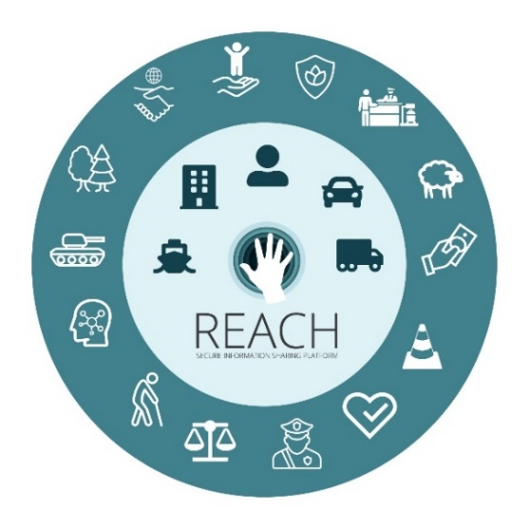 REACH has gone from strength-to-strength. Following its official launch in April 2019, Itree’s REACH won the 2019 Australian Business Award for New Product Innovation, and then won the RegTech Social Impact of the Year 2020 award.
Since October 2019, the national implementation of REACH, now called ‘Connect for Safety’ has helped Itree to:
- secure $5.9 million in funding over five years (including $3.9 million from the Commonwealth Government)
- create six new jobs, including technical support and product management
- start working with all state and territory child protection agencies
- achieve ‘technical go live’ in two states/territories with Business Go Live scheduled for mid-July 2020
- start on-boarding two more jurisdictions.
REACH – and Connect for Safety – cater to and work within the technology and privacy constraints of securely sharing personal and sensitive information.
Connect for Safety is overseen by the National Child Protection Information Sharing Inter-jurisdictional Governance Group.
“Although developed for child protection, REACH can be configured to any data sharing scenario where records are held in multiple systems, there is no common unique identifier, and data quality may be a challenge.”
Daniel Walsh, Head of Product – Itree

