Project Proposal - Guidance
Australian Space Agency
March 2022
space.gov.au

Please use your own cover page and logo when submitting your application and do not use the Australian Space Agency’s (the ‘Agency’) cover page nor the Agency’s logo or branding.

Contents
1 Part 1 - Strategic proposal 4
2 Part 2 - Technical proposal 7
3 Part 3 - Implementation proposal 16
4 Part 4 - Management proposal 21
5 Part 5 - Financial proposal 28

Purpose of the Project proposal template and Project proposal guidance documents
The Project proposal template and this associated guidance document are intended to support you to generate a project proposal. This should help ensure a suitable level of information is provided by you to allow a fair and efficient assessment of your application.
If there is any conflict, discrepancy, or inconsistency between the information in this document and the Grant Opportunity Guidelines, the information contained in the Grant Opportunity Guidelines prevails.
Your project proposal does not constitute your full application. You must also complete the questions in the online application, which includes a project description, key milestones, a summary budget, details of project partners and your response to assessment criteria. Your project proposal is a mandatory attachment to your online Demonstrator Mission Grant application.
The answers to the questions in the online application should summarise the key elements of your proposal while the attached project proposal should provide all the necessary details, evidence and justifications to enhance your application.
Use of this template is not mandatory, however it is highly recommended to read this guidance and review the template before generating your project proposal. All mission proposals should provide the following information as a minimum:
- Part 1 - Strategic proposal
- Part 2 - Technical proposal
- Part 3 - Implementation proposal
- Part 4 - Management proposal
- Part 5 - Financial proposal
Further detail on each of these sections is provided below.
You may add additional information in any relevant section if you consider that this would add value to your proposal. The use of graphs, charts, images and tables to help explain and justify the argumentation and data is highly encouraged, however when submitting your proposal, an individual attachment must not exceed 2MB in size. You can separate your proposal into its parts (e.g. Strategic proposal, Technical proposal, etc.) if needed, but all attachments must not exceed 20MB in total.
Please use your own cover page and logo when submitting your application and do not use the Australian Space Agency’s (the ‘Agency’) cover page nor the Agency’s logo or branding.

Part 1 - Strategic proposal
Provide a table of contents here
Your Strategic proposal should demonstrate the benefit of your project to:
- the Australian Civil Space Strategy 2019-28
- the Moon to Mars initiative
- your organisation(s) strategic goals, and
- the Australian space ecosystem.
You must provide details and evidence to support your claims.

Strategic requirements/conditions
List any strategic requirements or conditions that you need to meet and indicate your compliance status (e.g. comply, partially comply, do not comply). Strategic requirements or conditions may be from the Grant Opportunity Guidelines (the ‘Guidelines’), standards, or as required by your consortium. You should explain your compliance status and highlight where further detail may be found in your proposal.
Table X: Compliance to strategic requirements/ conditions
# | Requirement/ condition description | Compliance (Y/N/Partial) | Explanation | Proposal section
 | Description of the requirement/ condition | Compliance status | Explanation for compliance status and any conditions | Where in the proposal the compliance can be found
E.g.  01 | (Example) 80% of project expenditure shall be in Australia | Y |  | (example) Section 1.2, 1.3
02 | (Example) The majority of key skills and capability to keep in Australia include: system engineering, program management, design, key components and sub-system manufacturing, critical technology development, cyber security, software development, assembly, integration and testing | Partial | The following skills are to be kept in Australia, XXX.  The following skills would be outsourced overseas due to minimal experience in Australia, with the plan to bring these skills to Australia by XX | (example) Section 1.2.1
03 | (example) The project shall be revenue generating in XX years
04 | ….

Introduction
Provide an introduction and summary of the Strategic proposal. Outline the key points and messages you would like to bring across.

Benefit to Australia
Explain how your proposed project would support the implementation of the Australian Civil Space Strategy 2019-28 and support the objectives of the Demonstrator Mission Grant opportunity. Key information may include:
- the projected number of jobs created
- the projected revenue/exports for Australia
- benefits to other sectors.

Australian industry content
Key information may include:
- Your philosophy for consideration of Australian industry content
- the extent of Australian industry content in your project (by percentage of project expenditure)
- an explanation of the Australian industry content (e.g. where sourced, how it would be used)
- how you would maintain and enhance the Australian industry content of the project.
If further detail is provided elsewhere in your proposal, provide a summary with highlights here and reference relevant sections.

Australian capabilities and skills
Key information may include:
- Australian and non-Australian skills and capabilities to be used and grown
- how you would maximise the development of Australian skills and capabilities.

Australian facilities
Key information may include:
- Australian and non-Australian facilities to be used
- how you would maximise the suitable use of Australian industry facilities.

Australian program expenditure
Key information may include:
- the percentage of project expenditure to remain in Australia
- an explanation of any expenditure that would not remain in Australia, for example why products or services cannot or should not be sourced from Australian organisations.

<Other information>
Provide any other information you consider important to highlight about Australian industry content in your proposal.

Benefit to the Australian space ecosystem
Key information may include:
- any activities you would undertake to grow the broader Australian space ecosystem. Include (where known):
  - details
  - dates
  - groups involved
- how these activities would help/ support the Australian space ecosystem.
Additional details can be provided in other parts of the proposal, but it should be referenced with the key points summarised here.

Project business case
In this section, you should detail and justify how this project is going to help, grow and support your consortium/ organisation(s).

Project rationale
Explain the importance of this project to your consortium/ organisation(s) and how it fits into the aims of your business. How does this project contribute to your organisation’s vision for its place in the space industry?

Business case
Detail the benefits of this project to your organisation’s business case (or that of your project partners). This may include any potential commercial opportunities.
Key information may include:
- any product, process or service you intend to develop through this project that you may commercialise (in the space or non-space sectors)
- the potential market demand for your product, process or service
- your target market including:
  - intended customers
  - potential market size
- competitive analyses
- projected revenue growth for you and/ or your project partners as a result of the project.

Financial plan
Detail how you intend to access funding for your project that is not provided through the grant.

<Other information>
Any other information you consider important to highlight in relation to the project’s business case.

Part 2 - Technical proposal
Your Technical proposal should provide information on the complete mission, including technical considerations and proposed mission lifecycle. Please note: you may include a reference to the relevant section in your preliminary design review (PDR) for any of the sections in the Technical proposal, if the outcome / requirement / challenge / risk etc. has already been addressed in the PDR.
Provide a table of contents.

Compliance to Guidelines
List any high level technical requirements or conditions that you need to meet and indicate your compliance status (e.g. comply, partially comply, do not comply). You should explain your compliance status and include further details in Annex 2.A.
Table X: Compliance to technical requirements/ conditions
# | Requirement/ condition description | Compliance (Y/N/Partial) | Explanation | Proposal section
 | Description of the requirement/ condition | Compliance status | Explanation for compliance status and any conditions | Where in the proposal can the compliance be found
01 | Compliance to eligible activities | Y | Consortium commits | Annex 2.A
02
03
04
05
06

Introduction
Provide a summary of what is expected in the Technical proposal along with any key elements that you consider important to highlight.

Mission objectives and outcomes
In this section you should define your mission objectives, mission outcomes and the current status of your mission (completion of the PDR / CDR), along with any proposed secondary objectives that may be considered with your proposal.

Primary objectives and outcomes
A clear understanding of the primary objectives and outcomes are important for any mission. These objectives have been stated in the Guidelines and it is typical for a team to reiterate them - but the interpretation of the objectives can vary. Provide a detailed explanation of how your team understands the objectives and outcomes.
Key information may include:
- the primary objectives and outcomes of the mission
- assessment of the important attributes of these objectives and outcomes along with the implications
- any assumptions you have made.

Secondary objectives and outcomes
If there are any secondary objectives and associated outcomes that are proposed by the consortium / organisation(s), then the details should be outlined in this section.
Key information may include:
- any secondary objectives and outcomes of the mission
- assessment of the important attributes of these objectives and outcomes along with the implications
- any assumptions you have made
- explanation of how your secondary objectives would not jeopardise or dominate the primary objectives/ task of the mission.

<Other information>
Provide any other information you consider important to highlight about the mission objectives and outcomes.

Mission and system requirements
This section is about communicating the driving and critical requirements of your mission, along with their implication on the mission and system design.

Preliminary assessment of mission challenges
Key information may include:
- an assessment of key mission challenges and how they affect the design of your mission
- any key trade-offs that have been necessary to narrow your solution space. Include an explanation of these trade-offs and, if possible, an example of one
- how decisions have been made to arrive at your proposed mission concept
- how mission challenges would be mitigated
- any uncertainties or challenges still open to assessment.

Proposed mission concept
You should provide information on your proposed mission concept(s). You should articulate options including criteria that would be used to make a decision (e.g. trade-off approaches, method, and criteria). It is expected that the work process needed to finalise these decisions and designs should be included in the scope of work as detailed in the Implementation proposal.

Introduction of the mission concept
Provide a summary of your proposed preliminary mission concept, including key considerations and reasons why this is the best concept with the information available. Open work should be identified along with next steps.

Mission/ system architecture
Key information may include:
- overall mission/ system architecture
- launch, space and ground segments for the mission
- key considerations of the mission/ system architecture.

Concept of operations (CONOPS)
Explain your concept of how your mission would operate, including a justification of why this is the best solution and any critical or open points. You may provide figures to illustrate your concept.

System design and budgets
Key information may include:
- overall system design
- associated preliminary system-level budgets (and associated margin philosophies) including:
  - mass
  - power
  - link
  - etc.
- key system level design considerations and attributes.

Subsystem architectures/ considerations
Provide information/ justifications on the following subsystems (or subsystem options) for your mission concept(s):
- payload(s)
- communications
- operations
- power
- structures
- electrical/on board computer
- locomotion
- thermal
- any other relevant areas.

Mission risks
Detail the key risks of your proposed mission, along with the potential mitigation techniques. Explain how your approach manages the risk of the program and brings it into anticipated acceptable levels (for your consortium and key stakeholders).
Information on this topic can be found in Guidelines for Risk Management and NASA Risk Management Handbook.

System engineering approach
Key information may include:
- your system engineering approach for the development of the mission
- why you would take this approach
- any key considerations in taking this approach
- any standards you expect to use or adapt.

Design approach
Key information may include:
- how you would design the mission
- how you would assess your design to ensure it is iterating towards a solution.

Manufacturing, assembly, integration and testing (MAIT) approach
Key information may include:
- how you expect to manufacture, assemble, integrate and test the systems, technologies and products
- your procurement approach
- any standards you expect to use or adapt.

Verification and validation (V&V) approach
Key information may include:
- how you would verify and validate your project and the requirements.
You should provide a Verification Control documentation, fulfilled by Annex 2.B of the Technical proposal.

Critical technologies
You should identify and discuss any critical technology needed for your mission concept(s) to achieve the mission. Key information may include:
- the critical technologies
- whether the critical technologies are available to the consortium
- how you would acquire or develop the critical technologies (commercially off the shelf (COTS), develop in-house, etc.) and manage the associated technology risk
- the Technology Readiness Levels (TRLs) of the critical technologies.

Table X: Preliminary critical technologies list
Critical technology | System/ subsystem | Description |  | Present TRL (0 – 9) | TRL evidence | How to obtain it (COTS, build in-house) | Technology organisation | Location of technology | Long Lead Item? | Comments
Critical technology name | Which sub-system is this technology in (e.g., power, structures) | Description and why is it critical? | Present Technology Readiness Level (TRL) |  | Provide proof on TRL evidence | Provide details on how it is obtained (COTS, build in-house) | If procured, which organisation would provide this technology, provide details of this organisation e.g. heritage | Geographic location of technology to be procured or developed. | Yes or No, and the length of time needed to obtain it. | Any other comments
Technology 1
Technology 2
Technology X

Regulation considerations
Describe any regulatory considerations that need to be addressed. Identify any critical considerations that may affect the mission or major requirements you need to comply with. Include timelines for any necessary licence application processes (i.e. DECO, ACMA, OPP etc).

Open considerations
Describe any critical areas, key aspects or considerations that are still open that would need to be investigated and explain why these are important.

<Other information>
Any other information you consider important to highlight on the Technical proposal.

ANNEX 2.A: Compliance - Eligible activities
You must provide a statement of compliance against the eligible activities contained in the Demonstrator Mission Grant Opportunity Guidelines, using the table provided.
NOTE: To be eligible to apply for the Demonstrator Mission Grants, your project must be compliant and include eligible activities.
Table X: Compliance to eligible activities (that must be included in the proposal (Chapter 5.1 in the Guidelines))
# | Description | Compliance (Y/N/Partial) | Explanation | Proposal section
1 | Your project must include mission development activities (Phases C to E). Eligible activities may include remediation activities to ensure quality requirements are met moving into phase C, final design, project fabrication and assembly etc.
2 | Your project must aim to have an asset that is operational in space or be able to support an asset that is operational in space by April 2025.
3 | Your project must have a clear potential to support Moon to Mars activities.
4 | Your project must align with priorities in the Advancing Space: Australian Civil Strategy 2019 – 2028.
5 | Your project must have at least $1 million in eligible expenditure.

ANNEX 2.B: Verification methodology to the mission requirements

You must provide a statement of verification for mission requirements in the table provided.

Table X: Preliminary verification control list for mission requirements

Requirement | Description | Preliminary compliance (Y/N/Partial) | Preliminary verification method (A,D,I,T) | Preliminary verification level | Explanation
 | Description of requirement | Compliance status | How you would verify this requirement (Analysis, Demonstration, Inspection or Test) | What level this requirement would be verified at (System, Sub-system, component) | Key information on reason why this verification method was chosen

ANNEX 2.C+: Analysis, Budgets, Technical Assessments….
Please add any detailed technical budgets and clearly state the technical margins that are used. An example on how margins may be approached can be found in ARC-8070-1 – ‘Space flight system design and environmental test’.
.

Part 3 - Implementation proposal
Provide a table of contents.

Introduction
Summarise what is expected in this proposal along with the major points of your Implementation proposal.

Work logic
Provide a flow chart of your work logic including key milestones and decision points.

Planning
Explain and justify your project planning.
Key information may include:
- a summary of your mission schedule (provide a detailed schedule in Annex 3.A of the Implementation proposal)
- a justification of your mission schedule and areas of consideration
- proposed progress meetings and reviews, including milestones and major decision points
- team meeting occurrence and rationale.

Deliverable items list (DIL)
Key information may include:
- document delivery list (DDL) – the documents you expect to deliver and to whom, for each milestone. Please provide the detailed DDL in Annex 3.B of the Implementation proposal (refer to NPR 7120.5 Table I-6 for a reasonable framework)
- software deliverables – the software you expect to deliver and to whom, for each milestone
- hardware deliverables – the hardware you expect to deliver and to whom, for each milestone
- management deliverables – any project management deliverables expected at each milestone.

Work breakdown structure (WBS)
Provide a comprehensive work breakdown structure for the project. You should indicate which organisation would be performing the work.
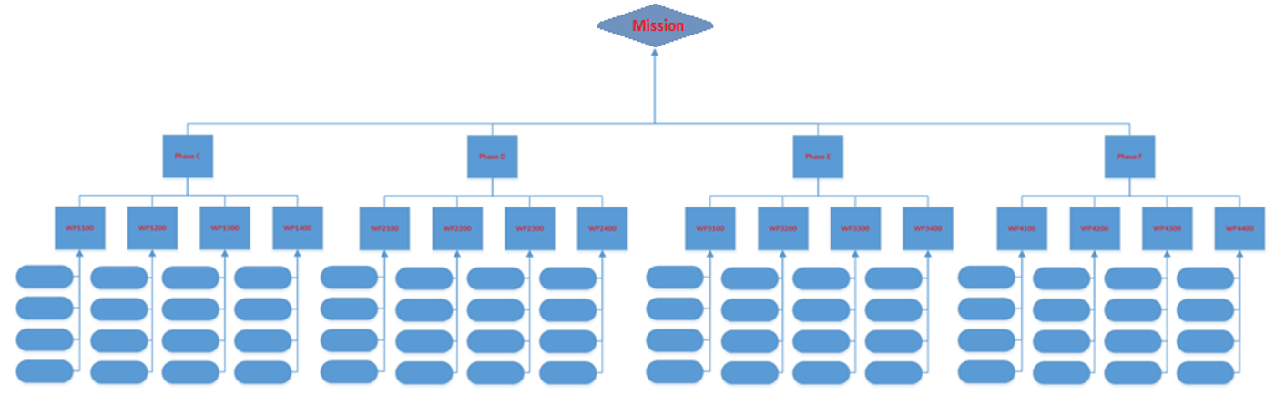
Figure X Work breakdown structure
You should also provide:
- details of how the WBS relates to achieving the key tasks for the mission
- a summary of the work package descriptions (WPDs) including the work package title, contractor, manager, phase the work package is in and effort to achieve the work package.
- WPDs (please provide the detailed WPDs in Annex 3.C of the Implementation proposal).

ANNEX 3.A: Mission schedule
Provide a detailed schedule outlining activities which would take place in this mission. This schedule should contain the milestones outlined in the Demonstrator Mission Grants opportunity guidelines (Appendix A.2) and any additional milestones that you identify.

ANNEX 3.B: Deliverable items list (DIL)
Provide a document delivery list for the mission.

ANNEX 3.C: Work package descriptions (WPDs)
You should provide work package descriptions for each of the identified work packages in the WBS. These should include outputs of each work package, duration and key personnel.
WP title | Provide the title for the WP
Responsible organisation | Provide the name of the organisation within the consortium that is responsible for this work
Start date (planned) | Provide the planned start date for the work
End date (planned) | Provide the planned end date for the work
WP manager | Provide the name of the key personnel managing this WP
Objectives
Provide the key objectives of the WP in the form of bullet points.

Tasks
Outline the tasks to be completed under this WP in the form of bullet points.
Dependencies
Identify task dependencies, i.e., pre-cursor tasks or other tasks that this item is required to enable
Risks
Outline key risks for task owners to be aware of/manage. These would usually link to the overall risk management plan.
Outputs
Provide the expected outputs of the WP. This should be consistent with the output list you would provide as part of the Technical proposal.

ANNEX 3.D+: <Any further annexes>
Provide further detailed information.

Part 4 - Management proposal
Provide a table of contents.

Compliance to management requirements/ conditions
Describe any high level management requirements/ conditions set by the Guidelines, standards or your consortium and state your compliance to them. You should explain your compliance status and highlight where further detail may be found in your proposal.
Table X: Compliance to complete management requirements/ conditions

# | Requirement/ condition description | Compliance (Y/N/Partial) | Comments | Proposal section
 | The description of the requirements | Your compliance status (Yes, No or Partial) | Key comments to this requirements, especially important when you have a partial compliance | Where in the proposal you demonstrate your compliance to this requirement
01 | The project’s consortium shall have a lead applicant | Y | The lead is <organisation name>.
02
03
04
05
X

Introduction and consortium overview
Summarise the management of your project including the consortium members, governance structures, geographic locations, etc. Explain why this is the best structure and team to conduct your project.
Outline the structure of the consortium.

Presentation of the organisations
Detail each organisation in the consortium for the mission project. Key information may include:
- summary of the organisations and what they do
- number of employees and annual turnover
- organisation management structure and global footprint
- any experience and heritage, including relevant space heritage that would be leveraged
- any past missions/projects conducted or in development/ under contract
- why the organisation should be a part of the consortium including the skills and capability to the organisation adds to the team
- any information that demonstrates that the organisations in the consortium can perform the mission.

Management of the activity

Consortium/ project management
Key information may include:
- how the consortium/partners/sub-contractors would be managed
- how contracts would be managed
- how changes with consortium members would be managed along with contract changes
- how disputes would be managed
- how you expect to work with the Agency, including any controls you would like in place.
- the key roles required to support project management.

Stakeholder management
Key information may include:
- your key internal stakeholders (internal managers at the consortium organisation, etc.) and how they would be managed including any controls you would like in place
- your key external stakeholders (e.g. the Agency, etc.) and how they would be managed including any controls you would like in place
- how changes of and with stakeholders would be managed
- the key roles required to support stakeholder management.

Technical management
Key information may include:
- how you would manage the objectives including how you would ensure secondary objectives do not overtake primary objectives
- how you would manage the requirements along with changes in the requirements
- how you would manage the change or non-conformances of technical project aspects
- how technical information would be managed
- what management controls would need to be in place to ensure the system works
- the key roles required to support technical management.

Scope creep
Discuss how you would manage scope creep and how you would ensure it does not add significant risk to the mission.

Risk management
Key information may include:
- how risk would be managed
- the controls you would need to put in place
- how you would ensure risk does not exceed acceptable levels
- how changes to risk would be managed
- the key roles required to support risk management.

Quality management
Key information may include:
- any critical aspects that may affect quality
- how you would manage quality of the project including the controls you would have in place
- how quality non-conformances of your project would be managed
- details of and justification for how you would utilise your review panel, the critical roles and competencies, and details (e.g. CVs and justifications) of members
- the key roles required to support quality management.

Regulation management
Key information may include:
- an explanation of the regulatory management required for the project
- the critical aspects of this management
- the key roles required to support regulatory management.

Digital management
Key information may include:
- how you would digitally manage your project to ensure efficiencies during the development and operations, including approaches, tools and databases, software (e.g. digital system engineering or MBSE software) etc.
- what experience you bring to apply the technology.

<Other information>
Add information regarding any other management processes relevant to your project.

Organisation of the activity

Project team structure
Key information may include:
- organisation/ company grouping, including geographic location
- contract structure
- project organisation breakdown structure (OBS) – including which organisations/companies, with key and supporting personnel, include geographic location
- lines of reporting for the project
- any other relevant information you think is necessary.
You should provide a detailed diagram of the structure of your consortium (see example below). Ensure the lead organisation/ company is clearly identified. Describe the capability each organisation brings to the team.
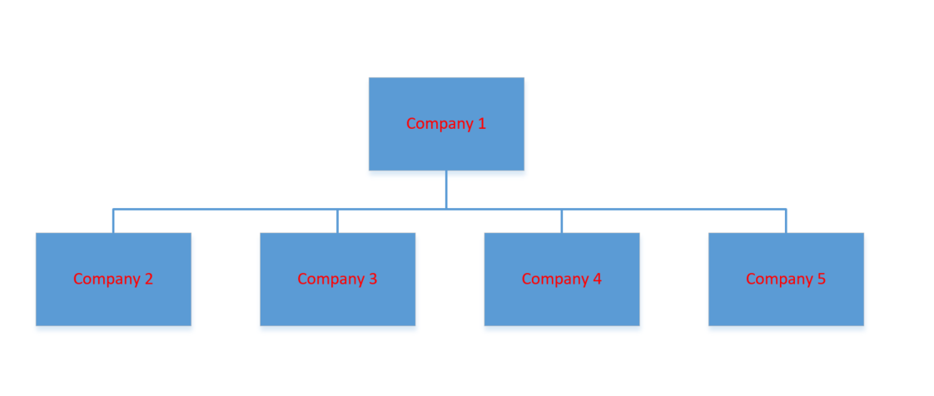
Figure X: Detailed project consortium
You should provide a detailed diagram of the project team hierarchy (see example below) including lines of reporting.
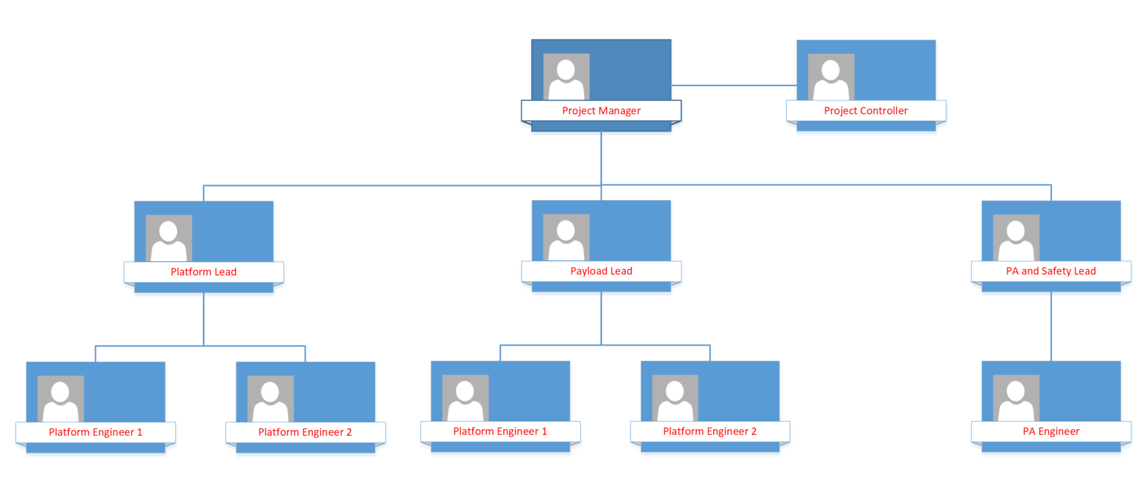
Figure X: Project team hierarchy

Consortium governance
You should clearly articulate the governance of your consortium, as this will be vital to manage your project.

Consortium capability
Describe the key capabilities needed to deliver the mission and clearly articulate the capabilities brought by each company or organisation in your consortium. All key capabilities must be identified. If a capability is not provided by a member of your consortium you must clearly articulate how you would gain that capability throughout the mission development.
Table X: Consortium capability matrix, with evidence (example).
 | Organisation 1 name | Organisation 2 name | Organisation 3 name | Organisation 4 name | Comment
Capability | Provide evidence of the relevant capability/ heritage that this organisation brings
Space heritage | 10 satellites built and operated successfully | 10 payloads delivered and operational | Space grade avionics supplied to 12 missions | Nil
General | 10 years’ experience in this capability, e.g. | Nil | Nil | 15 years of experience e.g….
System assembly | 5 years of experience this capability e.g. 2 years on mission X, 3 years on mission Y | 10 years of experience e.g.… | Nil | Nil
System Compatibility & Integration Testing | Nil | Nil | Nil | Nil
Operations | Nil | Nil | Nil | 12 years of experience e.g….
Risk Assessments | Nil | Nil | 5 years of experience e.g.… | Nil
Capability 5 | Nil | Nil | Nil | Nil | Capability 5 is identified and considered critical. The consortium is following action plan X to fulfil this capability by date Y
Capability …

<Other information>
Provide any other information you consider important to highlight.

Facilities
Provide details of all facilities you plan to use during mission development including capabilities and reasons for use. Any facilities critical to mission success should be clearly identified.
Provide details of any Australian facilities that could be used but are unavailable.

Software and tools
Provide details of all software and tools you plan to use during mission development including capabilities and reasons for use.

Key personnel
Key information may include:
- key personnel in technical, management and quality teams, including their skills, experience and the work packages they would support (CVs to be included in Annex 4.A of the Management proposal).

Other information
Provide any other information you consider important to highlight.

ANNEX 4.A: CVs
Provide all names and the CVs of the key personnel including their experience to justify their role. Any space experience, especially exploration space experience should be highlighted. A one page summary per key personnel is sufficient.

ANNEX 4.B+: <Any further annexes>

Part 5 - Financial proposal
Provide a table of contents.

Compliance to financial requirements/ conditions
Describe any high level financial requirements/ conditions set by the Guidelines, standards or your consortium and state your compliance to them. You should explain your compliance status and highlight where further detail may be found in your proposal.
Table X: Compliance to financial requirements/ conditions.
# | Requirement / condition description | Compliance (Y/N/Partial) | Explanation | Proposal section
 | Description of the requirement/ condition | Compliance status | Explanation for compliance status and any conditions | Where in the proposal the compliance can be found
01 | The grant funding shall be between $750 k and $10 M. | Y | $XX was requested for the grant | Annex X, budget…
02
03
04 | ….

Introduction

Provide an introduction and the key points of the Financial proposal.

Project budget
Key information may include:
- a summary of your budget
- justification and assumptions of the project budgets
- any key information to be emphasised.
Provide detailed information of your project budget in Annex 5.A of the Financial proposal. The format of your project budget is as per the Project Budget Template.

Contingency and management of contingency
Key information may include:
- the contingency and margins used in the budget to manage risk
- how you would manage the contingency throughout the project.

Milestone costs
Key information may include:
- a summary of your milestone costs
- justification and assumptions of the milestone costs
- any key information to be emphasised.
Provide detailed information of your milestone costs in Annex 5.A of the Financial proposal. The format of your milestone costs is as per the Project Budget Template.

<Other information>
Provide any other information you consider important to highlight.

ANNEX 5.A: Project budget & milestone costs
Please refer to Project Budget Template for the format.

ANNEX 5.B+: <Any other information>
Any other information.

