Regional Jobs and Investment Packages
Version 1 – March 2017

Contents
1. Regional Jobs and Investment Packages – process 5
2. Introduction 6
3. Program overview 6
4. Grant funding available 7
4.1 Your contribution 7
4.2 Exceptional circumstances 7
4.2.1 Co-funding requirements 8
5. Local Investment Plans 9
5.1 Local Planning Committees 9
5.2 Publication of plan 9
6. Grant funding streams 9
6.1 Local infrastructure 9
6.2 Business innovation 9
6.3 Skills and training 10
7. Local infrastructure 10
7.1 Grant amount and grant period 10
7.1.1 Grants available 10
7.1.2 Project duration 10
7.2 Eligibility criteria 10
7.2.1 Who is eligible? 10
7.2.2 Who is not eligible? 11
7.2.3 Additional eligibility requirements 11
7.2.4 Eligible local infrastructure projects 11
7.2.5 Eligible activities 12
7.2.6 Ineligible activities 12
7.2.7 Eligible expenditure 12
7.3 The merit criteria you need to address 13
7.3.1 Merit criterion 1 13
7.3.2 Merit criterion 2 13
7.3.3 Merit criterion 3 13
7.3.4 Merit criterion 4 14
8. Business innovation 15
8.1 Grant amount and grant period 15
8.1.1 Grants available 15
8.1.2 Project duration 15
8.2 Eligibility criteria 15
8.2.1 Who is eligible? 15
8.2.2 Who is not eligible? 15
8.2.3 Additional eligibility requirements 15
8.2.4 Eligible business innovation projects 16
8.2.5 Eligible activities 16
8.2.6 Eligible expenditure 16
8.3 The merit criteria you need to address 17
8.3.1 Merit criterion 1 17
8.3.2 Merit criterion 2 17
8.3.3 Merit criterion 3 18
8.3.4 Merit criterion 4 18
9. Skills and training 19
9.1 Grant amount and grant period 19
9.1.1 Grants available 19
9.1.2 Project duration 19
9.2 Eligibility criteria 19
9.2.1 Who is eligible? 19
9.2.2 Who is not eligible? 19
9.2.3 Additional eligibility requirements 20
9.2.4 Eligible skills and training projects 20
9.2.5 Eligible activities 20
9.2.6 Ineligible activities 21
9.2.7 Eligible expenditure 21
9.2.8 Eligible Learners 21
9.3 The merit criteria you need to address 21
9.3.1 Merit criterion 1 21
9.3.2 Merit criterion 2 22
9.3.3 Merit criterion 3 22
9.3.4 Merit criterion 4 22
10. How we assess your application (selection process) 24
10.1 Final decision 24
11. How to apply 25
11.1 Attachments to the application 25
11.2 Joint applications 26
12. If your application is successful 26
12.1 Grant agreement 26
12.2 Special regulatory requirements 27
12.2.1 Building Code 27
12.2.2 WHS Scheme 27
12.3 How we pay the grant 27
12.3.1 Local infrastructure grants and Business innovation grants payment arrangements 28
12.3.2 Skills and training grants payment arrangements 28
12.4 How we monitor your project 28
12.5 Progress reports 28
12.6 Final report 28
12.7 Ad-hoc report 29
12.8 Financial report 29
12.9 Compliance visits 29
12.10 Project variations 29
12.11 Keeping us informed 29
12.12 Evaluation 30
12.13 Tax obligations 30
13. Conflicts of interest 30
13.1 Your conflict of interest responsibilities 30
13.2 Our conflict of interest responsibilities 30
14. How we use your information 31
14.1 How we handle your confidential information 31
14.2 When we may disclose confidential information 31
14.3 How we use your personal information 32
14.4 Public announcement 32
14.5 Freedom of information 33
15. Grant acknowledgement 33
16. Enquiries and feedback 33
Appendix A. Definitions of key terms 34
Appendix B. Eligible expenditure guidelines 36
B.1 How we verify eligible expenditure 36
B.2 Plant and equipment expenditure 36
B.3 Construction expenditure 37
B.4 Information technology expenditure 38
B.5 Labour expenditure 38
Labour on-costs and administrative overhead 38
Contract expenditure 39
B.6 Other eligible expenditure 39
Appendix C. Ineligible expenditure 40
Appendix D. Maps showing pilot regions 41
Appendix E. Accountant declaration 51

Regional Jobs and Investment Packages – process
The Regional Jobs and Investment Packages is designed to achieve Australian Government objectives
The Regional Jobs and Investment Package (RJIP) is a $220 million investment by the Australian Government to help diversify regional economies, stimulate economic growth and deliver sustainable employment in ten pilot regions (RJIP regions).
⬇
Local Planning Committees established
Local Planning Committees are established in each RJIP region to develop a Local Investment Plan.
⬇
Local Investment Plans submitted
Committees submit Local Investment Plans, outlining industry growth sectors, new market opportunities and future workforce needs to the Minister and Department of Infrastructure and Regional Development.
⬇
The program opens
We publish the Local Investment Plans and advertise opening of grants on GrantConnect and business.gov.au.
⬇
You complete and submit a grant application
Your application should align with your region’s Local Investment Plan and these program guidelines
⬇
We assess all grant applications
We assess the applications against the eligibility criteria and notify you if you are not eligible. We then assess eligible applications against the merit criteria including an overall consideration of value for relevant money and compare it to other applications.
⬇
We make grant recommendations
We provide advice to the Ministerial Panel on the merits of each application.
⬇
Grant decisions are made
The Ministerial Panel decides which applications are successful.
⬇
We notify you of the outcome
We advise you of the outcome of your application.
⬇
We enter into a grant agreement
We will enter into a grant agreement with successful applicants. The type of grant agreement is based on the nature of the grant and proportional to the risks involved.
⬇
Delivery of grant
You undertake the grant activity as set out in your grant agreement. We manage the grant by working with you, monitoring your progress and making payments.
⬇
Evaluation of the Regional Jobs and Investment Packages
We evaluate the specific grant activity and Regional Jobs and Investment Packages as a whole. We base this on information you provide to us and that we collect from various sources.

Introduction
These guidelines set out the funding rules for the Regional Jobs and Investment Packages (RJIP) (the program) for applicants.
The Department of Industry, Innovation and Science (the department) is responsible for administering the program on behalf of the Department of Infrastructure and Regional Development, according to the requirements of the Commonwealth Grants Rules and Guidelines(CGRGs).
The program will run over four financial years from 2016-17 to 2019-20.
The program will open to applications in different selected regions, depending on when a Local Investment Plan is published for each region. We expect there will be only one round of applications for each region, which will open in the second quarter of 2017. Projects may run over multiple years. Any future rounds will be dependent on available funds.
We will publish the opening and closing dates and any other relevant information on business.gov.au.
We have defined key terms used in these guidelines in Appendix A.
You should read this document carefully before you fill out an application. We may vary these guidelines from time-to-time. We will publish amended guidelines on business.gov.au.

Program overview
The $220 million Regional Jobs and Investment Packages supports the Australian Government’s commitment to stimulate economic growth in Australian regions.
The program’s intended outcomes are to drive economic growth and create jobs in ten pilot regions by investing in projects that will
- diversify regional economies
- stimulate long term growth
- deliver sustainable employment
- enable applicants to enter new markets and sectors.
There are ten packages, each is a locally led pilot, enabling each region to determine local priorities and growth industries to drive economic growth in their region and create jobs.
A Local Planning Committee will be responsible for developing their Local Investment Plan that outlines industry growth sectors, new market opportunities and future workforce needs. Grants will be available in targeted competitive funding rounds to projects that align with the priorities in each region’s Local Investment Plan. Details about the Local Planning Committees are in section 5.1.
The program will invest in projects that will have long-term outcomes and will benefit the regions beyond the life of the program. Project outcomes should be sustainable without the need for ongoing government funding.
The program will only support new activities that go beyond business as usual or day-to-day functions.
The program does not fund any projects that have already started or where contracts are in place at the time of application.
We will monitor implementation closely and share the results and outcomes across all levels of government. This may influence the design and delivery of future regional development programs.

Grant funding available
The government will invest $220 million in ten pilot regions under this program. The Regional Jobs and Investment Packages will be evaluated and new regions may be considered in the future.
Funding is available across three streams.
- Local infrastructure
- Business innovation
- Skills and training
The amount available to each region is up to
QLD – Tropical North Queensland $20 million
QLD - Bowen Basin $30 million
QLD - Wide Bay Burnett $20 million
NSW - North Coast $25 million
NSW - South Coast $20 million
SA - Upper Spencer Gulf $20 million
VIC - Goulburn Valley $20 million
VIC - Latrobe Valley $20 million
VIC – Geelong $20 million
TAS - Regional Tasmania $25 million.
Maps showing the boundaries for each of these targeted regions are included at Appendix D.
Grants will be awarded on a competitive merit basis. We will assess your application against the eligibility and merit criteria and all other eligible applications across the three streams within your region.

Your contribution
You are required to provide co-funding towards your project, which demonstrates your commitment to the project. Grant funding will be up to 50 per cent of eligible project costs (grant percentage). Depending on your type of project, your contribution may come from your organisation, local and state governments or private sector investment.

Exceptional circumstances
The Australian Government recognises that some applicants may be experiencing exceptional circumstances resulting in a limited capacity to meet the co-funding requirement.
If you are a non-business applicant and you can demonstrate that you are experiencing exceptional circumstances, you may seek an exemption from the co-funding requirement. We will only consider an exemption to your 50 per cent contribution in exceptional circumstances and where you are applying under the
- Local Infrastructure stream
- Skills and training stream.
If you seek an exemption you must submit a supporting case which includes evidence demonstrating the exceptional circumstances you are experiencing and how they are preventing you from meeting the co-funding requirement. This must also include evidence to demonstrate the capacity to sustain the project’s outcomes.
The Ministerial Panel will consider requests for exemption, and will only grant exemptions in rare circumstances. The Ministerial Panel will grant an exemption if you have met the requirements under this section and presented a very strong case. If an exemption is not granted your application will be ineligible.
Before you consider seeking an exemption, note
- Exemptions will only be granted in rare circumstances.
- If an exemption is not granted your application will be ineligible and there will be no opportunity to resubmit your application in the same funding round.
- All applications, including those granted an exemption, will be assessed against each of the merit criteria. Applications with reduced or no co-funding may receive a lower score against the ‘value for money’ criterion (merit criterion 3).
- We encourage you to leverage cash contributions, community partnerships and in-kind contributions, even if you seek an exemption, to strengthen your application and increase your score against the ‘value for money’ criterion.
- To be competitive, your application will need to score highly against all merit criteria, and contribute toward the program’s outcomes.
Exceptional circumstances may include
- drought and/or disaster declaration
- limited financial capacity of the applicant
- impact of industry decline
- significant recent change in population or community demographics.

Co-funding requirements
The co-funding requirements are summarised in the following table.
Project circumstance | Co-funding requirement (cash) | Total Commonwealth Government funding (including this grant)
Projects not seeking an exceptional circumstances co-funding exemption | 1:1 ratio (for every $1 of grant funding requested you must contribute at least $1) | Up to 50 per cent of eligible project cost
Projects granted an exceptional circumstances co-funding exemption | Exempt from co-funding requirement (although any level of contribution is encouraged) | Up to 100 per cent of eligible project cost
Where your project costs are less than anticipated we will maintain the grant percentage in our payment of funds.

Local Investment Plans

Local Planning Committees
The Minister will appoint a Local Planning Committee in each pilot region to develop a Local Investment Plan.
To be competitive for funding, you will need to demonstrate that your project aligns with the industry growth sectors, new market opportunities and future workforce needs outlined in your region’s Local Investment Plan.
You can find more information about your Local Planning Committee, including membership at business.gov.au.

Publication of plan
Each Local Planning Committee will develop its Local Investment Plan and submit it to the Minister and the Department of Infrastructure and Regional Development.
We will open the program to applications in your region after your Local Investment Plan is published on business.gov.au. We expect applications to open in the second quarter of 2017.
If you are interested in submitting an application, you should register your details on business.gov.au and we will inform you when applications open in your region.

Grant funding streams
The program provides funding in three grant funding streams. Your project must align with one of these streams. There is a separate application form for each grant stream.
If you have a number of projects you may submit multiple applications. You must not start your project until you have an executed grant agreement in place. We will not pay for any expenditure you incur before an executed grant agreement is in place.
You should carefully read these guidelines to make sure you satisfy the eligibility and merit criteria relevant to the grant stream.

Local infrastructure
These grants are for local government bodies and agencies and not for profit organisations to invest in new or upgraded infrastructure projects. These projects will capitalise on opportunities for growth, deliver long-term economic benefits to regional communities, and create jobs.
The expected outcomes of these grants are to
- create new and upgraded infrastructure and facilities in regional communities
- create and sustain local jobs
- deliver sustainable economic and broader community benefits across the region.

Business innovation
These grants will enable business to build scale and capability to be competitive in new or growing markets that create sustainable employment. The expected outcomes of these grants are to
- create new local jobs in the region
- contribute to boosting the skills and knowledge of employees and people in the region
- create new or improved business services, products or goods that generate a benefit for the region
- enable local businesses to reach new customers, locally, nationally and overseas
- contribute to boosting the competitiveness, productivity and profitability of regional businesses beyond the period of funding
- allow regional businesses to take advantage of future economic opportunities.

Skills and training
These grants will provide funding to local government bodies and agencies and not for profit organisations. These projects will support training and upskilling of the regional workforce to meet regional priorities, take advantage of emerging opportunities and withstand major labour market changes.
The expected outcomes of these grants are to
- increase training, professional development or skills education opportunities that are aligned with emerging sectors and will support local employment
- boost investment in retraining employees or upskilling jobseekers to enable their sustained employment in growth sectors
- improve regional education and engagement with regional students learning online
- help employers access a skilled workforce that meets the demand for specialised expertise and knowledge in key sectors.

Local infrastructure

Grant amount and grant period

Grants available
The grant amount will be up to 50 per cent of eligible project costs (grant percentage) unless you are granted an exceptional circumstances co-funding exemption (see section 4.2).
- The minimum grant amount is $50,000.
- The maximum grant amount is limited to the available grant funding in your region (see section 4).
No more than 50 per cent of your total eligible project costs can be funded from Commonwealth government grants unless you are granted an exceptional circumstances co-funding exemption. You can fund the remaining 50 per cent of your total eligible expenditure through your own contributions or from state and/ or local government funding.

Project duration
You must complete your project by 30 June 2020.

Eligibility criteria
We cannot consider your application if you do not satisfy all eligibility criteria.

Who is eligible?
To be eligible you must
- have an Australian Business Number (ABN)
- and be one of the following entities:
  - a local government agency or body as defined in Appendix A
  - a not for profit organisation that is a legal entity and has been established for at least two years prior to the time of applying. You must demonstrate your not-for-profit status through one of the following:
    - current Australian Charities and Not-for-profits Commission (ACNC) registration
    - state or territory incorporated association status
    - other evidence such as constitutional documents and/or articles of association.
Joint applications are acceptable, provided you have a lead applicant who is the main driver of the project and is eligible to apply. You must have a formal arrangement in place with all parties.

Who is not eligible?
You are not eligible to apply if you are
- a for-profit organisation
- a not for profit organisation, established less than two years prior to the time of applying
- an individual, partnership or trust
- a Commonwealth, state or territory government agency or body (including government business enterprises)
- a school or hospital
- a higher education provider, or Technical and Further Education (TAFE) body
- a Regional Development Australia committee
- a Registered Training Organisation (RTO).

Additional eligibility requirements
In order to be eligible you must provide
- evidence from your board (or chief executive officer or equivalent if there is no board) that the project is supported and would be ready to commence within 12 weeks of executing the grant agreement, and that you can complete the project and meet the costs of the project not covered by grant funding
- evidence of funding commitment from other funding contributors (if applicable)
- an Accountant Declaration that confirms you can fund your share of the total project costs. You must use the Accountant Declaration form in Appendix E.
We cannot waive the eligibility criteria under any circumstances.

Eligible local infrastructure projects
To be eligible your project must
- be located within an eligible RJIP region (refer to Appendix D)
- include eligible activities and eligible expenditure
- have at least $100,000 in eligible expenditure, or have at least $50,000 in eligible expenditure if you are granted an exceptional circumstances co-funding exemption
- be a capital project or support a future capital project involving the construction of new infrastructure, or the upgrade or extension of existing infrastructure
- be ready to commence work within 12 weeks of executing the grant agreement.
You may apply for funding if you are located outside of an RJIP region, however you must demonstrate that your project will directly benefit an RJIP region and aligns with that region’s Local Investment Plan.
You must not start your project until you have an executed grant agreement in place. We will not pay for any expenditure you incur before an executed grant agreement is in place.

Eligible activities
Eligible activities must directly relate to the project and can include
- purchase of materials
- external labour hire
- construction of new and upgraded infrastructure
- plant and equipment hire, lease or purchase directly related to the project
- external consulting costs directly related to the delivery of the construction
- feasibility study for a future capital project.
We may also consider other activities to be eligible.

Ineligible activities
You can only spend grant funding on eligible project activities. The following activities are not eligible
- purchase of land or existing infrastructure
- repair or replacement of existing infrastructure where there is no demonstrated significant increase in benefit
- ongoing operating costs including utilities and staffing
- soft infrastructure, including computer software or hardware that is not an integral part of the funded capital project
- payment of salaries for employees
- project overhead items including office equipment, vehicles or mobile capital equipment. Examples include trucks and earthmoving equipment and internal plant operating costs.

Eligible expenditure
You can only spend grant funds on eligible expenditure you have incurred on an agreed project as defined in your grant agreement.
- For guidelines on eligible expenditure, see Appendix B.
- For a list of ineligible expenditure, see Appendix C.
We may update the guidelines on eligible expenditure from time to time. If your application is successful, the version in place when you submitted your application applies to your project.
You must incur the project expenditure between the project start and end date for it to be eligible. We will not pay for any expenditure you incur before an executed grant agreement is in place.

The merit criteria you need to address
To be competitive, you will need to address all merit criteria in your application. We will assess your application against each merit criterion using the weighting indicated.
The application form asks questions that relate to the merit criteria below. The amount of detail and supporting evidence you provide in your application should be relative to the project size, complexity and grant amount requested. You should define, quantify and provide evidence to support your answers.
We will only recommend funding to applications that score highly against all merit criteria, as these represent best value for money.

Merit criterion 1
The extent to which your project addresses the Local Investment Plan’s investment sectors and strategic priorities (20 points).
You may demonstrate this through identifying how your project aligns with
- investment sectors identified in the plan
- the strategic priorities in the plan - for example by unlocking further investment, reaching new markets or creating sustainable employment.

Merit criterion 2
The level of net economic benefit your project will deliver to the region during and beyond the project period (30 points).
You may demonstrate this through identifying
- expected number and types of local jobs created by the project in the immediate and long term, including skill level and sustainability
- expected increase in the value of new business activity
- expected increase in tourist visitation or export activity
- increased efficiency to the transport system or service delivery
- increased opportunities for Indigenous economic participation
- expected benefits for other organisations using the infrastructure – for example local businesses and community groups
- other indirect economic benefit including the extent that your project will use local suppliers and the potential for other companies or organisations in the region to create jobs as a result of your project.

Merit criterion 3
The value for money offered by your project (30 points).
You may demonstrate this through identifying
- the likelihood of the project going ahead without the grant funding. Explain how the grant will impact the project in terms of size, timing and reach if applicable.
- the expected return on investment for the project (including details about the projected return relative to the grant amount invested into the project)
- the extent to which the project leverages additional partnerships, cash or in-kind contributions from other organisations
- the extent to which the project leverages additional cash contributions beyond the mandatory 50 per cent.
- the extent to which the project delivers any broader community benefit

Merit criterion 4
Your capacity, capability and resources to carry out the project (20 points).
You may demonstrate this through identifying
- your track record with similar projects
- your access to personnel with the right skills and experience
- your readiness to commence the project with appropriate approvals planned for or in place
- details in your project plan which include
  - key risks
  - identifying key milestones
  - project budget
  - how you will manage project dependencies for example sourcing key resources and approvals from the issuing authorities.

Business innovation

Grant amount and grant period

Grants available
The grant amount will be up to 50 per cent of eligible project costs (grant percentage).
- The minimum grant amount is $50,000
- The maximum grant amount is limited to the available grant funding in your region (see section 4).
No more than 50 per cent of your total eligible project costs can be funded from Commonwealth, state or local government grants. You must fund at least 50 per cent of the eligible project costs.

Project duration
You must complete your project by 30 June 2020.

Eligibility criteria
We cannot consider your application if you do not satisfy all eligibility criteria.

Who is eligible?
To be eligible you must
- have an Australian Business Number (ABN)
- be non-tax-exempt
- and be one of the following entities:
  - a company, incorporated in Australia
  - an incorporated trustee on behalf of a trust.
Joint applications are acceptable, provided you have a lead applicant who is the main driver of the project and is eligible to apply. You must have a formal arrangement in place with all parties.

Who is not eligible?
You are not eligible to apply if you are
- income tax exempt
- an individual, partnership or trust (however, an incorporated trustee may apply on behalf of a trust)
- a Commonwealth, state and local government agency or body (including government business enterprises)
- a Regional Development Australia committee
- a Registered Training Organisation (RTO) or higher education provider.

Additional eligibility requirements
In order to be eligible you must provide
- evidence from your board (or chief executive officer or equivalent if there is no board) that the project is supported and would be ready to commence within 12 weeks of executing the grant agreement, and that you can complete the project and meet the costs of the project not covered by grant funding
- evidence of funding commitment from other funding contributors (if applicable)
- an Accountant Declaration that confirms you can fund your share of the total project costs. You must use the Accountant Declaration form in Appendix E.
We cannot waive the eligibility criteria under any circumstances.

Eligible business innovation projects
To be eligible your project must
- be located within an eligible RJIP region (refer to Appendix D)
- include eligible activities and eligible expenditure
- have at least $100,000 in eligible expenditure
- expand or grow your business
- be ready to commence work within 12 weeks of executing the grant agreement.
You may apply for funding if you are located outside of an RJIP region, however you must demonstrate that your project will directly benefit an RJIP region and aligns with that region’s local investment plan.
You must not start your project until you have an executed grant agreement in place. We will not pay for any expenditure you incur before an executed grant agreement is in place.

Eligible activities
Eligible activities must directly relate to the project and can include:
- acquiring, installing, constructing and commissioning new machinery and equipment
- fit out, alterations and/or extensions to existing premises related to the new machinery or equipment
- acquiring and developing new technology such as computer software and hardware
- nationally recognised, accredited or tailored training that is directly related to the project
- training required to navigate export barriers and/or access foreign markets
- expanding your business operations or opening new outlets in an eligible region
- moving your business from other areas of Australia to the eligible region. However, if you are relocating your business you must demonstrate that there are no significant negative impacts to the location you are moving from
- feasibility studies to support new business activity.
We may also consider other activities to be eligible.

Eligible expenditure
You can only spend grant funds on eligible expenditure you have incurred on an agreed project as defined in your grant agreement.
- For guidelines on eligible expenditure, see Appendix B.
- For a list of ineligible expenditure, see Appendix C.
We may update the guidelines on eligible expenditure from time to time. If your application is successful, the version in place when you submitted your application applies to your project.
You must incur the project expenditure between the project start and end date for it to be eligible. We will not pay for any expenditure you incur before an executed grant agreement is in place.

The merit criteria you need to address
To be competitive, you will need to address all merit criteria in your application. We will assess your application against each merit criterion using the weighting indicated.
The application form asks questions that relate to the merit criteria below. The amount of detail and supporting evidence you provide in your application should be relative to the project size, complexity and grant amount requested. You should define, quantify and provide evidence to support your answers. The application form displays word limits.
We will only recommend funding to applications that score highly against all merit criteria, as these represent best value for money.
The project should not compromise competitive neutrality in your region. This means grant funding should not subsidise one participant in a market and reduce the competitiveness of another participant.

Merit criterion 1
The extent to which your project addresses the Local Investment Plan’s investment sectors and strategic priorities (20 points).
You may demonstrate this through identifying how your project aligns with
- investment sectors identified in the plan
- the strategic priorities in the plan - for example by unlocking further investment, reaching new markets or creating sustainable employment.

Merit criterion 2
The level of net economic benefit the project will create for your business and the region during and beyond the project period (30 points).
You may demonstrate this through identifying
- expected number and types of local jobs created by the project in the immediate and long term, including skill level and sustainability
- how your project will improve the competitiveness and sustainability of your business
- the extent to which your project will create new markets, products or other opportunities for your business. Describe the market opportunity, route to market and commercial viability of your product or service
- the impact your project may have on your competitors in your region. You should demonstrate that your proposed project will not adversely affect other businesses in the region.
- the impact your project will have on building a sustainable workforce including the impact of any employment, training and reskilling activity
- the economic benefits your project will deliver to the region including
  - the extent your project will benefit other businesses and organisations e.g local suppliers
  - the potential for other companies or organisations in the region to create jobs as a result of your project
  - linkages with existing regional industry clusters, networks or research institutions
  - increasing opportunities for Indigenous economic participation.

Merit criterion 3
The value for money offered by your project (30 points).
You may demonstrate this through identifying
- the likelihood of the project going ahead without the grant funding. Explain how the grant will impact the project in terms of size, timing and reach if applicable
- the expected return on investment for the project (including details about the projected return relative to the grant amount invested into the project)
- the extent to which the project leverages additional partnerships, cash or in-kind contributions from other organisations
- the extent to which the project leverages additional cash contributions beyond the mandatory 50 per cent.

Merit criterion 4
Your capacity, capability and resources to carry out the project (20 points).
You may demonstrate this through identifying
- your track record with similar projects
- your access to personnel with the right skills and experience
- your readiness to commence the project with appropriate approvals planned for or in place
- details in your project plan which include
  - key risks
  - identifying key milestones
  - project budget
  - how you will manage project dependencies for example sourcing key resources and approvals from issuing authorities.

Skills and training

Grant amount and grant period

Grants available
The grant amount will be up to 50 per cent of eligible project costs (grant percentage) unless you are granted an exceptional circumstances co-funding exemption (see section 4.2).
- There is no minimum grant amount.
- The maximum grant amount is limited to the available grant funding in your region (see section 4).
No more than 50 per cent of your total eligible project costs can be funded from Commonwealth government grants unless you are granted an exceptional circumstances co-funding exemption. You can fund the remaining 50 per cent of your total eligible expenditure through your own contributions or from state and/ or local government funding.

Project duration
The maximum project period is 2 years.
You must complete your project by 30 June 2020.
The program will only invest in one-off skills and training projects and is not intended for ongoing skills and training initiatives. If your project goes beyond the life of the program, you must clearly outline how you will fund future skills and training activities without Australian Government funding.

Eligibility criteria
We cannot consider your application if you do not satisfy all eligibility criteria.

Who is eligible?
To be eligible you must
- have an Australian Business Number (ABN)
- and be one of the following entities:
  - a local government agency or body as defined in Appendix A
  - a not for profit organisation that is a legal entity and has been established for at least two years prior to the time of applying. You must demonstrate your not-for-profit status through one of the following:
    - current Australian Charities and Not-for-profits Commission (ACNC) registration
    - state or territory incorporated association status
    - other evidence such as constitutional documents and/or articles of association.
Joint applications are acceptable, provided you have a lead applicant who is the main driver of the project and is eligible to apply. For example you may wish to partner with training and education providers. You must have a formal arrangement in place with all parties.

Who is not eligible?
You are not eligible to apply if you are
- a for profit organisation
- a not for profit organisation, established less than two years prior to the time of applying
- an individual, partnership or trust
- a Commonwealth or state or territory government agency or body (including government business enterprises)
- a Regional Development Australia committee
- a school or hospital
- a higher education provider or Technical and Further Education (TAFE) body
- a Registered Training Organisation (RTO).

Additional eligibility requirements
In order to be eligible you must provide
- evidence from your board (or chief executive officer or equivalent if there is no board) that the project is supported and that you can complete the project and meet the costs of the project not covered by grant funding
- evidence of funding commitment from other funding contributors (if applicable)
- an Accountant Declaration that confirms you can fund your share of the total project costs. You must use the Accountant Declaration form in Appendix E.
We cannot waive the eligibility criteria under any circumstances.

Eligible skills and training projects
To be eligible your project must
- be located within an eligible RJIP region (refer to Appendix D)
- include eligible activities and eligible expenditure
- deliver skills and training to learners other than your employees
You may apply for funding if you are located outside of an RJIP region, however you must demonstrate that your project will directly benefit an RJIP region and aligns with that region’s local investment plan.
You must not start your project until you have an executed grant agreement in place. We will not pay for any expenditure you incur before an executed grant agreement is in place.

Eligible activities
Eligible activities must directly relate to the project and can include
- tailored non-accredited training or professional development activities
- skill sets from nationally recognised training
- training that is accredited through state and territory systems
- activities that improve access to education or training and make it easier for learners in regional areas to complete their training or education
- workforce studies relating to new training opportunities or workforce planning.
We may also consider other activities to be eligible.

Ineligible activities
You can only spend grant funding on eligible project activities. The following activities are not eligible.
- full qualifications including degrees and certificate courses

Eligible expenditure
You can only spend grant funds on eligible expenditure you have incurred on an agreed project as defined in your grant agreement.
- For guidelines on eligible expenditure, see Appendix B.
- For a list of ineligible expenditure, see Appendix C.
We may update the guidelines on eligible expenditure from time to time. If your application is successful, the version in place when you submitted your application applies to your project.
You must incur the project expenditure between the project start and end date for it to be eligible. We will not pay for any expenditure you incur before an executed grant agreement is in place.

Eligible Learners
We will only fund projects that provide training for individuals not employed by the applicant that
- have permanent residency, that is, as an Australian citizen or as a permanent resident of Australia; or a New Zealand passport holder who has worked in Australia for at least six months
- are of legal working age in the state or territory of employment
- satisfy any training program prerequisites, where applicable
- satisfy any licensing prerequisites, where applicable.

The merit criteria you need to address
To be competitive, you will need to address all merit criteria in your application. We will assess your application against each merit criterion using the weighting indicated.
The application form asks questions that relate to the merit criteria below. The amount of detail and supporting evidence you provide in your application should be relative to the project size, complexity and grant amount requested. You should define, quantify and provide evidence to support your answers. The application form displays word limits.
We will only recommend funding to applications that score highly against all merit criteria, as these represent best value for money.

Merit criterion 1
The extent to which your project addresses the Local Investment Plan’s investment sectors and strategic priorities (20 points).
You may demonstrate this through identifying how your project aligns with
- investment sectors identified in the plan
- the strategic priorities in the plan - for example by unlocking further investment, reaching new markets or creating sustainable employment.

Merit criterion 2
The level of net economic benefit your project will deliver to the region during and beyond the project period (30 points).
You may demonstrate this through identifying
- the extent to which your project will support local employment, for example by upskilling employees and job seekers in new and emerging growth sectors
- how many people will benefit directly from your training and skills project, for example how many new training opportunities will be made available
- the need for the training for a particular skill or expertise and the strategy to source training candidates
- how the project will assist workers affected by structural adjustment to retrain and gain employment in new and emerging growth sectors
- how the training will increase the capability and technical expertise of the local workforce
- how the project will enable the regional workforce to better meet demand from employers and build competitiveness
- how the project will increase opportunities for Indigenous economic participation.

Merit criterion 3
The value for money offered by your project (30 points).
You may demonstrate this through identifying
- the likelihood of the project going ahead without the grant funding. Explain how the grant will impact the project in terms of size, timing and reach if applicable.
- the expected return on investment for the project (including details about the projected return relative to the grant amount invested into the project)
- the extent to which the project leverages additional partnerships, cash or in-kind contributions from other organisations
- the extent to which the project leverages additional cash contributions beyond the mandatory 50 per cent.

Merit criterion 4
Your capacity, capability and resources to carry out the project (20 points).
You may demonstrate this through identifying
- your track record with similar projects
- your access to personnel with the right skills and experience
- your readiness to commence the project with appropriate approvals planned for or in place
- details in your project plan which include
  - key risks
  - identifying key milestones
  - project budget
  - how you will manage project dependencies for example sourcing key resources and approvals from issuing authorities.

How we assess your application (selection process)
We first assess your application against the eligibility criteria and then against the merit criteria. Only eligible applications will proceed to the merit assessment stage.
The Ministerial Panel will make decisions on requests for exceptional circumstances co-funding exemptions. If your request for an exemption is not granted, your application will be ineligible.
We will assess your application against the merit criteria and compare it to other eligible applications in your region before recommending which projects to fund.
To recommend your application for funding it must score highly against each merit criterion. We assess applications across the three streams for each region. While we assess all applications against the same merit criteria, we will score your application relative to the project size, complexity and grant amount requested. The evidence you provide to support your application should be proportional to the size and complexity of your project.
We may also seek advice from local, state or territory and Australian Government agencies, independent experts and other external parties.
We then provide advice to the Ministerial Panel on eligible applications and recommendations on which projects to fund.
If the selection process identifies unintentional errors in your application, we may contact you to correct or clarify the errors, but you cannot make any material alteration or addition.

Final decision
A Ministerial Panel decides which grants to approve taking into account our recommendations and the availability of grant funds. The Minister will chair this panel, and may include other Australian Government ministers.
In addition to the application, supporting material and our recommendations, the Ministerial Panel may consider other factors when deciding which projects to fund, including, but not limited to
- the balance of infrastructure, business innovation and skills and training projects in your region
- other projects or planned projects in the region, and the extent to which the proposed project may duplicate those projects or complement them and the services that they offer
- the level of funding allocated to an applicant in previous programs
If you are successful, you will receive a written offer.
If you are unsuccessful, we will notify you in writing and give you an opportunity to discuss the outcome with us. In the event of a future funding round, you can submit a new application for the same (or similar) project. You should include new or more information to address any weaknesses identified in your previous application. If a new application is substantially the same as a previous ineligible or unsuccessful application, we may refuse to consider it. The Ministerial Panel decision is final in all matters, including
- the approval of applications for funding
- the amount of grant funding awarded
- the terms and conditions of funding.
We cannot review decisions about the merits of your application.
The Ministerial Panel will not approve funding if there is insufficient program funds available across relevant financial years for the program.

How to apply
Before applying you should read and understand these guidelines, the sample application form and the sample grant agreements. There are different application forms for each stream available on your region’s page. View the sample grant agreements at business.gov.au.
You can only submit an application during a funding round. These will differ for each region depending on when we publish your region’s Local Investment Plan.
We will publish opening and closing dates for each region on business.gov.au. If you are interested in submitting an application, you should register your details on business.gov.au and we will inform you when you can submit your application.
To apply, you must
- complete the relevant application form on business.gov.au
- provide all the information requested
- address all eligibility and merit criteria
- include all necessary attachments.
When you submit your online application, we will provide you with an automated receipt number and a link. The link goes to a page where you can enter your email address to receive acknowledgment and a copy of your complete application.
You are responsible for making sure your application is complete and accurate. Giving false or misleading information is a serious offence under the Criminal Code 1995 (Cth). We will investigate any false or misleading information and may not progress your application. If you find an error in your application after submitting it, you should call us immediately on 13 28 46.
If we find an error or information that is missing, we may ask for clarification or additional information from you that will not change the nature of your application. However, we can refuse to accept any additional information from you that would change your submission after the application closing time.
If you need further guidance around the application process or if you are unable to submit an application online contact us at business.gov.au or by calling 13 28 46.

Attachments to the application
We require the following documents with your application
- project plans
- evidence of support from the board, CEO or equivalent
- trust deed (where applicable)
- accountant declaration in Appendix E (template provided on business.gov.au)
- evidence of your not-for-profit status (if applicable)
- verification of funding contributions from organisations other than the applicant.
You must attach supporting documentation to the application form in line with the instructions provided within the form. You should only attach requested documents. We will not consider information in attachments that we do not request. We assess your application based on the information you provide in the application form. You should refer to any supporting attachments in your application form under the relevant merit criterion.

Joint applications
We recognise that some organisations may want to join as a group to deliver a project. In these circumstances, you must appoint a lead organisation. Only the lead organisation can submit the application form and enter into the grant agreement with the Commonwealth. The application should identify all other members of the proposed group and include a letter of support from each of the project partners. Each letter of support should include
- details of the partner organisation
- an overview of how the partner organisation will work with the lead organisation and any other partner organisations in the group to successfully complete the project
- an outline of the relevant experience and/or expertise the partner organisation will bring to the group
- the roles/responsibilities the partner organisation will undertake, and the resources it will contribute (if any)
- details of a nominated management level contact officer.

If your application is successful

Grant agreement
If successful, you will receive a letter of offer.
You must enter into a grant agreement with the Commonwealth. We use two types of grant agreements in this program. Our selection will depend on the size and complexity of your project. Sample grant agreements are available on business.gov.au.
We must execute a grant agreement with you before we can make any payments. We are not responsible for any of your project expenditure until a grant agreement is executed.
The funding approval may have specific conditions determined by the assessment process or other considerations made by the Ministerial Panel. We will identify these in the offer of funding.
Prior to executing your grant agreement, we may ask you to provide evidence to support your estimated project costs.
If you enter an agreement under the Regional Jobs and Investment Packages you cannot receive other grants for the same activities from other Commonwealth, state or territory granting programs.
The Commonwealth may recover grant funds if there is a breach of the grant agreement.
You will have 30 days from the date of a written offer to execute a grant agreement with the Commonwealth (‘execute’ means both you and the Commonwealth have signed the agreement). During this time, we will work with you to finalise details. The offer may lapse if both parties do not sign the grant agreement within this time. Under certain circumstances, we may extend this period. We base the approval of your grant on the information you provide in your application. We will review any required changes to these details to ensure they do not impact the project as approved by the Ministerial Panel.

Special regulatory requirements
You are required to be compliant with all relevant laws and regulations. Wherever the government funds building and construction activities, the following special regulatory requirements apply.
- Code for the Tendering and Performance of Building Work 2016 (Building Code 2016)
- Australian Government Building and Construction WHS Accreditation Scheme (WHS Scheme).
These regulations are subject to the level of funding you receive as outlined below.
To be eligible, you must declare in your application that you comply with these requirements. You will need to declare you can meet these requirements in your grant agreement with the Commonwealth.

Building Code
The Building Code is administered by the Australian Building and Construction Commission.
The Building Code applies to all construction projects indirectly funded by the Australian government through grants and other programs where
- the value of Australian Government contribution to a project is at least $5 million and represents at least 50 per cent of the total construction project value; or
- regardless of the proportion of Australian Government funding, where the Australian Government contribution to a project is $10 million or more.

WHS Scheme
The WHS Scheme is administered by the Office of the Federal Safety Commissioner.
The Scheme applies to projects that are indirectly funded by the Australian Government where the head contracts for building work are greater than $4 million (GST inclusive) and
- the value of the Australian Government contribution to the project is at least $6 million and represents at least 50 per cent of the total construction project value; or
- regardless of the proportion of Australian Government funding, where the Australian Government contribution to a project is $10 million or more.

How we pay the grant
The grant agreement will state the
- maximum grant amount we will pay
- proportion of eligible expenditure covered by the grant (grant percentage)
We will not exceed the maximum grant amount under any circumstances. If you incur extra eligible expenditure, you must meet it yourself.

Local infrastructure grants and Business innovation grants payment arrangements
We will make payments quarterly unless otherwise agreed, in arrears, based on
- your achievement of milestones
- eligible expenditure incurred
- our acceptance of satisfactory progress reports.
We set aside 10 per cent of the total grant funding for the final payment. We will pay this when you submit a satisfactory final report demonstrating you have completed outstanding obligations for the project. We may need to adjust your progress payments to align with available program funds across financial years or to ensure we retain a minimum 10 per cent of grant funding for the final payment.

Skills and training grants payment arrangements
We will make an initial payment on execution of the grant agreement. We will make subsequent payments quarterly unless otherwise agreed, in arrears, as detailed above.

How we monitor your project
You must submit progress and financial reports in line with the grant agreement. We will provide sample templates for these reports as appendices in the grant agreement. You will also be able to download them from business.gov.au. We will remind you of your reporting obligations before a report is due. We will expect you to report on
- progress against agreed project milestones
- contributions of participants directly related to the project
- project expenditure, including expenditure of grant funds.
The amount of detail you provide in your reports should be relative to the project size, complexity and grant amount.
We will monitor the progress of your project by assessing reports you submit and may conduct site visits to confirm details of your reports if necessary. Occasionally we may need to re-examine claims, seek further information or request an independent audit of claims and payments.

Progress reports
Progress reports must
- include evidence of your progress towards completion of agreed project activities
- show the total eligible expenditure incurred to date
- be submitted by the report due date (You can submit reports ahead of time if you have completed relevant project activities.)
We will only make grant payments when we receive satisfactory progress reports.
You must discuss any project or milestone reporting delays with us as soon as you become aware of them.

Final report
When you complete the project, you must submit a final report.
Final reports must
- include the agreed evidence as specified in the grant agreement
- identify the total eligible expenditure incurred for the project
- be submitted within 90 days of completing the project
- be in the format provided in the grant agreement.

Ad-hoc report
We may ask you for ad-hoc reports on your project. This may be to provide an update on progress, or any significant delays or difficulties in completing the project.

Financial report
We may ask you to provide an independently audited financial acquittal report. A financial acquittal report will verify that you spent the grant in accordance with the grant agreement. The financial acquittal report template is attached to the sample grant agreement.

Compliance visits
We may visit you during the project period to review your compliance with the grant agreement. We may also inspect the records you are required to keep under the grant agreement. For large and complex projects, we may visit you after you finish your project. We will provide you with reasonable notice of any compliance visit.

Project variations
We recognise that unexpected events may affect project progress. In these circumstances, you can request a project variation, including
- changing project milestones
- extending the timeframe for completing the project but before 30 June 2020
- changing project activities
Note the program does not allow for an increase of grant funds.
If you want to propose changes to the grant agreement, you must put them in writing before the grant agreement end date. We can provide you with a variation request template.
If a delay in the project causes milestone achievement and payment dates to move to a different financial year, you will need a variation to the grant agreement. We can only move funds between financial years if there is enough program funding in the relevant year to allow for the revised payment schedule. If we cannot move the funds, you may lose some grant funding.
You should not assume that a variation request will be successful. We will consider your request based on factors such as
- how it affects the project outcome
- consistency with the program policy objective and any relevant policies of the department
- changes to the timing of grant payments
- availability of program funds.

Keeping us informed
You should let us know if anything is likely to affect your project or organisation.
We need to know of any key changes to your organisation or its business activities, particularly if they affect your ability to complete your project, carry on business and pay debts due.
You must also inform us of any changes to your
- name
- addresses
- nominated contact details
- bank account details.
If you become aware of a breach of terms and conditions under the grant agreement you must contact us immediately.
You must notify us of events relating to your project and provide an opportunity for the Minister or their representative to attend.

Evaluation
We will evaluate the program to determine the extent to which the funded activity is contributing to the program objectives and outcomes. We may use information from your application and project reports for this purpose. We may also interview you, or ask you for more information to help us understand how the grant impacted you and to evaluate how effective the program was in achieving its outcomes. We may contact you up to four years after you finish your project for more information to assist with this evaluation.

Tax obligations
If you are registered for the Goods and Services Tax (GST), we will add GST to your grant payment and provide you with a recipient created tax invoice.
Grants are assessable income for taxation purposes, unless exempted by a taxation law. We recommend you seek independent professional advice on your taxation obligations or seek assistance from the Australian Taxation Office. We do not provide advice on tax.

Conflicts of interest

Your conflict of interest responsibilities
A conflict of interest will occur if your private interests conflict with your obligations under the grant. Conflicts of interest could affect the awarding or performance of your grant. A conflict of interest can be
- real (or actual)
- apparent (or perceived)
- potential
We will ask you to declare, as part of your application, any perceived or existing conflicts of interests or that, to the best of your knowledge, there is no conflict of interest.
If you later identify that there is an actual, apparent, or potential conflict of interest or that one might arise in relation to your grant, you must inform us in writing immediately.

Our conflict of interest responsibilities
We recognise that conflicts of interest may arise with our staff, technical experts, advisory committee members and others delivering the program between
- their program duties, roles and responsibilities and
- their private interests.
We manage our conflicts of interest according to the APS Code of Conduct (section 13 (7) of the Public Service Act 1999). We publish our conflict of interest policy on the Department of Industry, Innovation and Science website.
Program officials must declare any conflicts of interest. If we consider a conflict of interest is a cause for concern, that official will not take part in the assessment of relevant applications under the program.

How we use your information
Unless the information you provide to us is
- confidential information as per 14.1, or
- personal information as per 14.3,
we may share the information with other Commonwealth or state government agencies and Members of Parliament for a relevant purpose such as
- to improve the effective administration, monitoring and evaluation of Australian Government programs
- for research
- to announce the awarding of grants.

How we handle your confidential information
We will treat the information you give us as sensitive and therefore confidential if it meets one of the four conditions below
- You clearly identify the information as confidential and explain why we should treat it as confidential.
- The information is commercially sensitive.
- Disclosing the information would cause unreasonable harm to you or someone else.
- You provide the information with an understanding that it will stay confidential.

When we may disclose confidential information
We may disclose confidential information
- to the committee and our Commonwealth employees and contractors or state government employees, to help us manage the program effectively
- to the Auditor-General, Ombudsman or Privacy Commissioner
- to the responsible Commonwealth or state government Minister or Assistant Minister
- to a House or a Committee or Members of the Australian Parliament.
We may also disclose confidential information if
- we are required or authorised by law to disclose it
- you agree to the information being disclosed, or
- someone other than us has made the confidential information public.

How we use your personal information
We must treat your personal information according to the Australian Privacy Principles (APPs) and the Privacy Act 1988. This includes letting you know
- what personal information we collect
- why we collect your personal information
- to whom we give your personal information.
We may give the personal information we collect from you to our employees and contractors, the committee, and other Commonwealth or state government employees and contractors, so we can
- manage the program
- research, assess, monitor and analyse our programs and activities.
We, or the Minister, may
- announce the names of successful applicants to the public
- publish personal information on the department’s websites.
You may read our Privacy Policy on the department’s website for more information on
- what is personal information
- how we collect, use, disclose and store your personal information
- how you can access and correct your personal information.

Public announcement
We will publish non-sensitive details of successful projects on, business.gov.au, the Department of Infrastructure and Regional Development website and/or GrantConnect website. We are required to do this by the Commonwealth Grants Rules and Guidelines and the Australian Government Public Data Policy Statement, unless otherwise prohibited by law. This information may include
- name of your organisation
- title of the project
- description of the project and its aims
- amount of grant funding awarded
- Australian Business Number
- business location
- your organisation’s industry sector.
We publish this information to ensure open access to non-sensitive data within Australian Government agencies to enable greater innovation and productivity across all sectors of the Australian economy.

Freedom of information
The Freedom of Information Act 1982 (FOI Act) applies to all documents we create, receive or store about the program. If someone requests a document under the FOI Act, we will release it (though we may need to consult with you and/or other parties first) unless it meets one of the exemptions set out in the FOI Act.

Grant acknowledgement
If you make a public statement about a project funded under the program, we require you to acknowledge the grant by using the following:
‘This project received grant funding from the Australian Government.’

Enquiries and feedback
For further information or clarification, you can contact us on 13 28 46 or by web chat or through our online enquiry form on business.gov.au.
We may publish answers to your questions on our website as Frequently Asked Questions.
The AusIndustry Customer Service Charter is available at business.gov.au. AusIndustry uses customer satisfaction surveys to improve its business operations and service.
If you have a complaint, call us on 13 28 46. We will refer your complaint to the appropriate manager.
If you are not satisfied with the way we handle your complaint, you can contact:
Head of Division
AusIndustry Business Services
GPO Box 2013
CANBERRA ACT 2601
You can also contact the Commonwealth Ombudsman with your complaint (call 1300 362 072). There is no fee for making a complaint, and the Ombudsman may conduct an independent investigation.

- Definitions of key terms
Term | Definition
Application form | The document issued by the program delegate that applicants use to apply for funding under the program.
AusIndustry | The division of the same name within the department.
Department | The Department of Industry, Innovation and Science.
Eligible activities | The activities undertaken by a grantee in relation to a project that are eligible for funding support
Eligible application | An application for grant funding under the program that the program delegate has determined is eligible for merit assessment in accordance with these guidelines.
Eligible expenditure | The expenditure incurred by a grantee on a project and which is eligible for funding support.
Eligible expenditure guidelines | The guidelines that are at Appendix B.
Grant agreement | A legally binding contract between the Commonwealth and a grantee for the grant funding
Grant funding or grant funds | The funding made available by the Commonwealth to grantees under the program.
Grantee | The recipient of grant funding under a grant agreement.
Infrastructure | Physical structures and facilities (e.g. buildings, roads, power supplies) needed for the operation of a community.
Local government body or agency | A local governing body as defined in the Local Government (Financial Assistance) Act 1995 (Cth).
Local Planning Committee | The body responsible for developing the Local Investment Plan in each pilot region.
Local Investment Plan | The plan developed by the Local Planning Committee and published by the Minister.
Minister | The Minister for Regional Development.
Ministerial Panel | The panel of Ministers that make decisions on projects to be funded.
Non-income-tax-exempt | Not exempt from income tax under Division 50 of the Income Tax Assessment Act 1997 (Cth) or under Division 1AB of Part III of the Income Tax Assessment Act 1936 (Cth).
Personal information | Has the same meaning as in the Privacy Act 1988 (Cth)
Program delegate | An employee of the department who is authorised by the Minister, or is otherwise duly authorised, to carry out the relevant functions in respect of the program (and all initiatives under the program).
Program funding or Program funds | The funding made available by the Commonwealth for the program.
Program guidelines | Guidelines that the Minister gives to the department to provide the framework for the administration of the program, as in force from time to time.
Project | A project described in an application for grant funding under the program.
Publicly funded research organisation (PFRO) | All higher education providers listed at Table A and Table B of the Higher Education Support Act 2003 (Cth) [as well as Commonwealth, state and territory government departments or agencies which undertake publicly funded research.]

- Eligible expenditure guidelines
This section provides guidelines on the eligibility of expenditure. We may update these guidelines from time to time, so you should make sure you have the current version from business.gov.au before preparing your application.
The program delegate makes the final decision on what is eligible expenditure and may give additional guidance on eligible expenditure if required.
To be eligible, expenditure must:
- be incurred by you within the project period
- be a direct cost of the project
- be incurred by you for approved project audit activities
- meet these eligible expenditure guidelines.
- How we verify eligible expenditure
If your application is successful, we will ask you to verify the project budget that you provided in your application when we negotiate your grant agreement. You may need to provide evidence such as quotes for major costs.
The grant agreement will also include details of the evidence you may need to provide when you achieve certain milestones in your project. This may include evidence related to eligible expenditure.
If requested, you will need to provide the agreed evidence along with your milestone achievement reports.
You must also keep payment records of all eligible expenditure, and must be able to explain how the costs relate to the agreed project milestones and activities. At any time, we may ask you to provide records of the expenditure you have paid. If you do not provide these records when requested, the expense may not qualify as eligible expenditure.
At the end of the project, we may ask you for an independent financial audit of all eligible expenditure from the project. We will include this requirement in your grant agreement if it is applicable.
- Plant and equipment expenditure
We consider costs of acquiring, constructing, upgrading or modifying plant and equipment, as well as any related commissioning costs as eligible expenditure. You must list commissioning costs as a separate item within the project budget in the application form, and on reports of expenditure during project milestones.
We cannot consider any expenditure paid before the project start date as eligible expenditure. Commissioning and installation costs paid after the project start date of plant and equipment paid for before the start date is not eligible expenditure.
You may purchase, lease (finance lease or operating lease under certain conditions) or build plant and equipment. You can only claim the purchase price of capital items, taking out any costs related to financing, including interest. You can also claim related freight and installation costs on capital expenditure.
Eligible costs for plant and equipment will normally need to be on your balance sheet.
We will only consider costs for plant and equipment not on your balance sheet under certain circumstances. We will only consider project costs with an operating lease to be eligible if:
- you integrate the plant or equipment into your organisation’s process; and
- you cannot transfer the plant or equipment and the lease period is at least 4 years.
Where you need to pay in instalments to purchase capital items (for example deposits, payment on installation, or payment on commissioning), you can claim the expenditure as you incur the cost.
For leased items, you will need to show an executed copy of the lease which identifies the capital cost of the item and the lease period. We will consider you to have incurred the full cost of the leased items when:
- you have received the capital item
- you have entered into a formal lease agreement, and
- you make the initial payment.
In your agreement, we may ask you to provide evidence of plant and equipment expenditure, such as:
- purchase price
- invoices and payments (e.g. tax invoices and receipts from suppliers confirming payment)
- commitment to pay for the capital item (e.g. supplier contract, purchase order or executed lease agreement)
- receipt of capital items (e.g. supplier or freight documents)
- associated costs such as freight and installation (e.g. supplier documents)
- details of labour costs (for construction expenditure)
- the capital item on your premises (e.g. date stamped photographic evidence).
If you claim expenditure for the construction of plant and equipment, we limit this to:
- the costs of materials
- direct construction labour salary costs
- contractor costs
- freight and establishment costs.
Grant payments for capital items may affect your tax obligations. We recommend that you seek independent professional advice on tax related matters.
- Construction expenditure
Construction expenditure is eligible under the local infrastructure and business innovation grant funding streams. The expenditure must directly relate to the agreed project. Eligible costs for construction expenditure will normally need to be on your balance sheet. Costs for acquiring land and existing buildings is ineligible.
Under the local infrastructure stream, you can construct new and upgrade infrastructure and facilities. This includes fitting out a new building or upgrading existing infrastructure.
Under the business innovation stream, you can fit out, alter and/or extend existing premises related to the project.
- Information technology expenditure
Acquisition of computer software and hardware including labour costs involved in developing or applying new and leading edge technology is eligible expenditure, where the technology will contribute directly to the agreed project and assist your organisation to engage with growth sectors.
- Labour expenditure
Eligible labour expenditure for the grant covers the direct labour costs of employees you directly employ on the core elements of the project. We consider a person an employee when you pay them a regular salary or wage, out of which you make regular tax instalment deductions.
We consider costs for technical, but not administrative, project management activities eligible labour expenditure. However, we limit these costs to 10 per cent of the total amount of eligible labour expenditure claimed.
We do not consider labour expenditure for leadership or administrative staff (such as CEOs, CFOs, accountants and lawyers) as eligible expenditure, even if they are doing project management tasks.
Eligible salary expenditure includes an employee’s total remuneration package as stated on their Pay As You Go (PAYG) Annual Payment Summary submitted to the ATO. We consider salary-sacrificed superannuation contributions as part of an employee’s salary package if the amount is more than what the Superannuation Guarantee requires.
The maximum salary for an employee, director or shareholder, including packaged components that you can claim through the grant is $150,000 per financial year.
For periods of the project that do not make a full financial year, you must reduce the maximum salary amount you claim proportionally.
You can only claim eligible salary costs when an employee is working directly on agreed project activities during the agreed project period.

Labour on-costs and administrative overhead
You may increase eligible salary costs by an additional 30% allowance to cover on-costs such as employer paid superannuation, payroll tax, workers compensation insurance, and overheads such as office rent and the provision of computers.
You should calculate eligible salary costs using the formula below:
You cannot calculate labour costs by estimating the employee’s worth. If you have not exchanged money (either by cash or bank transactions) we will not consider the cost eligible.
Evidence you will need to provide can include:
- details of all personnel working on the project, including name, title, function, time spent on the project and salary
- ATO payment summaries, pay slips and employment contracts.

Contract expenditure
Eligible contract expenditure is the cost of any agreed project activities that you contract others to do. These can include contracting:
- another organisation
- an individual who is not an employee, but engaged under a separate contract.
All contractors must have a written contract prior to starting any project work—for example, a formal agreement, letter or purchase order which specifies:
- the nature of the work they perform
- the applicable fees, charges and other costs payable.
Invoices from contractors must contain:
- a detailed description of the nature of the work
- the hours and hourly rates involved
- any specific plant expenses paid.
Invoices must directly relate to the agreed project, and the work must qualify as an eligible expense as if you had claimed it directly (without engaging a contractor). The costs must also be reasonable and appropriate for the activities performed.
We will require evidence of contractor expenditure that may include:
- an exchange of letters (including email) setting out the terms and conditions of the proposed contract work
- purchase orders
- supply agreements
- invoices and payment documents.
You must ensure all project contractors keep a record of the costs of their work on the project. We may require you to provide a contractor’s records of their costs of doing project work. If you cannot provide these records, the relevant contract expense may not qualify as eligible expenditure.
- Other eligible expenditure
Other eligible expenditures for the project may include:
- commissioning
- staff training that directly supports the achievement of project outcomes
- financial auditing of project expenditure
- costs you incur in order to obtain planning, environmental or other regulatory approvals during the project period. However, associated fees paid to the Commonwealth, state, territory and local governments are not eligible
- incidental costs related to procuring training
- contingency costs up to a maximum of 10% of the eligible project costs. Note that we make payments based on actual costs incurred.
Other specific expenditures may be eligible as determined by the program delegate.
Evidence you need to supply can include supplier contracts, purchase orders, invoices and supplier confirmation of payments.

- Ineligible expenditure
This section provides guidelines on what we consider ineligible expenditure. We may update these guidelines from time to time, so you should make sure you have the current version from the business.gov.au website before preparing your application.
The program delegate may impose limitations or exclude expenditure, or further include some ineligible expenditure listed in these guidelines in a grant agreement or otherwise by notice to you.
Examples of ineligible expenditure include:
- research not directly supporting eligible activities
- activities, equipment or supplies that are already being supported through other sources
- costs incurred prior to executing a grant agreement
- any in-kind contributions
- financial costs, including interest
- costs such as rent and utilities
- non-project-related staff training and development costs
- insurance costs (the participants must effect and maintain adequate insurance or similar coverage for any liability arising as a result of its participation in funded activities)
- debt financing
- depreciation of plant and equipment beyond the life of the project
- maintenance costs
- costs of purchasing, leasing, depreciation of, or development of land
- costs of acquiring existing buildings
- site preparation activities which are not directly related to the project
- opportunity costs relating to any losses due to allocating resources to the agreed grant project
- costs of manufacturing production inputs
- costs related to obtaining resources used on the project, including interest on loans, job advertising and recruiting, and contract negotiations
- routine operational expenses, including communications, accommodation, office computing facilities, printing and stationery, postage, legal and accounting fees and bank charges
- costs related to preparing the grant application, preparing any project reports (except the costs of independent audit reports we require) and preparing any project variation requests
- overseas travel costs.
This list is not exhaustive and applies only to the expenditure of the grant funds. Other costs may be ineligible where we decide that they do not directly support the achievement of the planned outcomes for the project or that they are contrary to the objective of the program.
You must ensure you have adequate funds to meet the costs of any ineligible expenditure associated with the project.
- Maps showing pilot regions
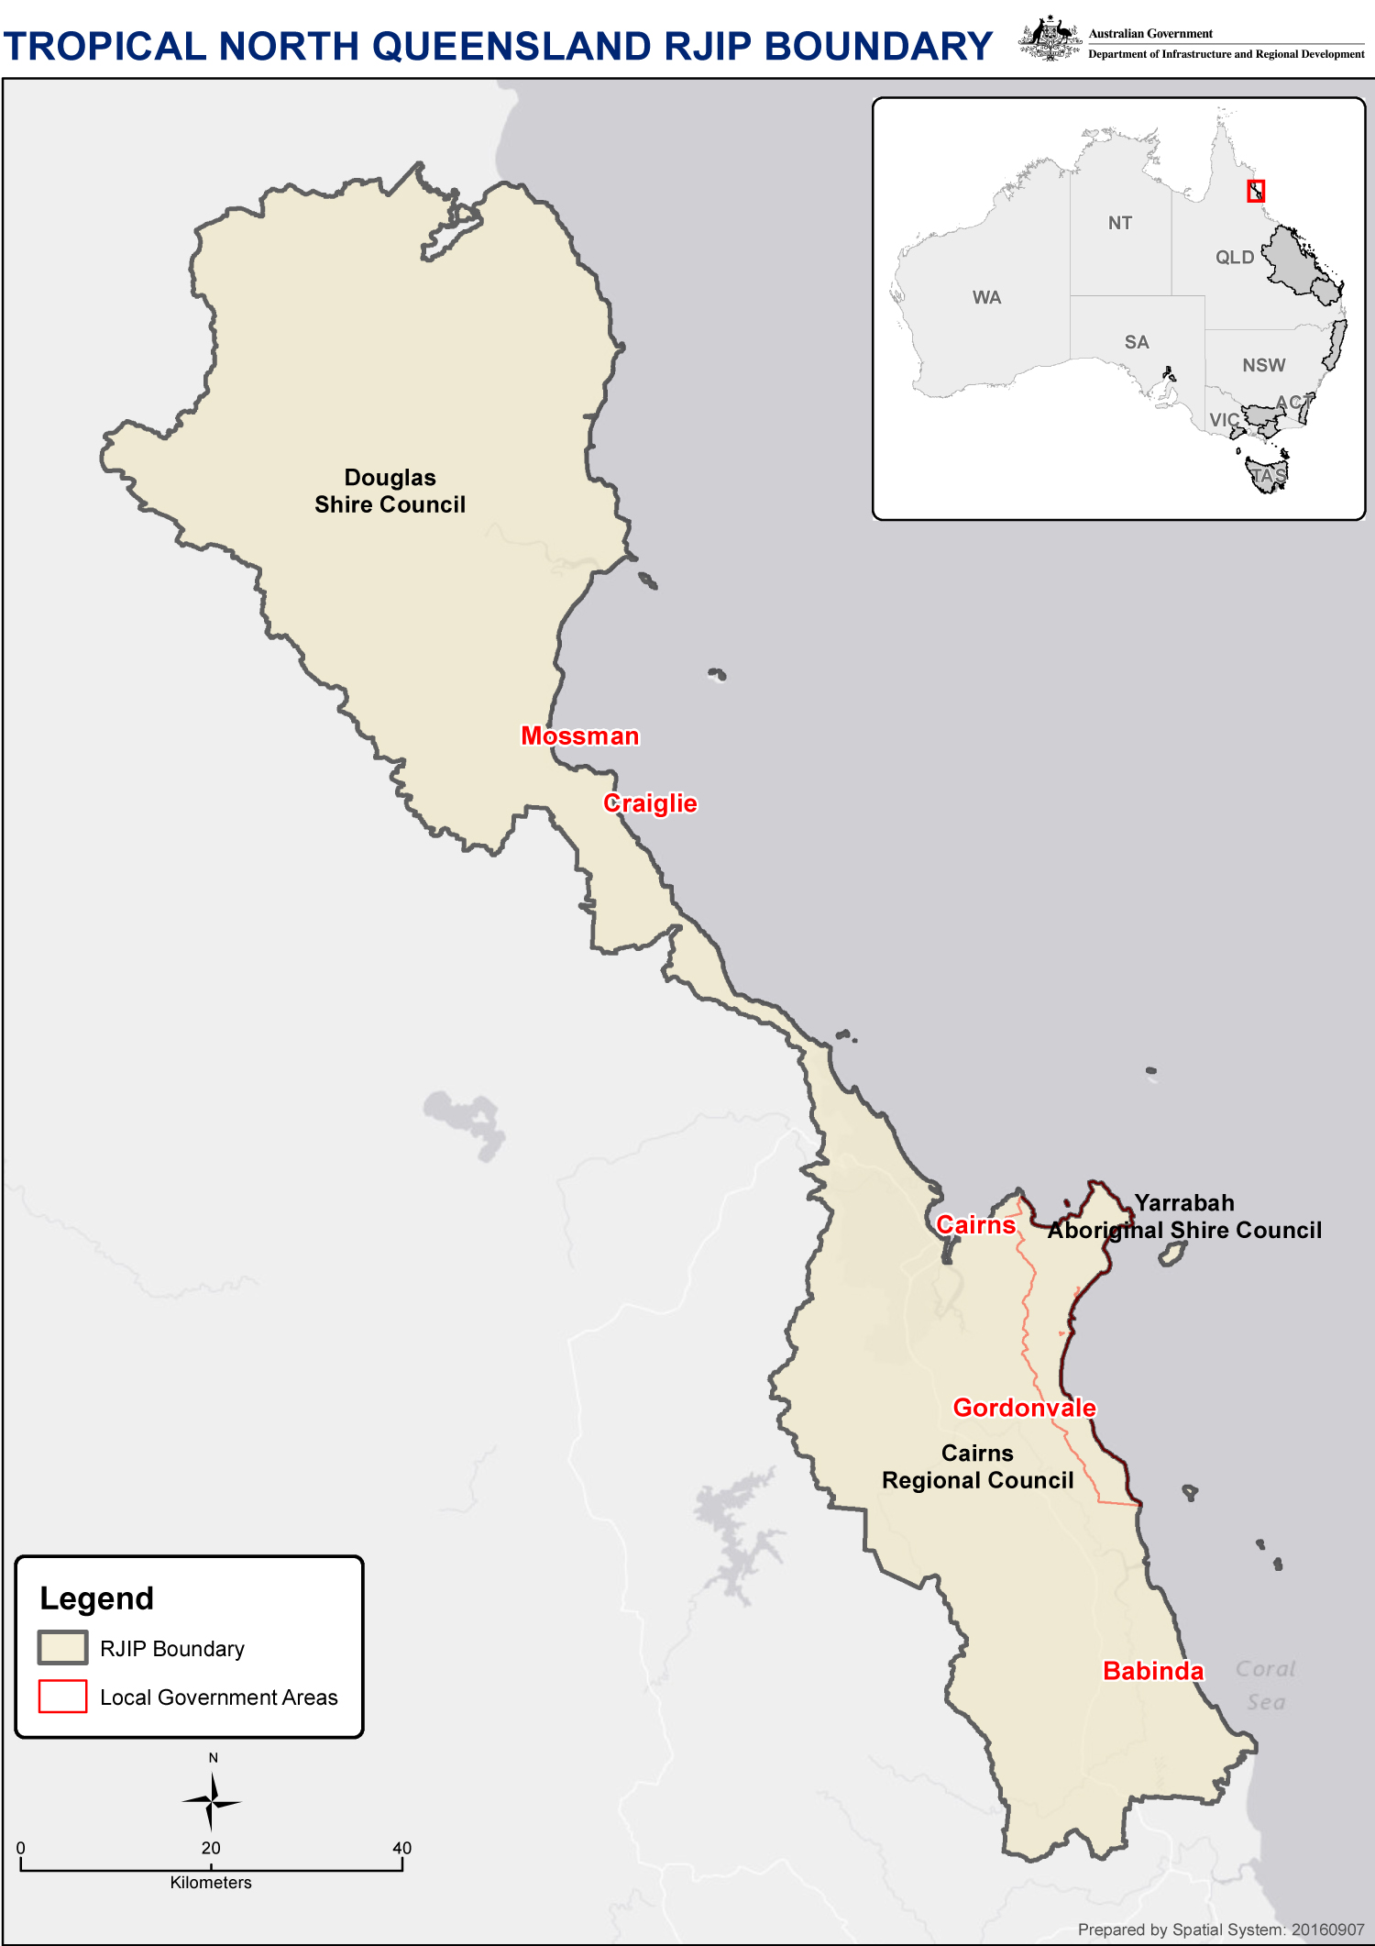

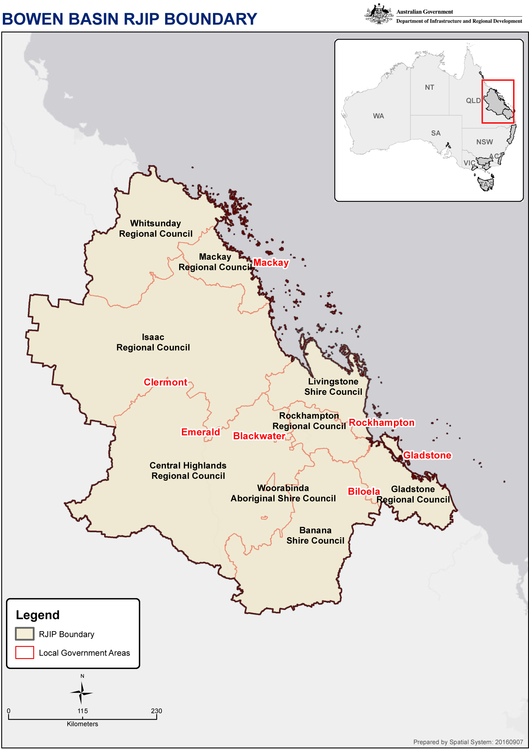

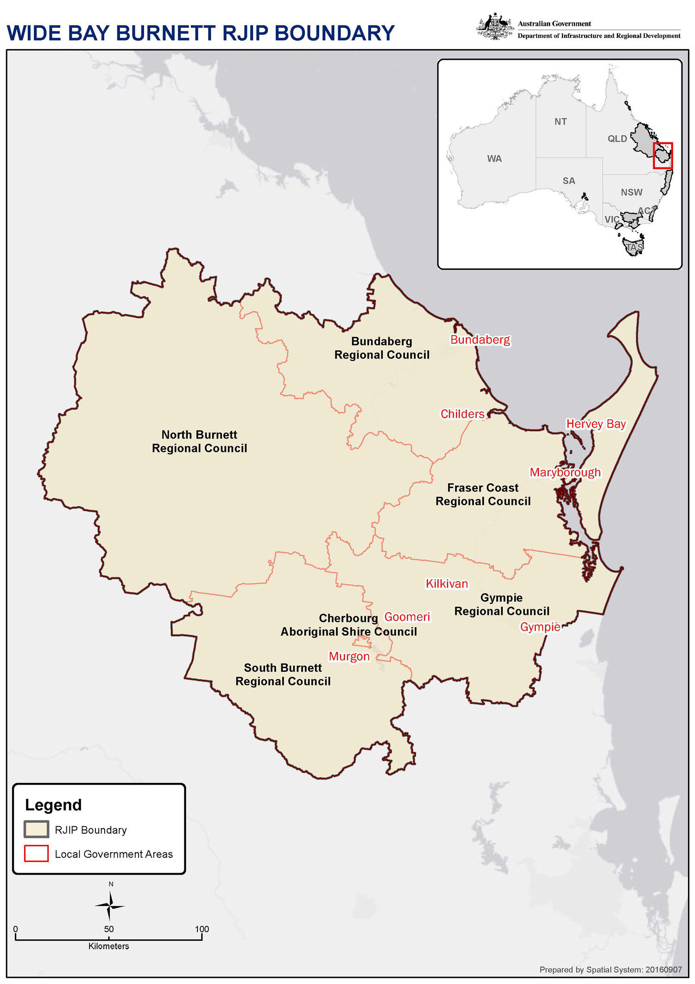

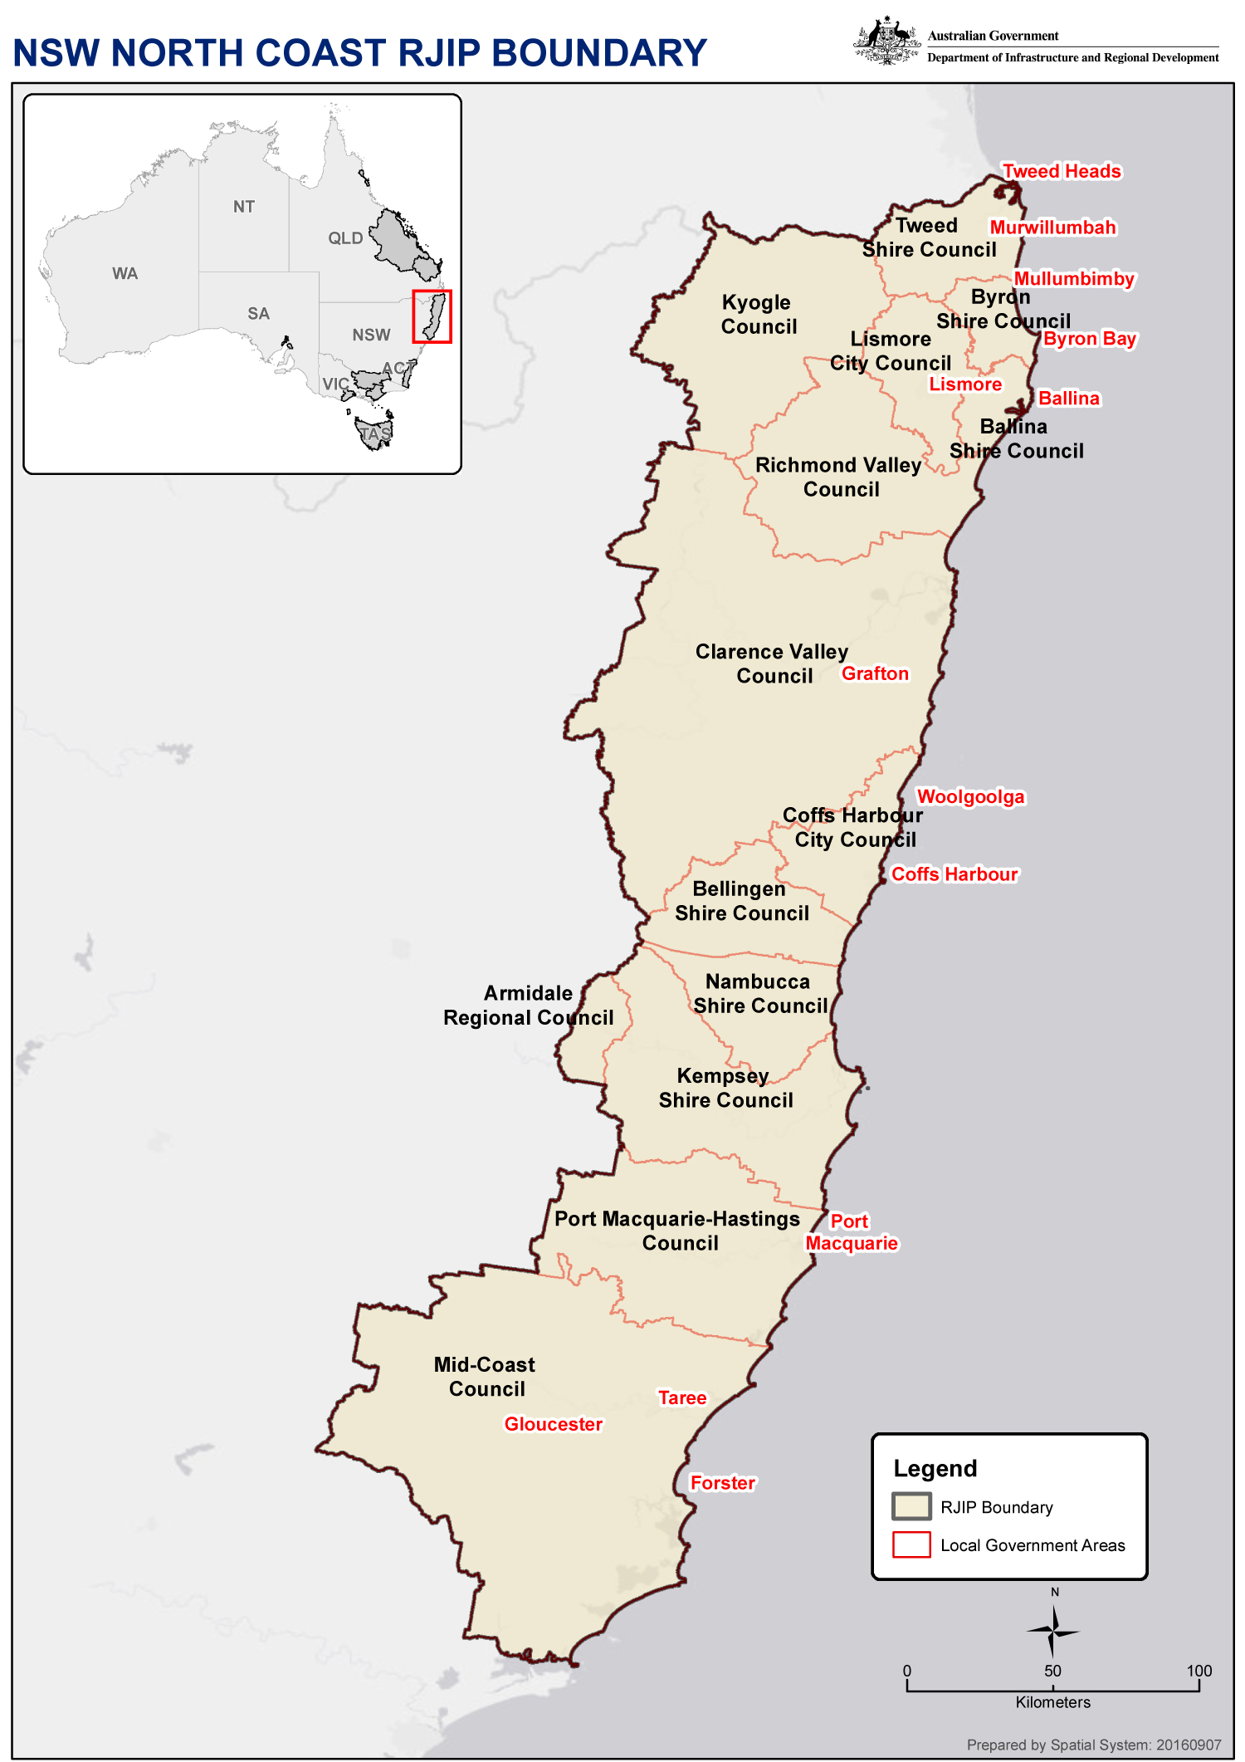

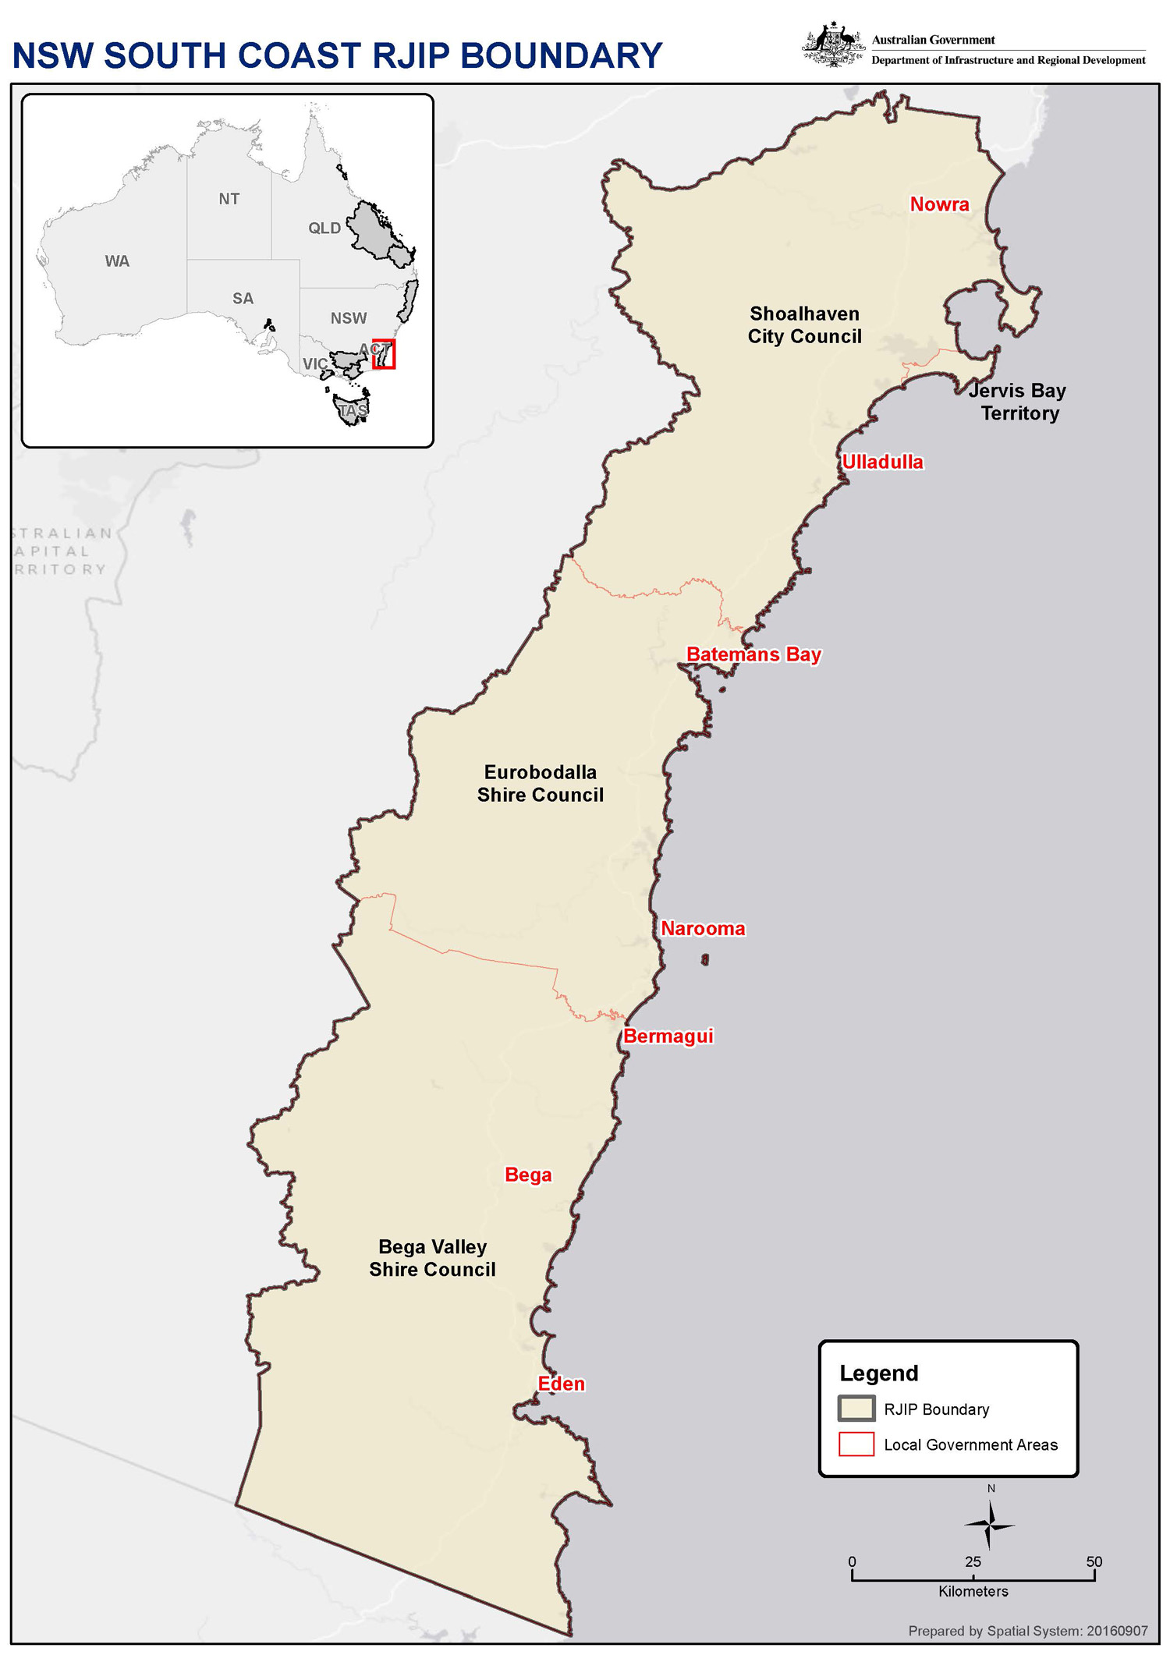

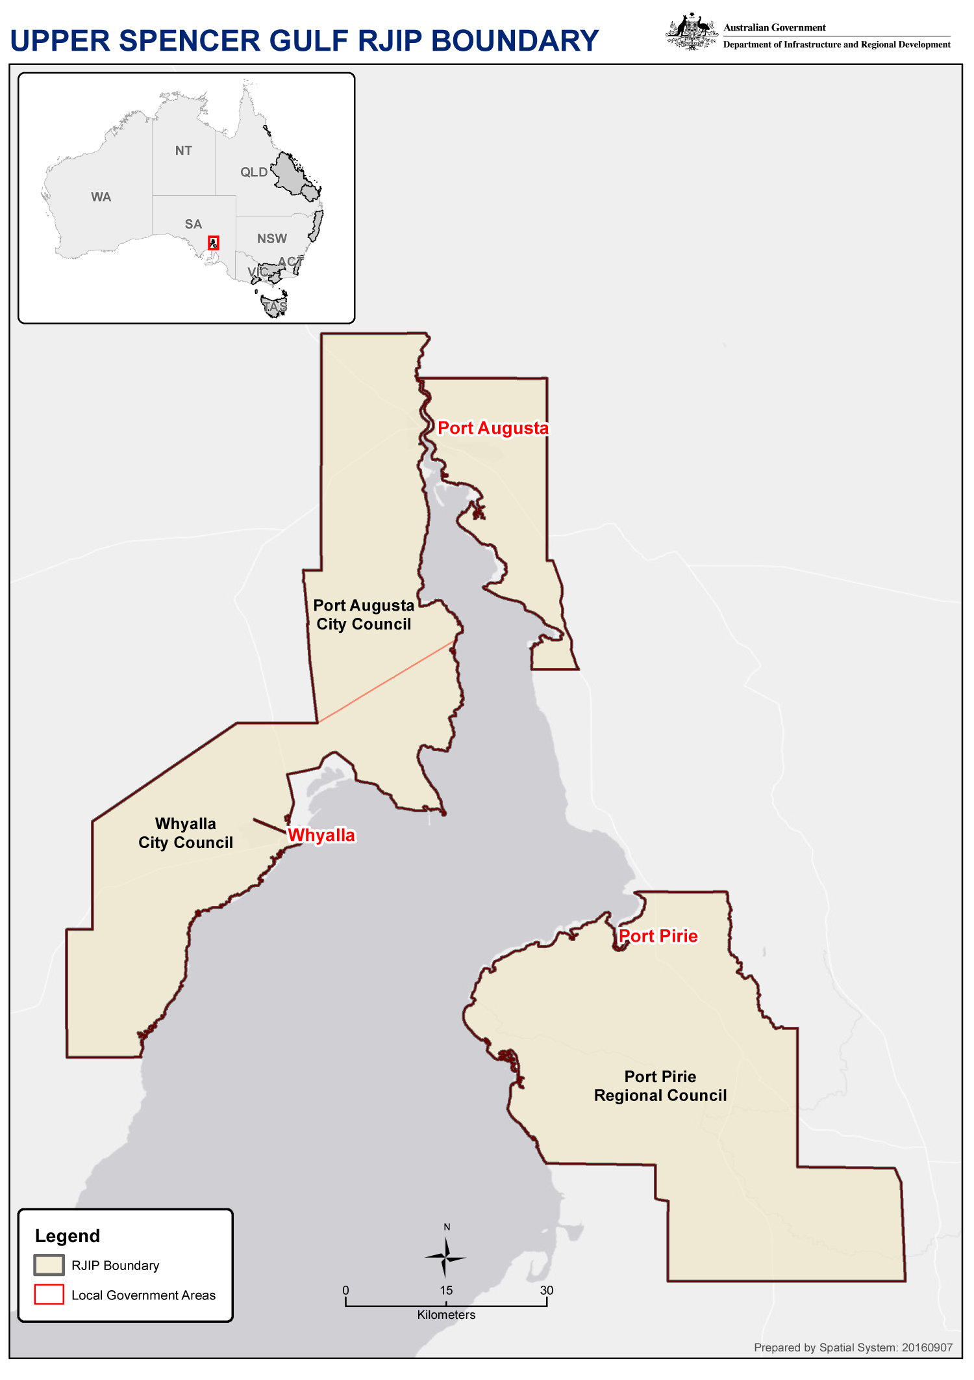
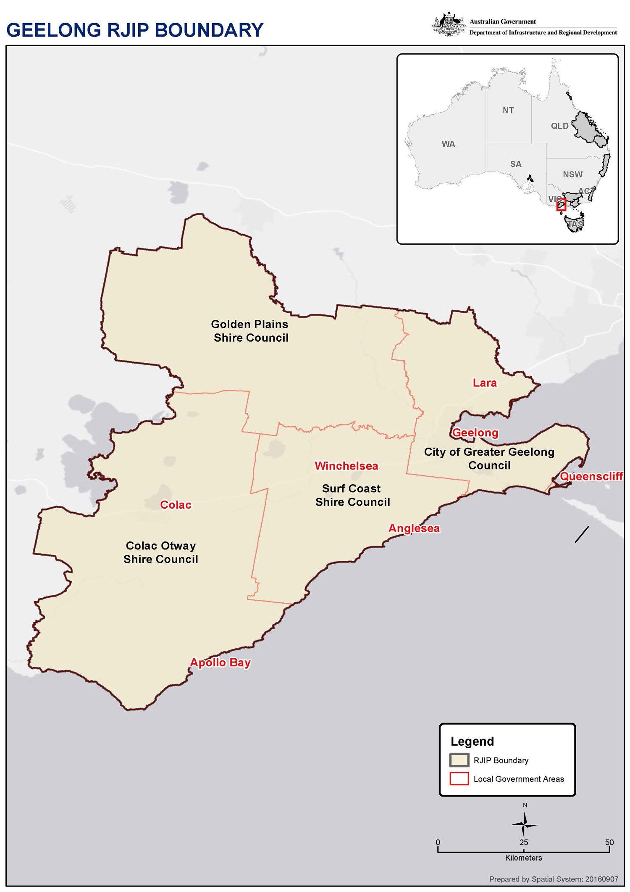

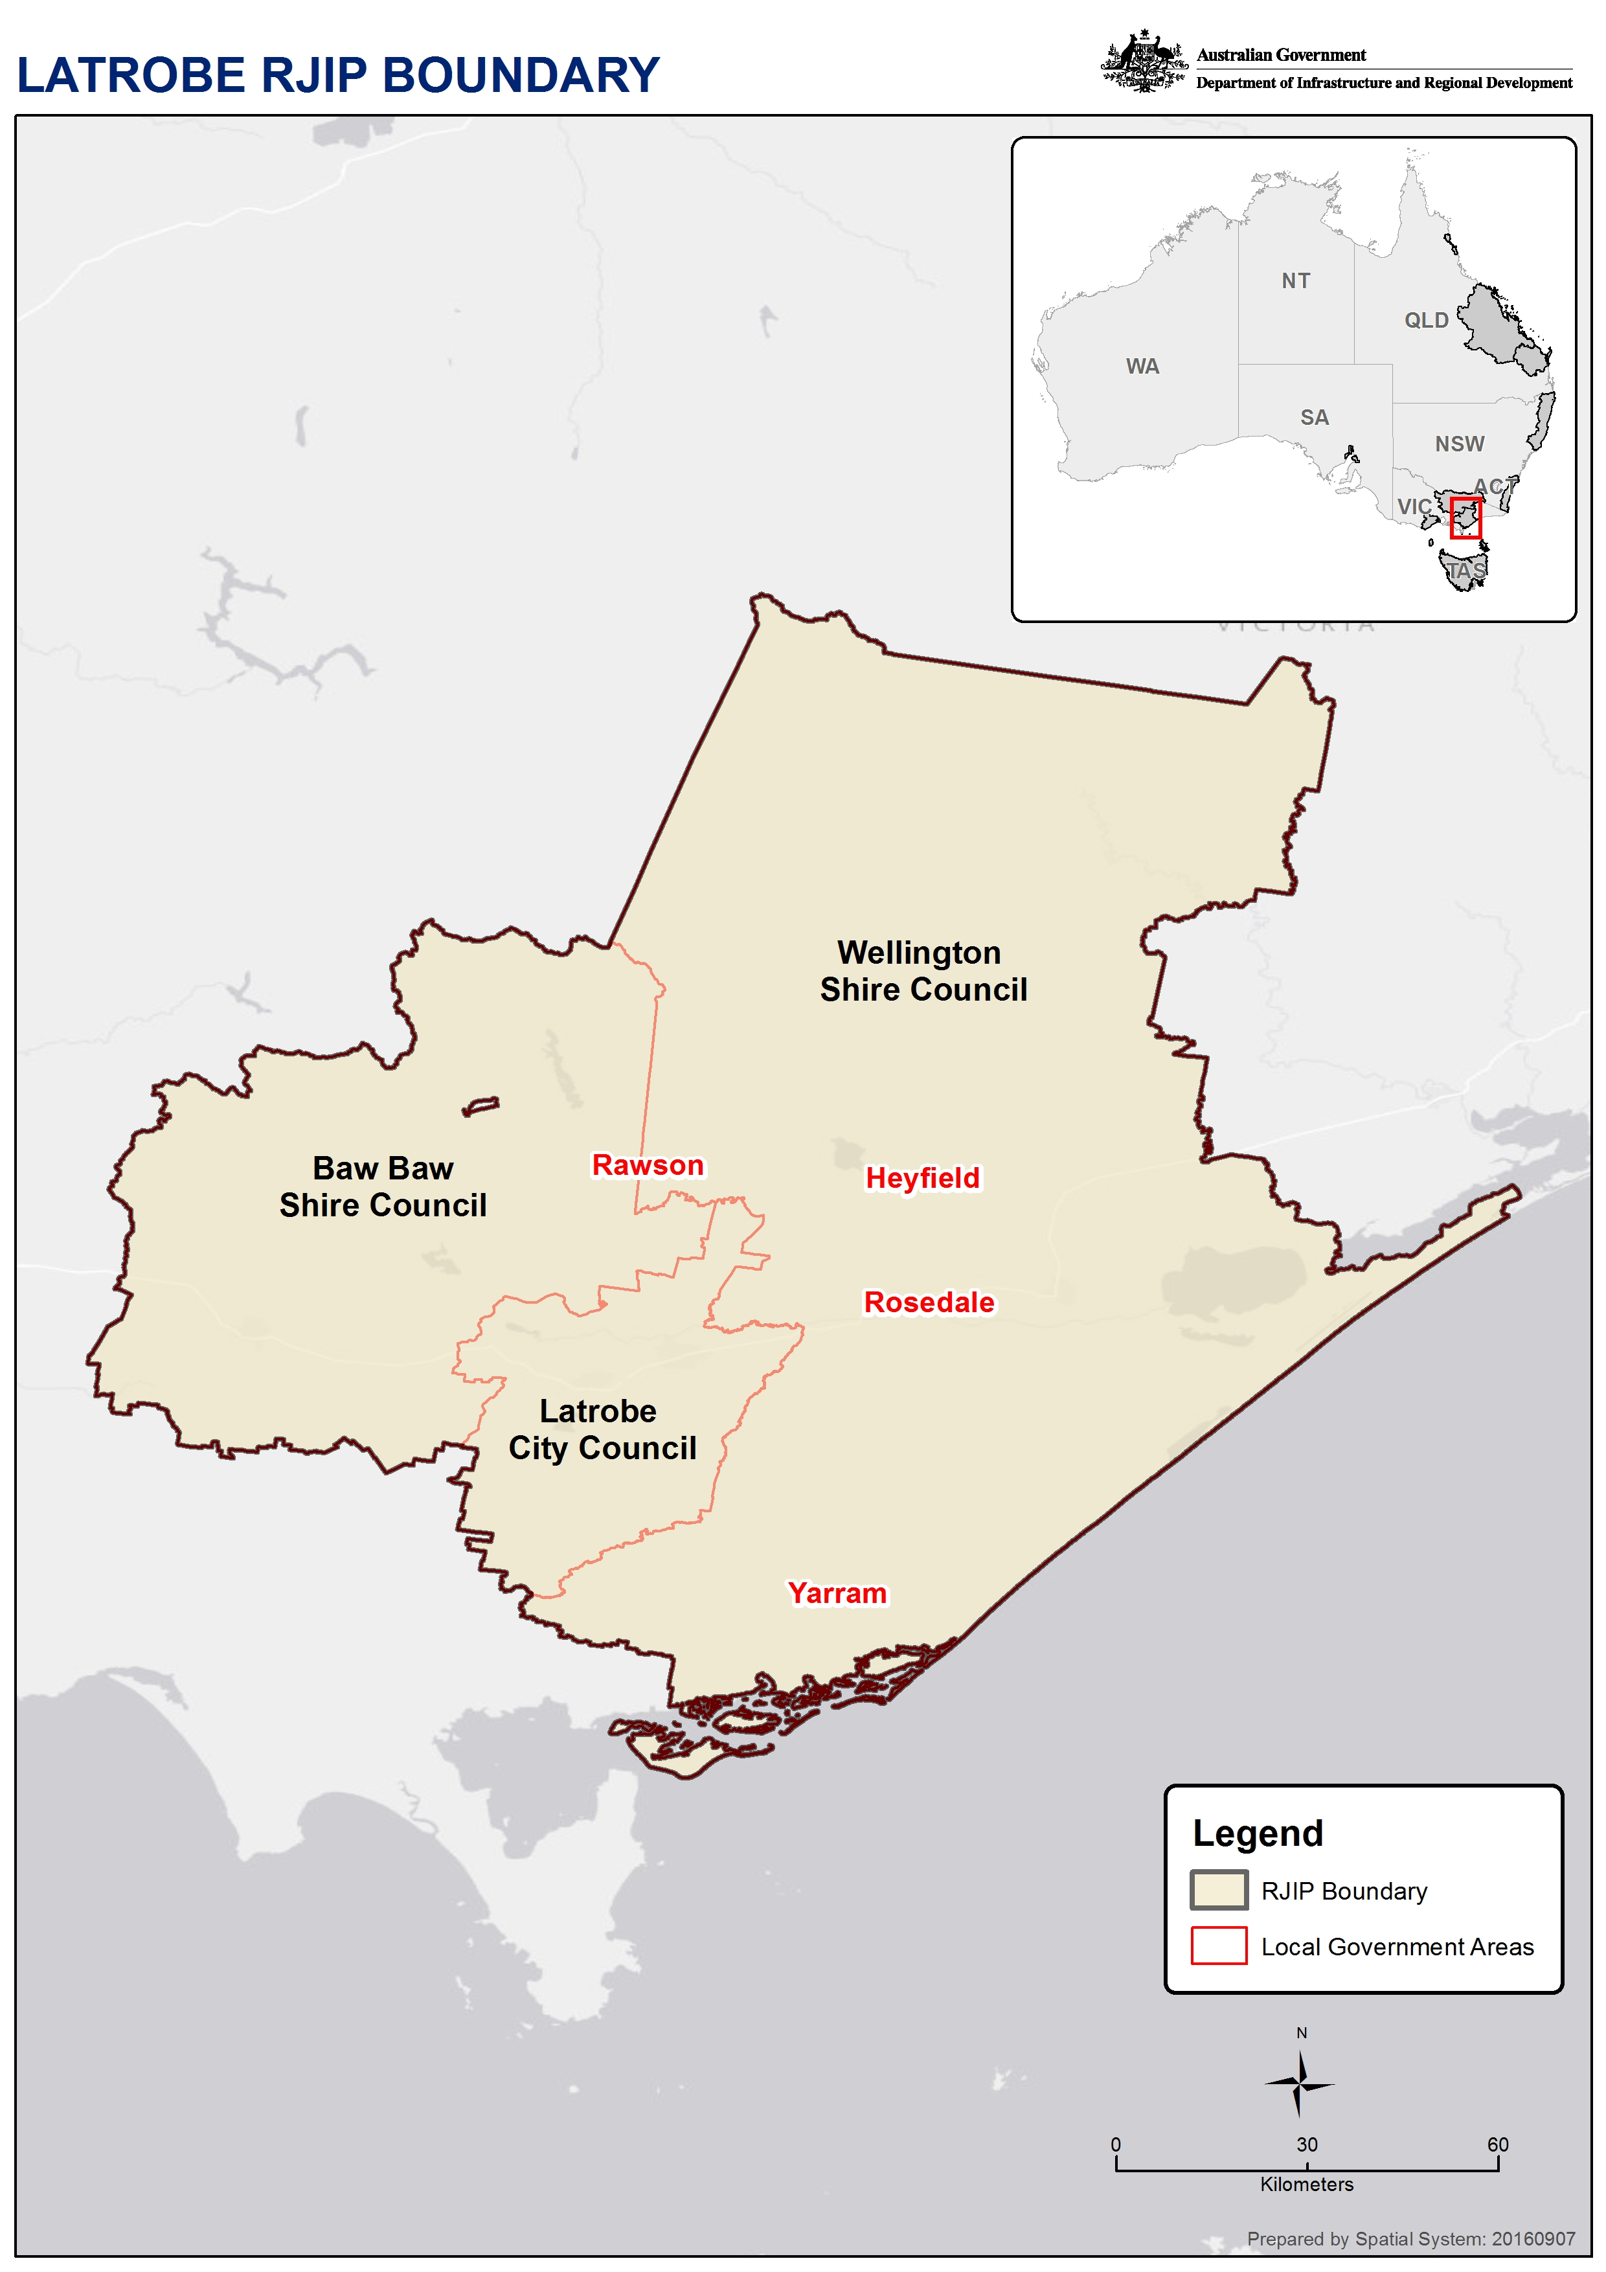

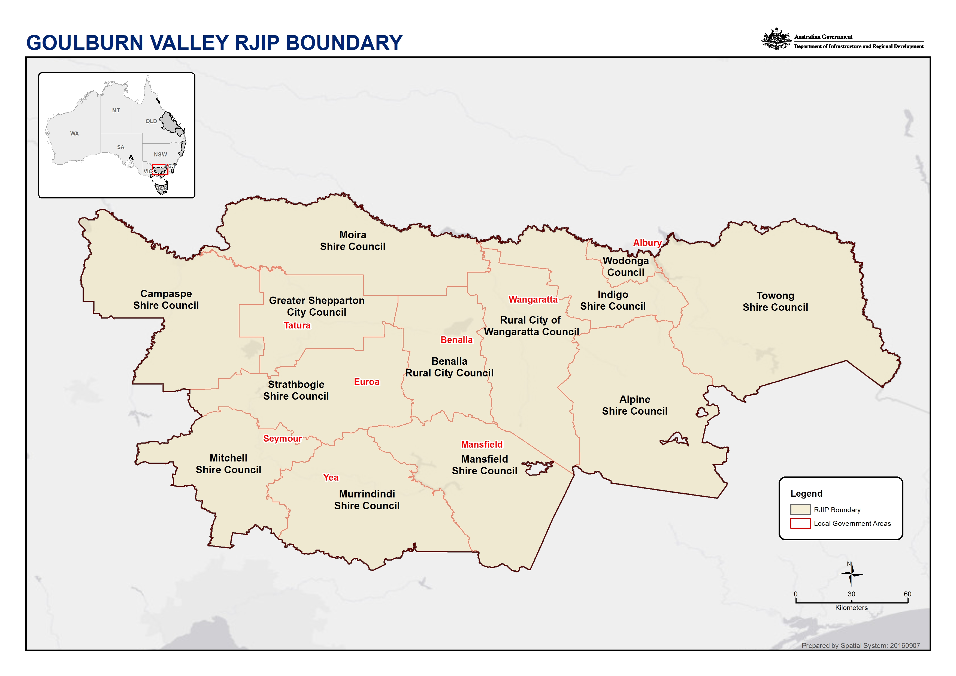
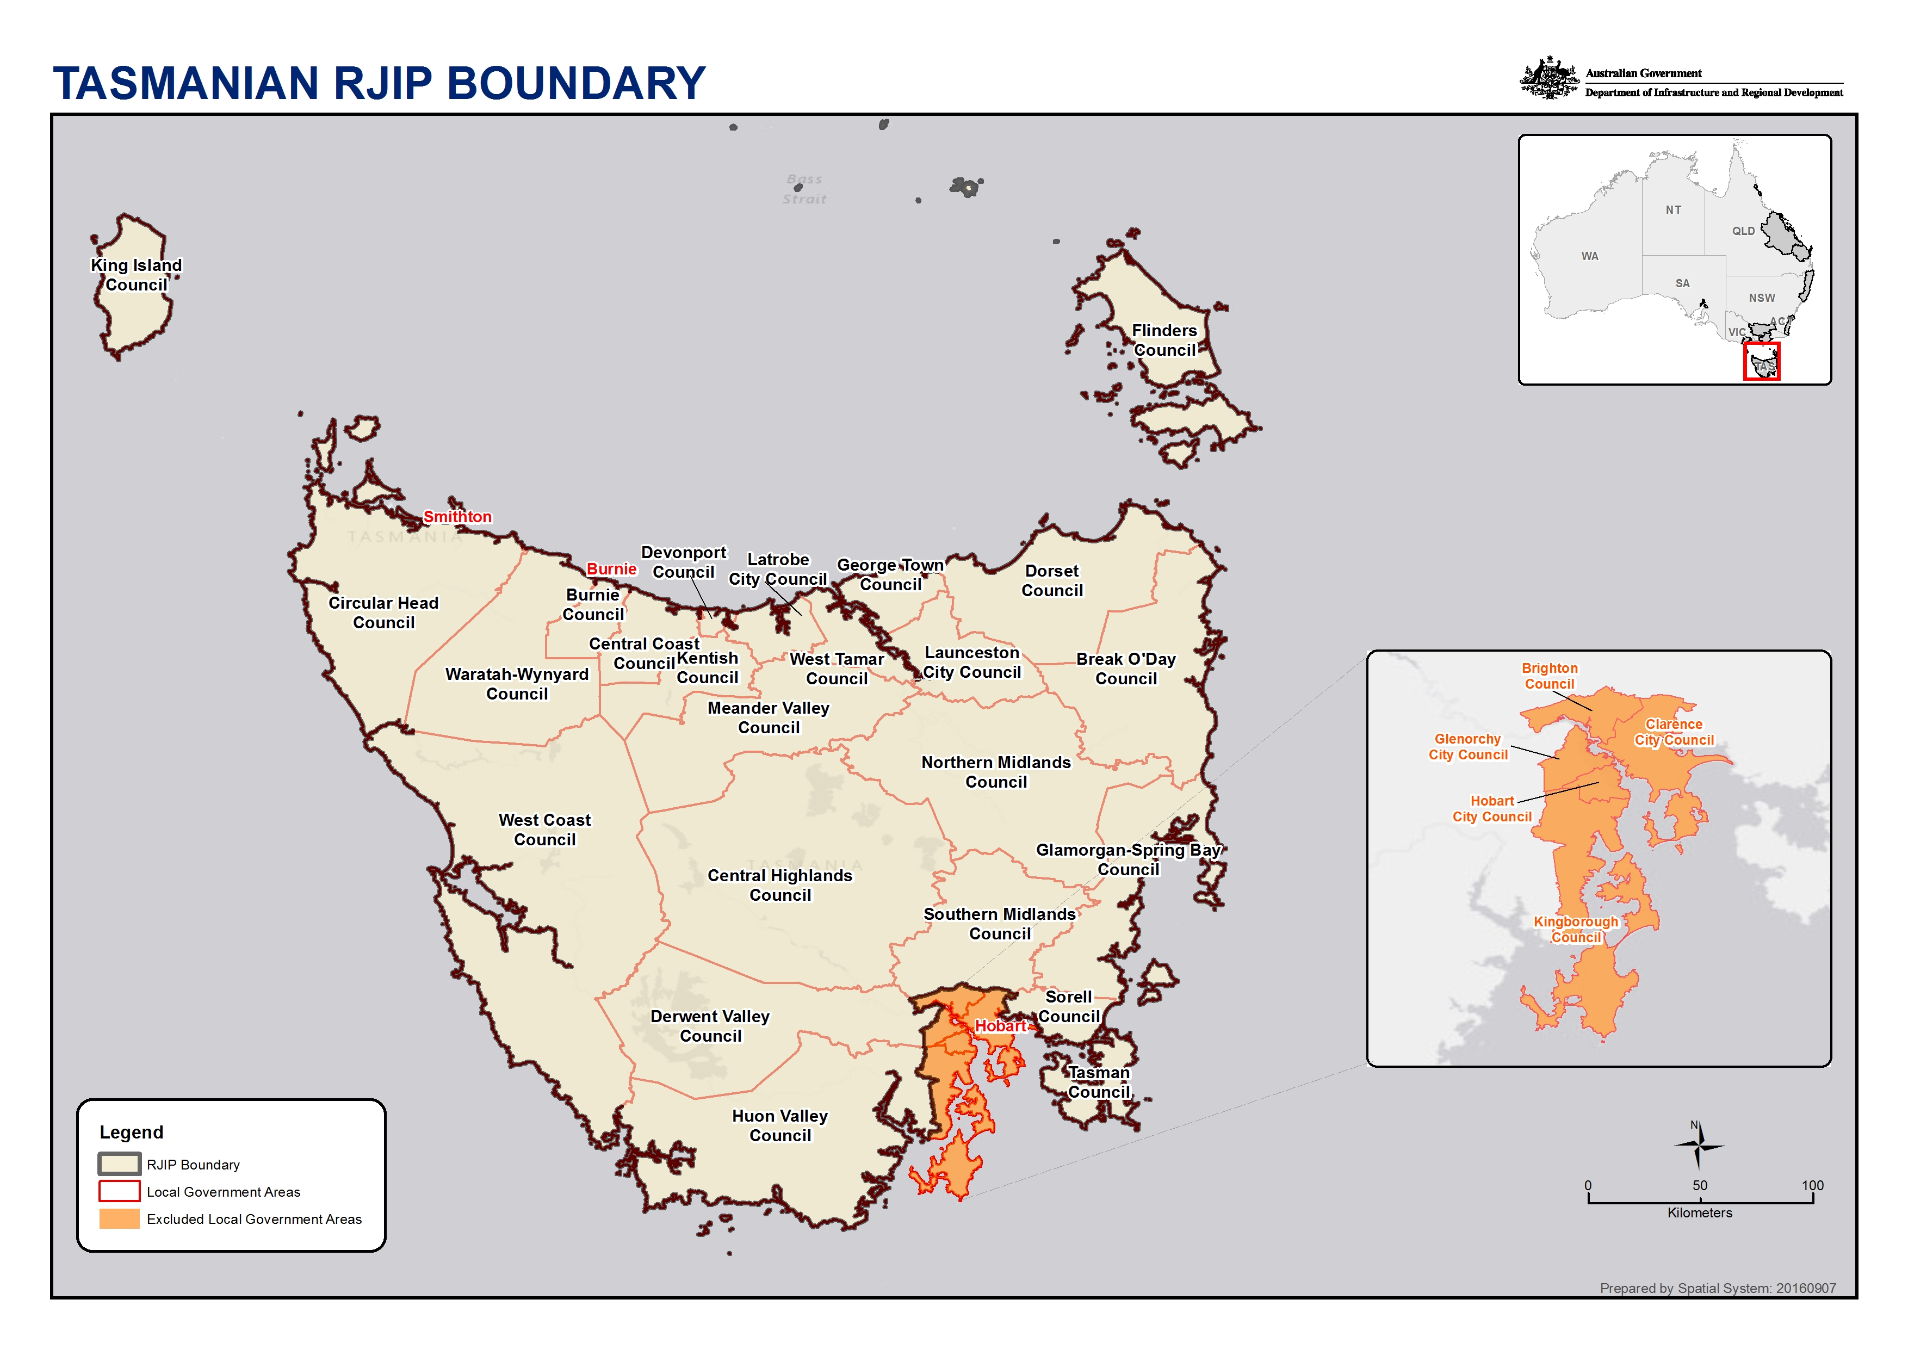
- Accountant declaration
Regional Jobs and Investment Packages
Accountant declaration
Role of person making declaration | Accountant or Chief Financial Officer (CFO)
Name
Contact details
Qualification | Chartered Accountant  Certified Practicing Accountant  CPA Australia  Chartered Accountants Australia and New Zealand  Institute of Public Accountants
Membership number
Applicant’s name
Applicant’s ABN
I declare that:
On the basis of the evidence [applicant name] has supplied to me, I consider that [applicant name] is able to fund its share of the total cost of the proposed project from the following source of funding - [insert source of funding].
This opinion is based on the applicants share being [insert amount] out of total project expenditure of [insert amount].
The applicant is part of a consolidated group for tax purposes. Yes No
Signature
Signed on this day of 20

http://www.finance.gov.au/resource-management/grants/
https://www.abcc.gov.au/building-code/building-code-2016
http://www.fsc.gov.au/sites/fsc/needaccredited/accreditationscheme/pages/theaccreditationscheme
https://www.abcc.gov.au/
http://www.fsc.gov.au/sites/FSC
http://www.industry.gov.au/AboutUs/InformationPublicationScheme/Ourpolicies/Pages/Library%20Card/ConflictofInterestandInsideTradeExpectationsofInnovationEmployees.aspx
http://www.industry.gov.au/Pages/PrivacyPolicy.aspx
https://infrastructure.gov.au/department/grants/index.aspx
http://www.dpmc.gov.au/resource-centre/data/australian-government-public-data-policy-statement
http://www.ombudsman.gov.au/

