Reducing Light Pollution in Coastal Communities

Opening date: | 9 February 2023
Closing date and time: | 5:00pm Australian Eastern Daylight Time on 9 March 2023  Please take account of time zone differences when submitting your application.
Commonwealth policy entity: | Department of Climate Change, Energy, the Environment and Water (DCCEEW)
Administering entity: | Department of Industry, Science and Resources (DISR)
Enquiries: | If you have any questions, contact us on 13 28 46.
Date guidelines released: | 9 February 2023
Type of grant opportunity: | Open competitive

Contents
1. Reducing Light Pollution in Coastal Communities processes 4
2. About the grant program 5
3. Grant amount and grant period 6
3.1. Grants available 6
3.2. Project period 6
4. Eligibility criteria 6
4.1. Who is eligible? 6
4.2. Additional eligibility requirements 6
4.3. Who is not eligible? 7
5. What the grant money can be used for 7
5.1. Eligible activities 7
5.2. Eligible locations 8
5.3. Ineligible activities 8
5.4. Eligible expenditure 8
5.5. What you cannot use the grant for 9
6. The assessment criteria 10
6.1. Assessment criterion 1 10
6.2. Assessment criterion 2 10
7. How to apply 11
7.1. Attachments to the application 11
7.2. Joint applications 12
7.3. Timing of grant opportunity 12
8. The grant selection process 12
8.1. Who will approve grants? 13
9. Notification of application outcomes 13
10. Successful grant applications 13
10.1. Grant agreement 13
10.2. Project/Activity specific legislation, policies and industry standards 14
10.3. How we pay the grant 14
10.4. Tax obligations 14
11. Announcement of grants 15
12. How we monitor your grant activity 15
12.1. Keeping us informed 15
12.2. Reporting 15
12.2.1. Progress reports 15
12.2.2. End of project report 16
12.2.3. Ad-hoc reports 16
12.3. Independent audits 16
12.4. Compliance visits 16
12.5. Grant agreement variations 16
12.6. Evaluation 17
12.7. Grant acknowledgement 17
13. Probity 17
13.1. Conflicts of interest 17
13.2. How we use your information 18
13.2.1. How we handle your confidential information 18
13.2.2. When we may disclose confidential information 18
13.2.3. How we use your personal information 19
13.2.4. Freedom of information 19
13.3. Enquiries and feedback 19
14. Glossary 21
Appendix A 23
Appendix B 24

Reducing Light Pollution in Coastal Communities processes
The Reducing Light Pollution in Coastal Communities Program is designed to achieve Australian Government objectives
This grant opportunity is part of the above grant program which contributes to the Department of Climate Change, Energy, the Environment and Water (DCCEEW)’s Outcome 2: Conserve, protect and sustainably manage Australia’s biodiversity, ecosystems, environment and heritage through research, information management, supporting natural resource management, establishing and managing Commonwealth protected areas, and reducing and regulating the use of pollutants and hazardous substances. The DCCEEW works with stakeholders to plan and design the grant program according to the Commonwealth Grants Rules and Guidelines.
⬇
The grant opportunity opens
We publish the grant guidelines on business.gov.au and GrantConnect.
⬇
You complete and submit a grant application
You complete the application form, addressing all the eligibility and assessment criteria in order for your application to be considered.
⬇
We assess all grant applications
We review the applications against eligibility criteria and notify you if you are not eligible.
We assess eligible applications against the assessment criteria including an overall consideration of value with relevant money and compare it to other eligible applications.
⬇
We make grant recommendations
We provide advice to the decision maker on the merits of each application.
⬇
Grant decisions are made
The decision maker decides which applications are successful.
⬇
We notify you of the outcome
We advise you of the outcome of your application. We may not notify unsuccessful applicants until grant agreements have been executed with successful applicants.
⬇
We enter into a grant agreement
We will enter into a grant agreement with successful applicants. The type of grant agreement is based on the nature of the grant and proportional to the risks involved.
⬇
Delivery of grant
You complete the grant activity as set out in your grant agreement. DISR manage the grant by working with you, monitoring your progress and making payments.
⬇
Evaluation of the Reducing Light Pollution in Coastal Communities
DCCEEW will evaluate the specific grant activity and the Reducing Light Pollution in Coastal Communities program as a whole. We base this on information you provide to us and that we collect from various sources.

About the grant program
The Reducing Light Pollution in Coastal Communities Grant Program (the program) will run over two years from 2022-23 to 2023-24. The program will provide funding to promote management of light pollution in priority coastal areas (Appendix A) for the benefit of Environment Protection and Biodiversity Act 1999 (EPBC Act) listed marine turtles, seabirds and migratory shorebirds.
In 2020, the Australian Government developed the National Light Pollution Guidelines for Wildlife to raise awareness of the impacts of light pollution on wildlife and provide guidance on managing light pollution for the benefit of wildlife including marine turtles, migratory shorebirds, and seabirds. The Recovery Plan for Marine Turtles in Australia 2017 identifies light pollution as a high-risk threat to marine turtles, as it can misorient and disorient hatchlings and prevent them from navigating to open ocean. Light pollution can also impact on seabirds by preventing fledglings from taking their first flight and can adversely affect migratory shorebirds at roosting sites.
The objectives of the program are to:
- raise community awareness of the potential impacts of light pollution on coastal and marine environments and the species that rely on them
- support the development and implementation of light management policies and practices at the local level for the benefit of EPBC Act listed marine turtles, seabirds and shorebirds
- facilitate retrofitting and/or installing best practice wildlife-sensitive lighting systems to reduce light pollution adjacent to marine turtle nesting beaches, seabird rockeries, or migratory shorebird roosting sites.
The intended outcomes of the program are:
- an increased recognition of the benefits of reducing light pollution
- the reduction of light pollution at ecologically sensitive sites to support conservation and recovery of EPBC listed marine turtles, seabirds and shorebirds
- the support of local communities to ensure best practise light management practices are established and progressed into the future.
We administer the program according to the Commonwealth Grants Rules and Guidelines (CGRGs).
This document sets out:
- the eligibility and assessment criteria
- how we consider and assess grant applications
- how we notify applicants and enter into grant agreements with grantees
- how we monitor and evaluate grantees’ performance
- responsibilities and expectations in relation to the opportunity.
The Department of Industry, Science and Resources (the department/DISR) is responsible for administering this grant opportunity on behalf of the Department of Climate Change, Energy, the Environment and Water (DCCEEW).
We have defined key terms used in these guidelines in the glossary at section 0.
You should read this document carefully before you fill out an application.

Grant amount and grant period
The Australian Government has announced a total of $500,000 for the program.

Grants available
The grant amount will be up to 100 percent of eligible project expenditure (grant percentage).
- The minimum grant amount is $15,000.
- The maximum grant amount is $50,000.
You are responsible for the remaining eligible and ineligible project costs.
Contributions to your project are encouraged and may be cash or in-kind contributions.
You can only submit one application per applicant per Local Government area for funding under this grant program.
Additional funding for the project can come from any source including Commonwealth, state, territory and local government grants. However, you cannot receive funding for the same activities under this grant opportunity.

Project period
You must complete your project by 31 March 2024.

Eligibility criteria
We cannot consider your application if you do not satisfy all eligibility criteria.

Who is eligible?
To be eligible you must:
- have an Australian Business Number (ABN)
and be one of the following entities:
- an Australian local government agency or body
- an entity incorporated in Australia (including Indigenous organisations registered with the Office of the Registrar of Indigenous Corporations and Aboriginal and Torres Strait Islander land councils)
- an Australian state/territory government agency or body
- publicly funded research organisation (PFRO) as defined in section 0.
Joint applications are acceptable, provided you have a lead organisation who is the main driver of the project and is eligible to apply. For further information on joint applications, refer to section 7.2.

Additional eligibility requirements
We can only accept applications where:
- you can declare that your project does not duplicate other government-funded management actions that are already underway in the project location
- you agree that you will deliver your project in accordance with relevant legislation, policies, management arrangements and industry standards
- you declare that any required approvals are in place or will be in place to allow completion of your project
- you provide all mandatory attachments as outlined in section 7.1
- the project is located in a priority location listed in Appendix A.
We cannot waive the eligibility criteria under any circumstances.

Who is not eligible?
You are not eligible to apply if you are:
- an organisation, or your project partner is an organisation, included on the National Redress Scheme’s website on the list of ‘Institutions that have not joined or signified their intent to join the Scheme’
- an employer of 100 or more employees that has not complied with the Workplace Gender Equality Act (2012).
- an individual
- a partnership
- an unincorporated association
- a cooperative
- any organisation not included in section 4.1
- a trust (however, an incorporated trustee may apply on behalf of a trust)
- a non-corporate Commonwealth entity.

What the grant money can be used for

Eligible activities
To be eligible your project must:
- be aimed at the program objectives and outcomes outlined at section 2
- be in one or more of the priority locations (see Appendix A)
- have at least $15,000 in eligible expenditure.
Eligible activities may include:
- developing or enhancing a light pollution management policy for EPBC listed marine turtles, seabirds and shorebirds (though other wildlife may be included as additional considerations) to be adopted by the relevant local government authority to reduce existing light pollution in a selected priority location/s (see Appendix A)
- developing a light pollution management plan to reduce existing light pollution impacts on EPBC Act listed marine turtles, seabirds and migratory shorebirds, which may include identifying:
  - the source(s) of the light pollution
  - the scale of problem(s) (i.e. landscape scale, local)
  - light owners and/managers and/or communities and land tenure (i.e. public or private entities) that would need to be engaged in light management to reduce light pollution across the region
  - potential and feasible solutions to manage light impacts that are not currently being undertaken (i.e. increase vegetation between light source and nesting beach or shield lighting or placing lighting on timers/dimmers)
  - current barriers to reducing light pollution (i.e. is light management plan/feasibility study or funds needed to implement specific mitigations).
- implementing an existing light pollution management plan that benefits EPBC Act listed marine turtles, seabirds or migratory shorebirds
- raising awareness of the impacts of light pollution on EPBC listed marine turtles, seabirds and shorebirds
- building community partnerships to tackle light pollution
- consulting a relevant lighting professional to determine activities or designs necessary to reduce light pollution
- retrofitting and/or installing light pollution management devices and/or infrastructure to reduce light pollution adjacent to seabird rockeries, marine turtle nesting beaches or migratory shorebird habitat
- reporting on project outcomes (including the identification of activities outside the scope of the grant that would be necessary to reduce light pollution within the grant recipient’s community).
- monitoring the efficacy of interventions addressing light pollution on marine turtles, seabirds and migratory shorebirds
- project management, coordination and reporting.
Note: projects with on ground activities to implement light management plans or retrofit existing lighting infrastructure to enhance environmental outcomes should include monitoring to test the efficacy of changes.
We may also approve other activities.

Eligible locations
Your project must be delivered in one or more of the priority locations for light pollution mitigation. Priority locations were determined through an independent assessment procured by DCCEEW that identified important marine turtle nesting areas, shorebird roosting sites and seabird breeding sites at high risk from the impacts of light pollution.
The list of the priority locations is at Appendix A.

Ineligible activities
Activities not supported by the program include:
- light management for wildlife that does not include management for marine turtles, migratory shorebirds or seabirds
- management of lighting that is not a problem for EPBC listed marine turtles, shorebirds and seabirds
- light management designed solely for the benefit of humans
- any activities occurring outside the duration of the project period
- development of a light management plan where environmental approval conditions require the development of a light management plan.

Eligible expenditure
You can only spend grant funds on eligible expenditure you have incurred on an agreed project as defined in your grant agreement.
Eligible expenditure items include the following items where directly related to the project:
- salaries and on-costs (maximum of 30 percent) for personnel directly employed in delivering the project activities (on a pro-rata basis relative to their time commitment)
- contractor costs or expert advice
- costs for communication and engagement activities, including promotional activities
- costs associated with managing collaborations and partnerships with Traditional Owners, ranger groups, industry and/or the local community
- costs associated to obtain planning, environmental or other regulatory approvals during the project period. However, associated fees paid to the Commonwealth, state, territory and local governments are not eligible
- purchase or hire of equipment, materials and supplies to support on ground activities (including technologies or devices, first aid and personal protective equipment required to deliver eligible project activities)
- venue/facility hire required to deliver eligible project activities
- domestic travel (eligible air transportation is limited to the economy class fare for each sector travelled; where non-economy class air transport is used only the equivalent of an economy fare for that sector is eligible expenditure. Where non-economy class air transport is used, the grantee will require evidence showing what an economy air fare cost at the time of travel)
- contingency costs of up to a maximum of 10 percent of the eligible project costs
- costs of project related administration, planning, consultation, coordination, monitoring and reporting installation of equipment and infrastructure as part of eligible project activities.
We may update the guidance on eligible and ineligible expenditure from time to time. If your application is successful, the version in place when you submitted your application applies to your project.
If your application is successful, we may ask you to verify project costs that you provided in your application. You may need to provide evidence such as quotes for major costs.
Not all expenditure on your project may be eligible for grant funding. The Program Delegate (who is senior responsible officer within the department with responsibility for administering the program) makes the final decision on what is eligible expenditure and may give additional guidance on eligible expenditure if required.
To be eligible, expenditure must:
- be a direct cost of the project
- be incurred by you for required project audit activities.
You must incur the project expenditure between the project start and end date for it to be eligible unless stated otherwise.
You may elect to commence your project from the date we notify you that your application is successful. We are not responsible for any expenditure you incur until a grant agreement is executed. The Commonwealth will not be liable, and should not be held out as being liable, for any activities undertaken before the grant agreement is executed.

What you cannot use the grant for
Expenditure items that are not eligible are:
- the provision of goods, services or support for activities that are not directly related to eligible grant activities
- routine operation, business as usual or running costs including accommodation, office facilities, printing and stationery, postage, legal and accounting fees and bank charges
- purchase of land or buildings
- retrospective funding or works underway
- financing costs, including interest
- activities likely to have a significant adverse impact on any matter of national environmental significance under the EPBC Act 1999
- activities likely to have a significant adverse impact on Indigenous cultural heritage
- costs incurred in the preparation of a grant application or related documentation
- fees paid to the Commonwealth, state, territory and local governments associated with obtaining environmental or other regulatory approvals
- overseas travel
- meals and alcohol
- lobbying activities and media campaigns that could be considered political in nature (whole or in part)
- activities for which other Commonwealth, state and territory government bodies have primary responsibility.

The assessment criteria
You must address all assessment criteria in your application. We will assess your application based on the weighting given to each criterion.
The application form asks questions that relate to the assessment criteria below. The amount of detail and supporting evidence you provide in your application should be relative to the project size, complexity and grant amount requested. You should provide evidence to support your answers. The application form displays character limits for each response.
We will only consider funding applications that score at least 50 percent against each assessment criterion, as these represent best value for money.

Assessment criterion 1
Alignment with the program objectives and outcomes (60 points).
You must describe the activity and provide information that demonstrates:
- how your project will raise awareness of the impacts of light pollution on marine and coastal species and build community support for addressing those impacts
- how your project will reduce light pollution and its impacts on seabird rockeries, marine turtle nesting beaches or migratory shorebird habitats identified in the priority locations in Appendix A
- how your project supports or contributes to the relevant policies, including, but not limited to, the National Light Pollution Guidelines for Wildlife and where relevant, the Threatened Species Strategy 2022-2032, and relevant Conservation Advices and Recovery Plans
- how your project involves local communities including Indigenous partnerships and Traditional Owner engagement
- how you will use your grant funding to leverage support and funding opportunities from other partners and community stakeholders.
In your letters of support from community stakeholders provide details of their contribution to the project.

Assessment criterion 2
Capacity, capability, and resources to deliver the project (40 points).
You must demonstrate this by describing:
- your track record of successfully managing similar projects
- your access to personnel with the right skills and experience in delivering your project activities
- how you will manage the project including obtaining approvals, methodology, budget, risk management and governance
- how you will monitor and measure the benefit of the project for EPBC listed marine turtles, shorebirds and seabirds.

How to apply
Before applying you should read and understand these guidelines, the sample application form and the sample grant agreement published on business.gov.au and GrantConnect. Applicants should read all eligibility and assessment criteria closely and attach detailed evidence that supports the assessment criteria.
You will need to set up an account to access our online portal.
To apply, you must:
- complete and submit your application through the online portal
- provide all the information requested
- address all eligibility and assessment criteria
- include all necessary attachments.
You can view and print a copy of your submitted application on the portal for your own records.
You are responsible for making sure your application is complete and accurate. Giving false or misleading information is a serious offence under the Criminal Code Act 1995 (Cth). If we consider that you have provided false or misleading information, we may not progress your application. If you find an error in your application after submitting it, you should call us immediately on 13 28 46.
After submitting your application, we can contact you for clarification if we find an error or any missing information, including evidence that supports your eligibility/merit. The acceptance of any additional information provided after the submission of your application is at the discretion of the Program Delegate. Additional information should not materially change your application at the time it was submitted and therefore may be refused if deemed to be purely supplementary.
If you need further guidance around the application process, or if you have any issues with the portal, contact us at business.gov.au or by calling 13 28 46.

Attachments to the application
You must provide the following documents with your application:
- for joint applications, a letter of support from each of the project partners (where applicable)
- if applying as an incorporated association or incorporated not for profit organisation and you do not have an active state or territory incorporated association registration or ACNC registration at the time of application, you must provide Constitutional documents and/or Articles of Association that demonstrate the character of the organisation (where applicable)
- trust deed (where applicable)
- letters of support from the community, such as regional stakeholder and Traditional owners and their contribution to the project (where applicable).
You must attach supporting documentation to the application form in line with the instructions provided within the form. You should only attach requested documents. The total of all attachments cannot exceed 20MB. We will not consider information in attachments that we do not request.

Joint applications
We recognise that some organisations may want to join together as a group to deliver a project. In these circumstances, you must appoint a lead organisation. Only the lead organisation can submit the application form and enter into the grant agreement with the Commonwealth. The application should identify all members of the proposed group and include a letter of support from each of the project partners. Each letter of support should include:
- details of the project partner
- an overview of how the project partner will work with the lead organisation and any other project partners in the group to successfully complete the project
- an outline of the relevant experience and/or expertise the project partner will bring to the group
- the roles/responsibilities the project partner will undertake, and the resources it will contribute (if any).
You must have a formal arrangement in place with all parties prior to execution of the grant agreement.

Timing of grant opportunity
You can only submit an application between the published opening and closing dates. We cannot accept late applications.
If you are successful, we expect you will be able to commence your project around May 2023.
Table 1: Expected timing for this grant opportunity
Activity | Timeframe
Assessment of applications | 4 weeks
Approval and announcement of successful applicants | 4 weeks
Negotiations of grant agreements | 3 weeks
Notification to unsuccessful applicants | 2 weeks
Earliest start date of project | The date you are notified your application has been successful
Project completion date | 31 March 2024

The grant selection process
We first review your application against the eligibility criteria. If eligible, we will then assess it against the assessment criteria. Only eligible applications will proceed to the assessment stage.
We consider your application on its merits, based on:
- how well it meets the criteria
- how it compares to other applications
- whether it provides value with relevant money
- consideration of geographical spread across priority areas.
When assessing whether the application represents value with relevant money, we will have regard to:
- the overall objectives of the grant opportunity
- the evidence provided to demonstrate how your project contributes to meeting those objectives
- the relative value of the grant sought
- the project risks.
We will establish a committee comprised of officers from DCCEEW to assess applications. The committee may also seek additional advice from independent technical experts.
If applications are scored the same, the committee will consider value for money and alignment to the program objectives, spread across priority areas and geographical spread to recommend applications for funding.
The committee will assess your application against the assessment criteria, geographic distribution, alignment to published Conservation Advices and Recovery Plans (where relevant for Light Pollution mitigation), the feasibility of the project and compare it to other eligible applications before recommending which projects to fund. The assessment panel will be required to perform their duties in accordance with the CGRGs.
If applications score the same, the committee will consider value for money, alignment to the program objectives and geographic distribution, to recommend applications for funding.

Who will approve grants?
A general manager in DCCEEW decides which grants to approve taking into account the application assessment and the availability of grant funds.
The decision maker’s decision is final in all matters, including:
- the grant approval
- the grant funding to be awarded
- any conditions attached to the offer of grant funding.
We cannot review decisions about the merits of your application.
The decision maker will not approve funding if there is insufficient program funds available across relevant financial years for the program.

Notification of application outcomes
We will advise you of the outcome of your application in writing. If you are successful, we advise you of any specific conditions attached to the grant.
If you are unsuccessful, we will give you an opportunity to discuss the outcome with us.

Successful grant applications

Grant agreement
You must enter into a legally binding grant agreement with the Commonwealth. The grant agreement has general terms and conditions that cannot be changed. Sample grant agreements are available on business.gov.au and GrantConnect. The grant agreement has general terms and conditions that cannot be changed. A sample grant agreement is available on business.gov.au and GrantConnect.
We will manage the grant agreement through the online portal. This includes issuing and executing the grant agreement.
Execute means both you and the Commonwealth have accepted the agreement. You must not start any program activities until a grant agreement is executed. We are not responsible for any expenditure you incur and cannot make any payments until a grant agreement is executed.
The approval of your grant may have specific conditions determined by the assessment process or other considerations made by the Program Delegate. We will identify these in the offer of grant funding.
If you enter an agreement under the Reducing Light Pollution in Coastal Communities Grant, you cannot receive other grants for the same activities from other Commonwealth, state or territory granting programs.
The Commonwealth may recover grant funds if there is a breach of the grant agreement.
We will use an exchange of letters grant agreement for smaller projects where we consider your project to be relatively straightforward. We will send you a letter of offer advising that your application has been successful. You accept the offer by signing and returning to us. We consider the agreement to be executed from the date we receive your signed document. You will have 30 days from the date of our letter to sign and return to us otherwise the offer may lapse.

Project/Activity specific legislation, policies and industry standards
You must comply with all relevant laws, regulations and Australian Government sanctions in undertaking your project. You must also comply with the specific legislation/policies/industry standards that follow. It is a condition of the grant funding that you meet these requirements. We will include these requirements in your grant agreement.
In particular, you will be required to comply with:
- State/territory legislation in relation to working with children
- State/Territory legislation in relation to protected species and places
- State/Territory legislation in relation to activities around waterways
- State/Territory legislation in relation to animal welfare and ethics
- State/Territory legislation in relation to biosecurity.

How we pay the grant
The grant agreement will state the:
- maximum grant amount we will pay
- proportion of eligible expenditure covered by the grant (grant percentage)
- any in-kind contributions you will make
- any financial contribution provided by you or a third party.
We will pay 100 per cent of the grant on execution of the grant agreement. You will be required to report how you spent the grant funds at the completion of the project.

Tax obligations
If you are registered for the Goods and Services Tax (GST), where applicable we will add GST to your grant payment and provide you with a recipient created tax invoice. You are required to notify us if your GST registration status changes during the project period. GST does not apply to grant payments to government related entities.
Grants are assessable income for taxation purposes, unless exempted by a taxation law. We recommend you seek independent professional advice on your taxation obligations or seek assistance from the Australian Taxation Office. We do not provide advice on tax.

Announcement of grants
We will publish non-sensitive details of successful projects on GrantConnect. We are required to do this by the Commonwealth Grants Rules and Guidelines unless otherwise prohibited by law. We may also publish this information on business.gov.au. This information may include:
- name of your organisation
- title of the project
- description of the project and its aims
- amount of grant funding awarded
- Australian Business Number
- business location
- your organisation’s industry sector.

How we monitor your grant activity

Keeping us informed
You should let us know if anything is likely to affect your project or organisation.
We need to know of any key changes to your organisation or its business activities, particularly if they affect your ability to complete your project, carry on business and pay debts due.
You must also inform us of any changes to your:
- name
- addresses
- nominated contact details
- bank account details.
If you become aware of a breach of terms and conditions under the grant agreement, you must contact us immediately.
You must notify us of events relating to your project and provide an opportunity for the Minister or their representative to attend.

Reporting
You must submit reports in line with the grant agreement. We will provide the requirements for these reports as appendices in the grant agreement. We will remind you of your reporting obligations before a report is due. We will expect you to report on:
- progress against agreed project milestones
- project expenditure, including expenditure of grant funds
- contributions of participants directly related to the project.
The amount of detail you provide in your reports should be relative to the project size, complexity and grant amount.
We will monitor the progress of your project by assessing reports you submit and may conduct site visits to confirm details of your reports if necessary. Occasionally we may need to re-examine claims, seek further information or request an independent audit of claims and payments.

Progress reports
Progress reports must:
- include details of your progress towards completion of agreed project activities
- show the total eligible expenditure incurred to date
- be submitted by the report due date (you can submit reports ahead of time if you have completed relevant project activities).
We will only make grant payments when we receive satisfactory progress reports.
You must discuss any project or milestone reporting delays with us as soon as you become aware of them.

End of project report
When you complete the project, you must submit an end of project report.
End of project reports must:
- include the agreed evidence as specified in the grant agreement
- identify the total eligible expenditure incurred for the project
- include a declaration that the grant money was spent in accordance with the grant agreement and to report on any underspends of the grant money
- be submitted by the report due date.

Ad-hoc reports
We may ask you for ad-hoc reports on your project. This may be to provide an update on progress, or any significant delays or difficulties in completing the project.

Independent audits
We may ask you to provide an independent audit report. An audit report will verify that you spent the grant in accordance with the grant agreement. The audit report requires you to prepare a statement of grant income and expenditure. The report template is available on business.gov.au and GrantConnect.

Compliance visits
We may visit you during the project period to review your compliance with the grant agreement. We may also inspect the records you are required to keep under the grant agreement. We will provide you with reasonable notice of any compliance visit.

Grant agreement variations
We recognise that unexpected events may affect project progress. In these circumstances, you can request a variation to your grant agreement, including:
- changing project milestones
- extending the timeframe for completing the project
- changing project activities.
The program does not allow for an increase of grant funds.
If you want to propose changes to the grant agreement, you must put them in writing before the project end date. You can submit a variation request via our online portal.
If a delay in the project causes milestone achievement and payment dates to move to a different financial year, you will need a variation to the grant agreement. We can only move funds between financial years if there is enough program funding in the relevant year to allow for the revised payment schedule. If we cannot move the funds, you may lose some grant funding.
You should not assume that a variation request will be successful. We will consider your request based on factors such as:
- how it affects the project outcome
- consistency with the program policy objective, grant opportunity guidelines and any relevant policies of the department
- changes to the timing of grant payments
- availability of program funds.

Evaluation
DCCEEW will evaluate the grant program to measure how well the outcomes and objectives have been achieved. We may use information from your application and project reports for this purpose. We may also interview you or ask you for more information to help us understand how the grant impacted you and to evaluate how effective the program was in achieving its outcomes.
We may contact you up to two years after you finish your project for more information to assist with this evaluation.

Grant acknowledgement
If you make a public statement about a project funded under the program, including in a brochure or publication, you must acknowledge the grant by using the following:
‘This project received grant funding from the Australian Government.’
If you erect signage in relation to the project, the signage must contain an acknowledgement of the grant.
If you promote your project on social media, where character limits allow, use the following handles and hashtags:
Twitter – @DCCEEW
Facebook and Instagram – @DCCEEW

Probity
We will make sure that the grant opportunity process is fair, according to the published guidelines, incorporates appropriate safeguards against fraud, unlawful activities and other inappropriate conduct and is consistent with the CGRGs.

Conflicts of interest
Any conflicts of interest could affect the performance of the grant opportunity or program. There may be a conflict of interest, or perceived conflict of interest, if our staff, any member of a committee or advisor and/or you or any of your personnel:
- has a professional, commercial or personal relationship with a party who is able to influence the application selection process, such as an Australian Government officer
- has a relationship with or interest in, an organisation, which is likely to interfere with or restrict the applicants from carrying out the proposed activities fairly and independently or
- has a relationship with, or interest in, an organisation from which they will receive personal gain because the organisation receives a grant under the grant program/grant opportunity.
As part of your application, we will ask you to declare any perceived or existing conflicts of interests or confirm that, to the best of your knowledge, there is no conflict of interest.
If you later identify an actual, apparent, or perceived conflict of interest, you must inform us in writing immediately.
Conflicts of interest for Australian Government staff are handled as set out in the Australian Public Service Code of Conduct (Section 13(7)) of the Public Service Act 1999 (Cth). Committee members and other officials including the decision maker must also declare any conflicts of interest.
We publish our conflict of interest policy on the department’s website. The Commonwealth policy entity also publishes a conflict of interest policy on its website.

How we use your information
Unless the information you provide to us is:
- confidential information as per 13.2.1, or
- personal information as per 13.2.3,
we may share the information with other government agencies for a relevant Commonwealth purpose such as:
- to improve the effective administration, monitoring and evaluation of Australian Government programs
- for research
- to announce the awarding of grants.

How we handle your confidential information
We will treat the information you give us as sensitive and therefore confidential if it meets all of the following conditions:
- you clearly identify the information as confidential and explain why we should treat it as confidential
- the information is commercially sensitive
- disclosing the information would cause unreasonable harm to you or someone else
- you provide the information with an understanding that it will stay confidential.

When we may disclose confidential information
We may disclose confidential information:
- to the committee and our Commonwealth employees and contractors, to help us manage the program effectively
- to the Auditor-General, Ombudsman or Privacy Commissioner
- to the responsible Minister or Assistant Minister
- to a House or a Committee of the Australian Parliament.
We may also disclose confidential information if
- we are required or authorised by law to disclose it
- you agree to the information being disclosed, or
- someone other than us has made the confidential information public.

How we use your personal information
We must treat your personal information according to the Australian Privacy Principles (APPs) and the Privacy Act 1988 (Cth). This includes letting you know:
- what personal information we collect
- why we collect your personal information
- to whom we give your personal information.
We may give the personal information we collect from you to our employees and contractors, the committee, and other Commonwealth employees and contractors, so we can:
- manage the program
- research, assess, monitor and analyse our programs and activities.
We, or the Minister, may:
- announce the names of successful applicants to the public
- publish personal information on the department’s websites.
You may read our Privacy Policy on the department’s website for more information on:
- what is personal information
- how we collect, use, disclose and store your personal information
- how you can access and correct your personal information.

Freedom of information
All documents in the possession of the Australian Government, including those about the program, are subject to the Freedom of Information Act 1982 (Cth) (FOI Act).
The purpose of the FOI Act is to give members of the public rights of access to information held by the Australian Government and its entities. Under the FOI Act, members of the public can seek access to documents held by the Australian Government. This right of access is limited only by the exceptions and exemptions necessary to protect essential public interests and private and business affairs of persons in respect of whom the information relates.
If someone requests a document under the FOI Act, we will release it (though we may need to consult with you and/or other parties first) unless it meets one of the exemptions set out in the FOI Act.

Enquiries and feedback
For further information or clarification, you can contact us on 13 28 46 or by web chat or through our online enquiry form on business.gov.au.
We may publish answers to your questions on our website as Frequently Asked Questions.
Our Customer Service Charter is available at business.gov.au. We use customer satisfaction surveys to improve our business operations and service.
If you have a complaint, call us on 13 28 46. We will refer your complaint to the appropriate manager.
If you are not satisfied with the way we handle your complaint, you can contact:
General Manager
Business Grants Hub
Department of Industry, Science and Resources
GPO Box 2013
CANBERRA ACT 2601
You can also contact the Commonwealth Ombudsman with your complaint (call 1300 362 072). There is no fee for making a complaint, and the Ombudsman may conduct an independent investigation.

Glossary
Term | Definition
Administering entity | The entity that is not responsible for the policy however is responsible for the administration of part or all of the grant administration processes.
Application form | The document issued by the Program Delegate that applicants use to apply for funding under the program.
Assessment criteria | The specified principles or standards, against which applications will be judged. These criteria are also used to assess the merits of proposals and, in the case of a competitive grant opportunity, to determine application ranking.
Committee | A Departmental committee comprising of members from DCCEEW.
Department | The Department of Industry, Science and Resources.
Decision maker | The person who makes a decision to award a grant.
Eligible activities | The activities undertaken by a grantee in relation to a project that are eligible for funding support as set out in 5.1.
Eligible application | An application or proposal for grant funding under the program that the Program Delegate has determined is eligible for assessment in accordance with these guidelines.
Eligibility criteria | The mandatory criteria, which must be met to qualify for a grant. Assessment criteria may apply in addition to eligibility criteria.
Eligible expenditure | The expenditure incurred by a grantee on a project and which is eligible for funding support as set out in 5.3.
Grant agreement | A legally binding contract between the Commonwealth and a grantee for the grant funding.
Grant funding or grant funds | The funding made available by the Commonwealth to grantees under the program.
GrantConnect | The Australian Government’s whole-of-government grants information system, which centralises the publication and reporting of Commonwealth grants in accordance with the CGRGs.
Grantee | The recipient of grant funding under a grant agreement.
Guidelines | Guidelines that the Minister gives to the department to provide the framework for the administration of the program, as in force from time to time.
Light pollution | Light pollution is the presence of unwanted, inappropriate, or excessive artificial lighting.
Local Government area | A spatial unit which represents the whole geographical area of responsibility of a local governing body (listed in Appendix A) as defined by the Local Government (Financial Assistance) Act 1995.
Minister | The Commonwealth Minister for the Environment and Water.
Personal information | Has the same meaning as in the Privacy Act 1988 (Cth) which is:  Information or an opinion about an identified individual, or an individual who is reasonably identifiable:  - whether the information or opinion is true or not; and  - whether the information or opinion is recorded in a material form or not.
Priority Locations | See Appendix A
Program Delegate | A senior responsible officer within the department with responsibility for administering the program.
Program funding or Program funds | The funding made available by the Commonwealth for the program.
Project | A project described in an application for grant funding under the program.
Publicly funded research organisation (PRFO) | All higher education providers listed at Table A and Table B of the Higher Education Support Act 2003 (Cth) and corporate Commonwealth entities, and state and territory business enterprises which undertake publicly funded research.

Appendix A
Priority locations for light pollution mitigation.
Your project must be delivered in one of the following locations:
Priority areas for Seabird and Migratory Shore Birds | Relevant LGA for Seabirds and Migratory Shore Birds |  | Priority areas for Marine Turtles | Relevant LGA for Marine Turtles
Dampier Archipelago, WA¹ | City of Karratha |  | Dampier Archipelago + Cape Lambert, WA¹ | City of Karratha
Esperance, WA | Shire of Esperance |  | Lowendal Islands + Barrow Island, WA | Shire of Ashburton
Geelong/Port Phillip Bay, VIC | City of Greater Geelong  Shire of Mornington Peninsula  City of Melbourne  Hobsons Bay City Council |  | Ashburton Region, WA | Shire of Ashburton
Warrnambool/Port Fairy/Portland, VIC | Warrnambool City Council Moyne Shire Council Glenelg Shire Council |  | Mon Repos, QLD | Bundaberg Regional Council
Georgetown, TAS | Georgetown Council |  | Gladstone, QLD¹ | Gladstone Regional Council
Port Lincoln, SA | City of Port Lincoln |  | Torres Strait Islands | Torres Strait Island Regional Council
Galupa/Nhulunbuy, NT | East Arnhem Regional Council
Gold Coast, QLD/Ballina NSW | City of Gold Coast  Shire of Byron  Ballina Shire Council
Newcastle/Nelson Bay, NSW | City of Newcastle  Port Stephens Council
Gladstone, QLD¹ | Gladstone Regional Council
Sarina/Mackay, QLD | Mackay Regional Council
¹Seabird and Shorebirds priority sites that overlap marine turtle priority sites

Appendix B
Priority location maps
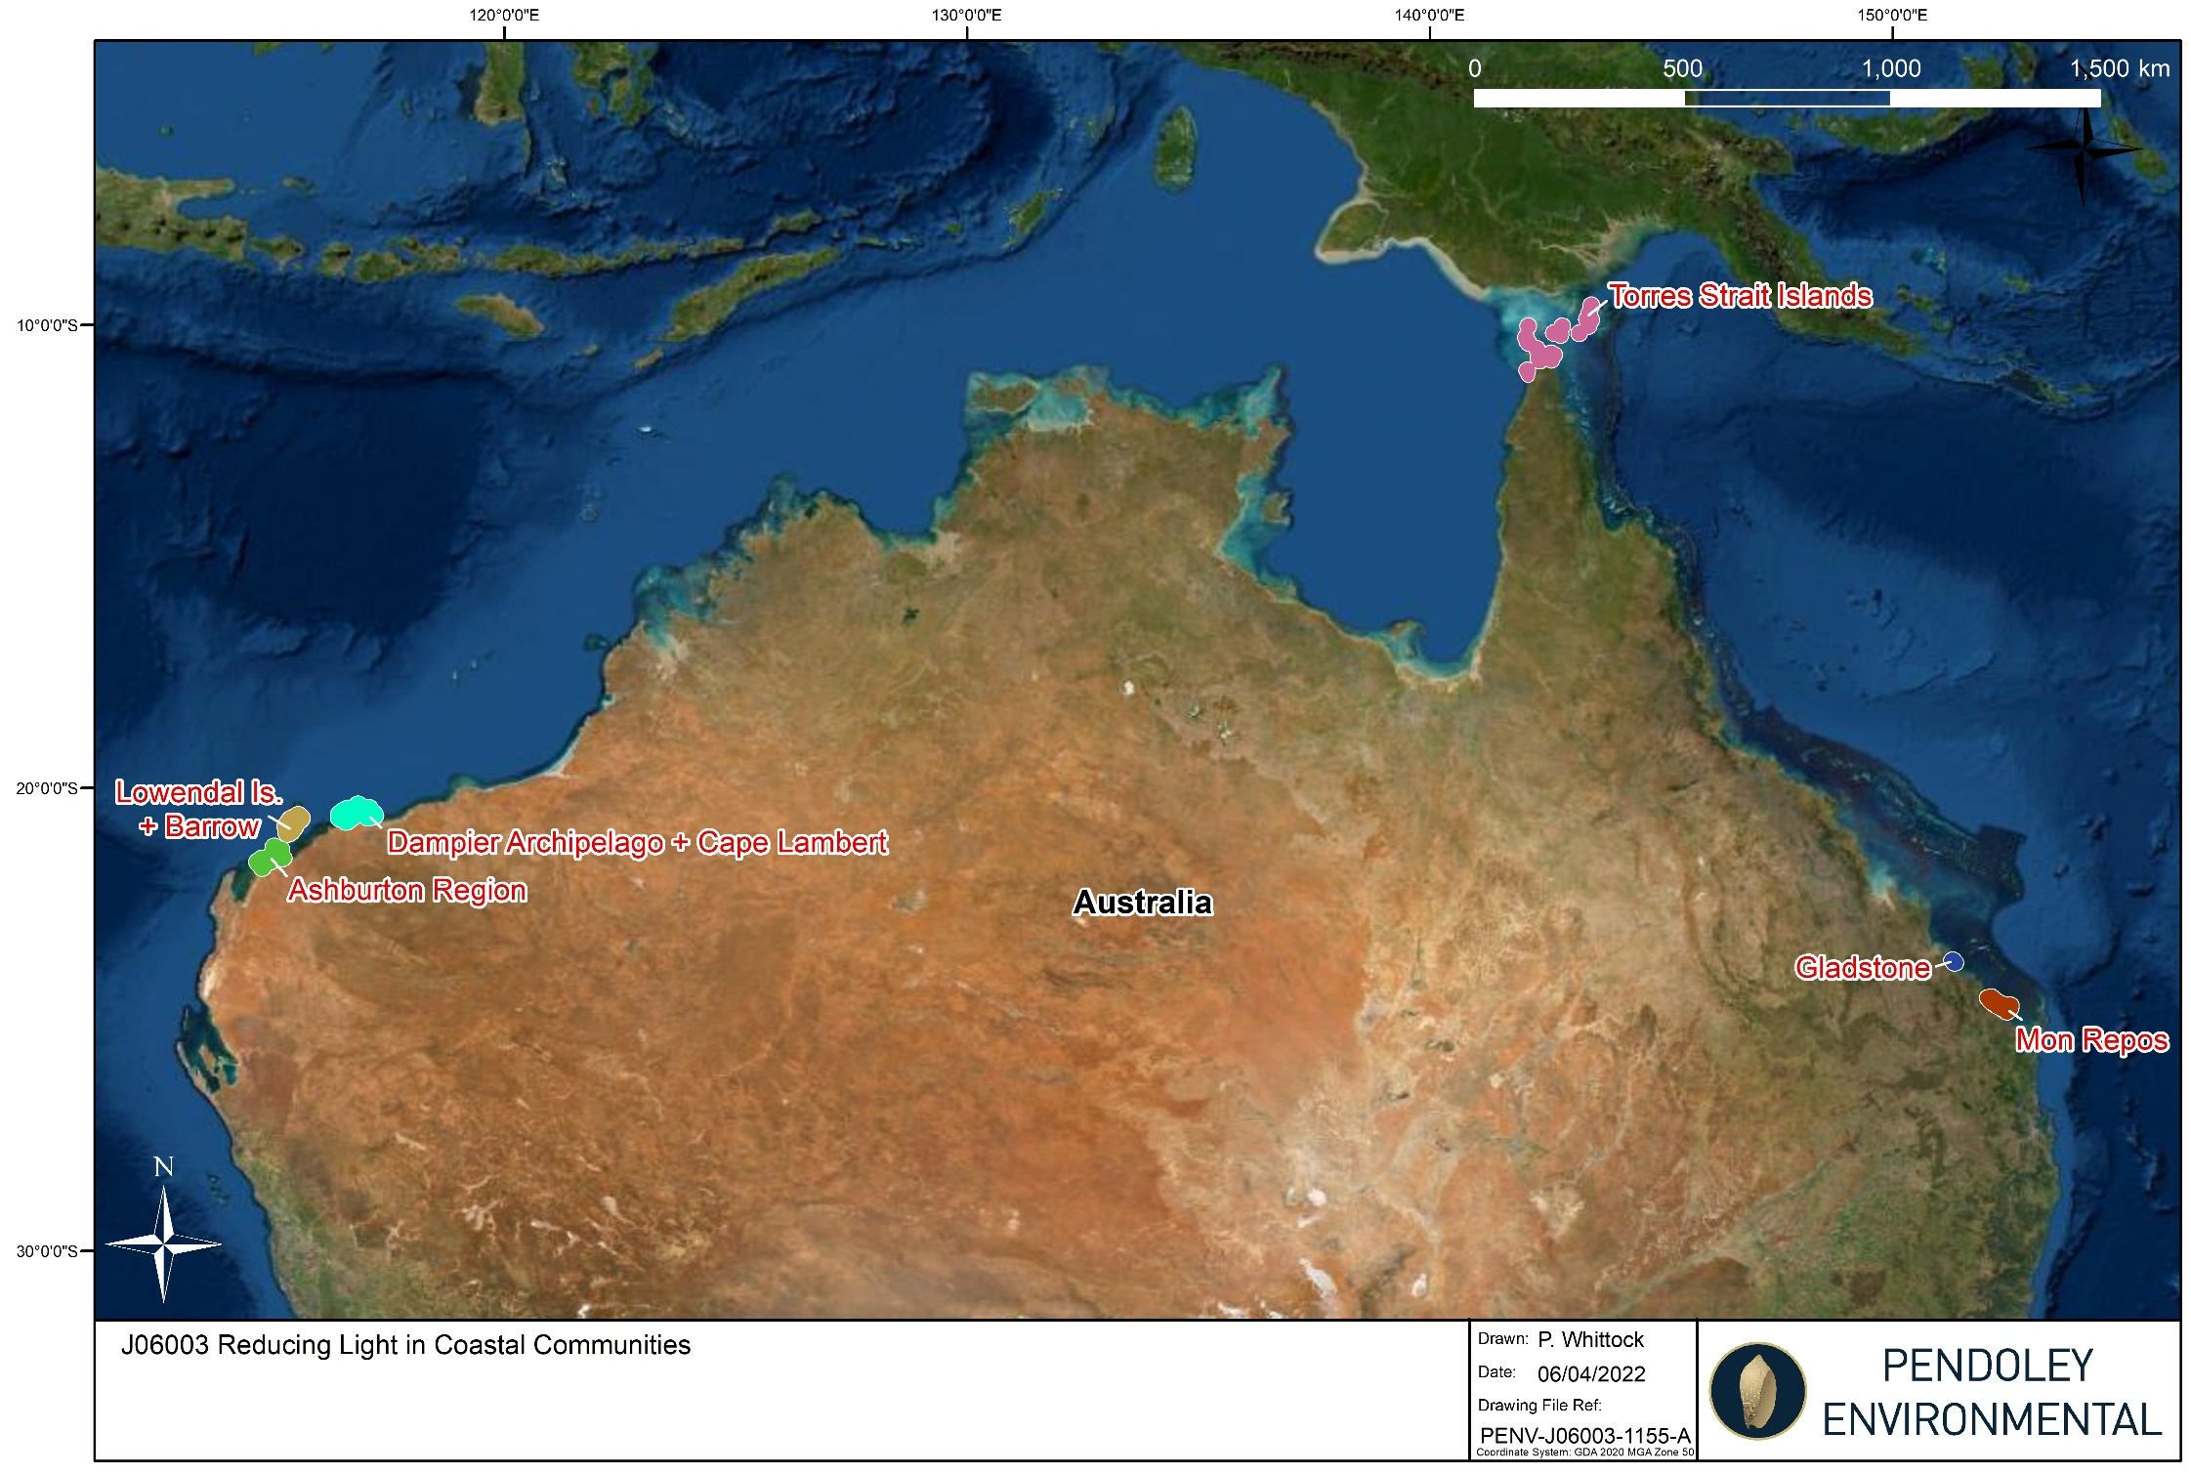
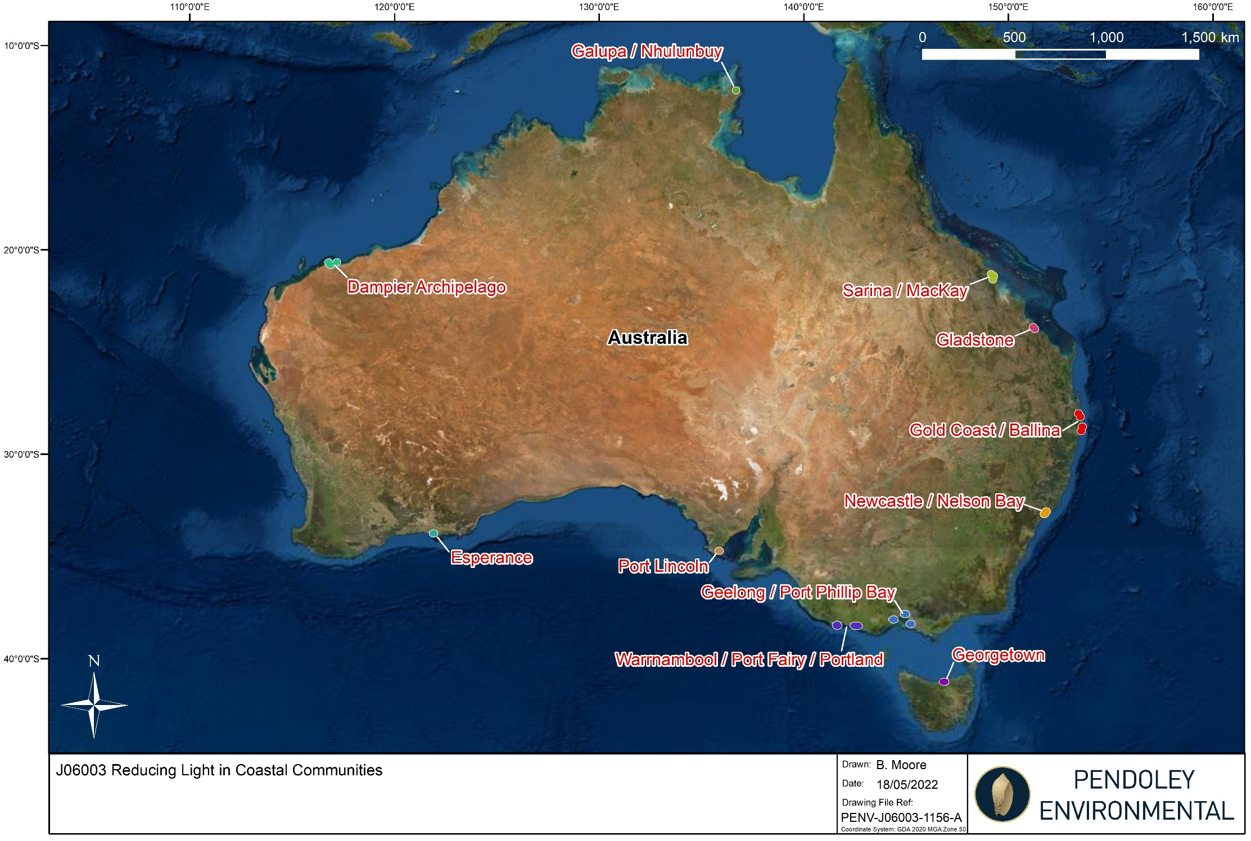

https://www.finance.gov.au/government/commonwealth-grants/commonwealth-grants-rules-guidelines
See Australian Taxation Office ruling GSTR 2012/2 available at ato.gov.au
https://www.legislation.gov.au/Details/C2019C00057
https://www.industry.gov.au/sites/default/files/July%202018/document/pdf/conflict-of-interest-and-insider-trading-policy.pdf?acsf_files_redirect
https://www.industry.gov.au/data-and-publications/privacy-policy
http://www.ombudsman.gov.au/

