early stage Venture Capital Limited Partnerships (esVCLP) sydney, nsw
Investing in Technology Innovation for Global Disruption
Empowering Australian entrepreneurs to build and scale industry-disrupting technology across critical sectors
Investible was founded by Creel Price and Trevor Folsom in 2014. The two entrepreneurs founded Blueprint Management Group in 1998 and exited in 2008 for $109 million.
The pair formed Investible to bring together Trevor’s investment and tech start-up advisory experience and Creel’s passion for entrepreneurship, which included developing the curriculum for the the Branson Centre of Entrepreneurship in South Africa.
Investible began by offering entrepreneur development programs, supported by an angel-investor syndicate to provide angel capital to promising companies. Its first fund, the Investible Early Stage Fund, an ESVCLP, was registered in December 2017 and reached first close in May 2018 with $10 million committed capital (Fund). The Fund then reached final close with $22.5 million (in excess of its $20 million target).
Co Founders of Investible Trevor Folsom (L) and Creel Price (R)
The Fund invests at the seed stage in exciting technology-enabled businesses across a wide variety of sectors (with the exception of biotech), emphasising its ability to identify and support high-potential founders to scale globally.
Investible has grown from a Sydney-based team of five to a global operation, including a six person investment team, operations in Singapore and an active, global investor network, known as Club Investible.
Since the Fund was established, Investible has invested in 28 early-stage companies, all of which are trading today.
Investible’s vision is to create a healthy entrepreneurial ecosystem, which speaks to the co-founders’ backgrounds, global success and entrepreneurial passions.
One of the first opportunities identified by the Fund, Manettas Seafood, has been a true success story. Since investment, Manettas has expanded into the wholesale space with the launch of ShoreTrade, an online platform that connects fisherman and
co-ops with wholesalers.
ShoreTrade now supplies many in the fishing industry supply chain, including wholesalers and processors as well as the hospitality industry, with sustainable fresh seafood, Australia wide.
The platform also facilitates export demand from the United States and Asia, showing the scale of Australian commercialisation.

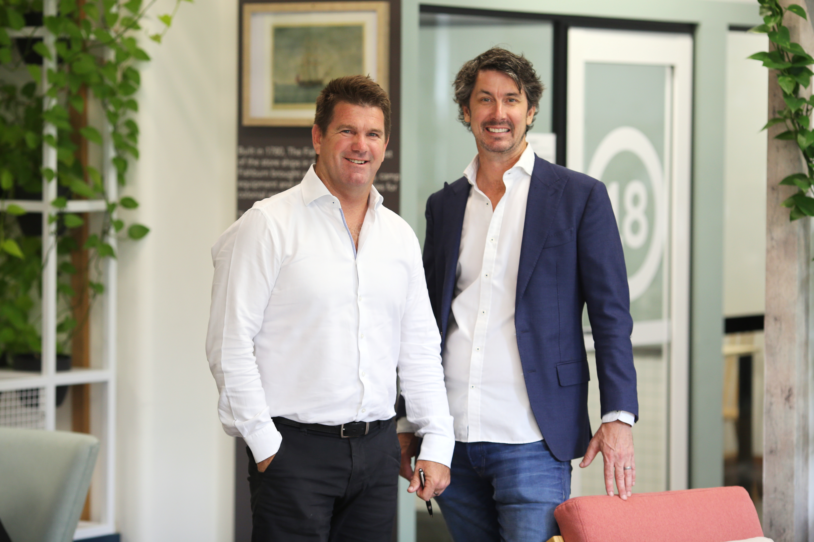

The potential realised by ShoreTrade is still being explored as it continues to evolve with support from Investible and its network of investors and ecosystem partners.
Presently, Shoretrade is seeing quarterly revenue of around $2 million with an additional $2 million in quarterly revenue generated by the Manettas retail business and is an example of the benefits of early stage investment and support for both founders and investors.
Features
- Since mid-2018, Investible has funded 28 companies through the ESVCLP program.
- The key passion for Investible and its investors is identifying, supporting and scaling the world’s best early stage founders.
- Investible has successfully completed one ESVCLP fund with the vision to establish a second ESVCLP fund in 2021 with an experienced management team.
- Its first Fund investment, Manettas Seafood, has launched an online platform to connect fisherman direct with buyers, driving sustainable seafood supply locally and internationally.

- With support from Investible Manettas has already generated $4 million in quarterly transactions.
How the Government has helped?
The benefits under the ESVCLP program were critical in the establishment of the Fund as an early-stage focused venture capital provider.
The ESVCLP has enabled Investible to attract more investors who were seeking new opportunities to invest in and support innovative early stage companies.
“The ESVCLP regime has been great for the ecosystem. Australian entrepreneurs and companies have taken their businesses global, and these companies will inspire the next group of local entrepreneurs. If we didn’t have appropriate investment funds here and local entrepreneurs had to seek capital from foreign investors, it would weaken the entire ecosystem.”
Daniel Veytsblit, Investment Director at Investible

Further information on:
ShoreTrade visit www.shoretrade.com
Investible visit www.investible.com
Venture Capital Limited Partnerships visit business.gov.au or call 13 28 46.

