OneVentures–growing Australian venture capital
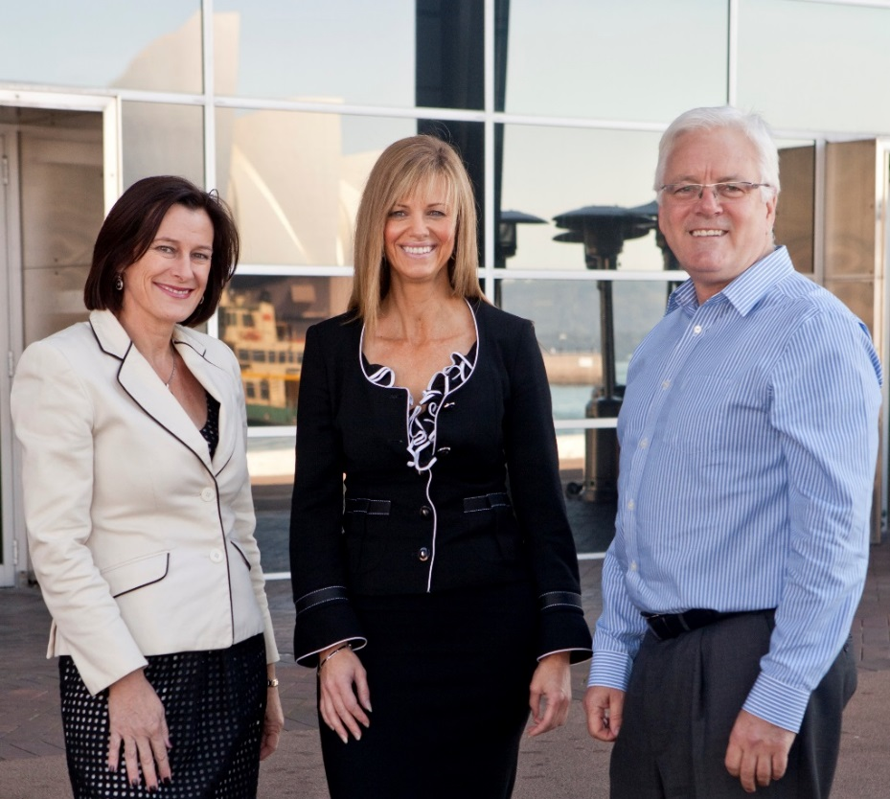
The OneVentures team—Dr Deaker at centre.
Dr Michelle Deaker, founder of OneVentures, wants Australia to grow its venture capital industry to help innovative start-ups and young high growth companies get off the ground.
A venture capital firm, OneVentures manages $320 million worth of funds for investment in emerging Australian companies, operating three early stage venture capital limited partnerships (ESVCLPs) and eight co-investment funds.
Dr Deaker believes successful start-ups are critical to Australia’s economic success.
“If we don’t participate in the innovation and digital economy, we will become service outposts for other countries’ businesses in the future, rather than having our own industries,” she says.
“The development of Australian-owned new globally focused industries will bring productivity and efficiency gains.”

Expanding venture capital investment
Dr Deaker says changes introduced through the Australian Government’s National Innovation and Science Agenda in 2016 to encourage greater venture capital investment to grow start-ups, have produced good results.
The changes improved the structure and tax incentives available to investors using ESVCLPs. They allow an increase in the size of funds from $100 to 200 million, expanding the pool of available capital; a 10 per cent tax offset on capital deployed into start-up companies; and maintaining a tax exempt environment when investments are realised.
“These changes to the way ESVCLPs can operate have helped us to expand our fund and consequently the number of investments we can make,” Dr Deaker says.
“Early stage companies that previously had to look offshore or consider sub-scale listings on the ASX can now access professional venture capital with experienced managers here in Australia.
“The ESVCLP changes introduced by the government definitely makes venture capital investment more attractive to high net worth individuals and family offices.”

Building businesses
A former technology entrepreneur herself, Dr Deaker says venture capital is about more than just investing capital in a business. For her it’s about opening networks, in some cases collaborating with researchers and using her team’s business skills and expertise to grow fledgling businesses.
“We are doing a lot of hands-on work with growth phase companies,” she says.
She cites Vaxxas, a technology company that has invented a needle-free nanopatch to deliver vaccines which is now working with the World Health Organisation and pharmaceutical companies.
“With Vaxxas, we've been instrumental in the company’s development from day one—we pulled it out of the University of Queensland, established the company, did the first business development pitch to the pharmaceuticals, hired the management team and have now raised about $45 million,” she says.
Hatchtech, a single treatment head lice product, has been another success story for OneVentures and the firm has provided vital backing to Smart Sparrow, an e-learning company that allows the development of next gen courseware for online teaching. Smart Sparrow now has around 50 employees and is used in about 200 universities around the world.
OneVentures is also a licensed fund manager for the Australian Government’s new $500 million Biomedical Translation Fund which matches investment in innovative biotech companies on a dollar for dollar basis.
The Australian Government venture capital programs work with private venture capital fund managers to provide capital and professional expertise to innovative Australian companies.
Visit the OneVentures website.

