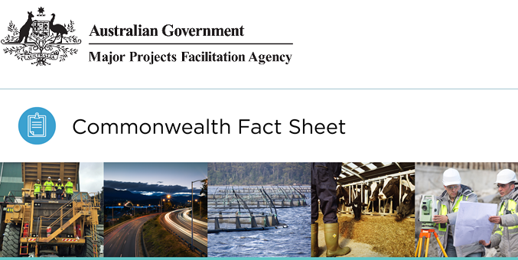

AUSTRALIAN JOBS ACT 2013
If your project involves capital expenditure of $500 million or more, you may have to prepare an Australian Industry Participation plan to provide Australian businesses with full, fair and reasonable opportunity to supply key goods and services to the project.

What approvals do I need?
Proponents of projects with capital expenditure on the construction and upgrade of eligible facilities totalling AUD $500 million or more are required to develop an Australian Industry Participation (AIP) plan.

Who provides approvals?
The Australian Industry Participation (AIP) Authority regulates AIP plans under the Australian Jobs Act 2013.

How do I get Commonwealth approval?
Project proponents are required to notify the AIP Authority of their project as early as possible to discuss the trigger date of the AIP plan. The trigger date is the final date at which a project must have an AIP plan approved by the AIP Authority.
Trigger events (as per Section 13(4) of the Jobs Act) include for example when you:
- enter into a contract with another person under which the other person becomes a procurement entity in the project
- request bids for the supply of key goods or services
- first contact a supplier to request pricing details for any of the key goods or services
- develop a construction and contracting methodology
- make an environmental submission
- prepare technical specifications.
The day of the earliest trigger event will be the trigger date for a project. The AIP Authority can also specify a trigger date or negotiate with you to agree to one regardless of outstanding approvals and approval milestones .
A draft AIP plan needs to be submitted 90 days before the trigger date. Upon approval of the AIP plan, project proponents must submit six-monthly compliance reports until the project’s completion. For new facilities, compliance reports are also required for the initial two years of operations phase. For more information and guidance around trigger dates for major projects, visit the AIP Authority website.

More information

Commonwealth
For guidelines and further information, visit the AIP Authority website or contact:
Phone: 02 6213 6404
Email: aip@industry.gov.au

Major Projects Facilitation Agency
If you would like assistance to identify the regulatory obligations for your project, please visit our Online Tool or contact us:
Email: MPFA@industry.gov.au

