Regional Jobs and Investment Packages  
  
North Coast Region of New South Wales  
Local Investment Plan

May 2017

Table of Contents

1 Introduction 4

2 Regional overview and analysis 4

3 Investment Sectors and Strategic Priorities 6

3.1 Investment Sector: Food Manufacturing & Agribusiness 8

3.2 Investment Sector: Digital Economy 9

3.3 Investment Sector: Advanced Manufacturing 10

3.4 Investment Sector: Visitor Economy 12

3.5 Investment Sector: Education & Training Industry 14

3.6 Investment Sector: Ageing Economy 16

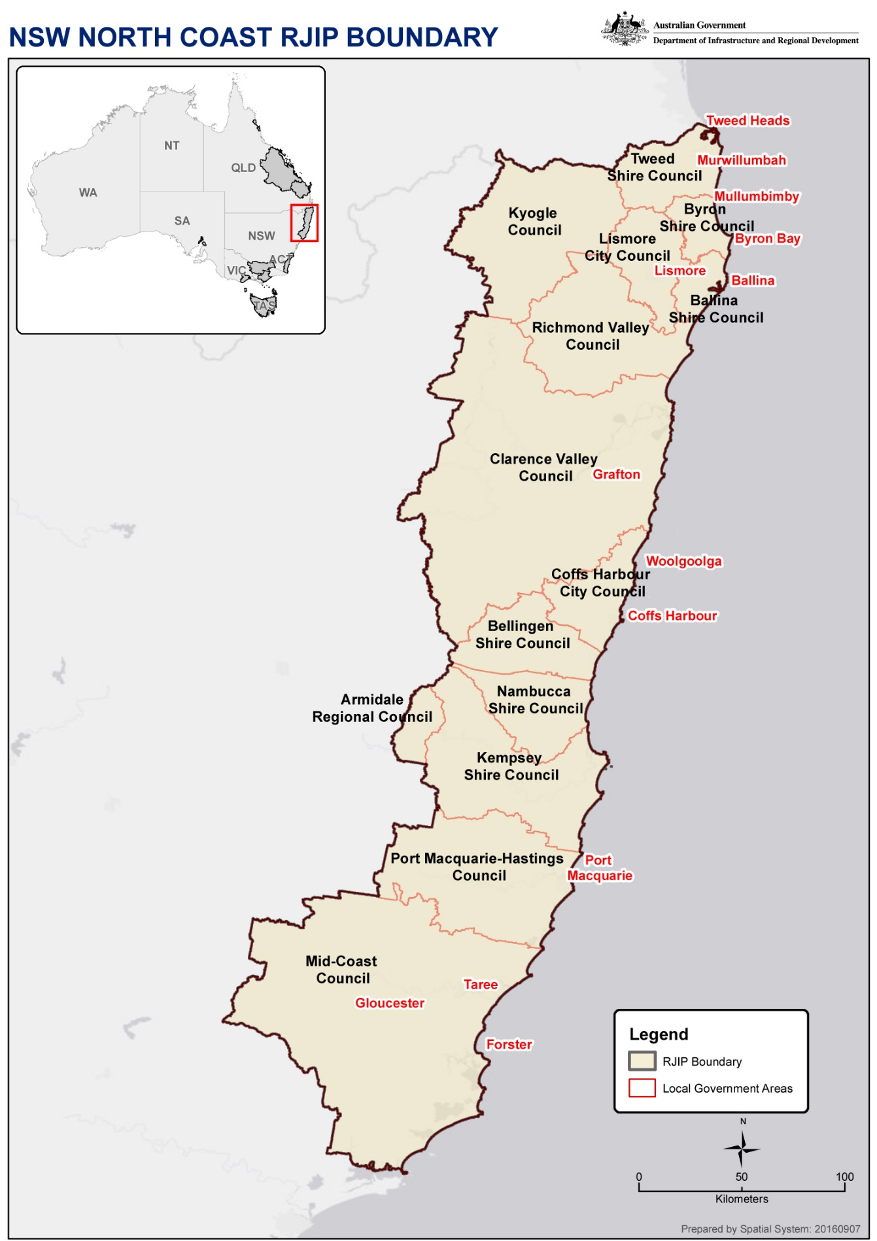

## Introduction

The North Coast Region RJIP Committee has drawn on the considerable skills and industry experience of its members and others to consider industry areas and potential for investment across the region. The Committee also drew on strategies and data contained in several reports and information services such as REMPLAN, the NSW Department of Planning and Environment’s North Coast Regional Plan 2036 and the North Coast Regional Implementation Plan 2036, Regional Economic Profiles and Local Government data. This consultative phase and data analysis has identified critical industry areas such as Agribusiness and Food Processing, Manufacturing, the Digital Economy, Health and Aged Care, the Visitor Economy, Education and Local Government. Based on the Australian Bureau of Statistics data and the recently released North Coast Regional Plan 2036 a picture of the current economic strength of the region and its emerging growth paths has become clear.

The Committee endeavoured to identify those strategic industry areas that could grow high income earning employment where possible. This type of technology-based higher income job profile would deliver high leverage back to the economy in income earned and consumer spending.

## Regional overview and analysis

The North Coast Region of New South Wales is home to over 560,000 people who live across its 3.5 million hectares of national parks and farmland. The 520 kilometres of beaches and coastline from Taree to Tweed Heads comprise some of the best Australia has to offer.

Key statitstics from regional area

The North Coast Region economy generates $28bn in Gross Regional Product with $51.8bn in total output and employs around 170,000 people across several key industry segments. Tourism, Agriculture and Food Manufacturing make up a considerable proportion of this economy and will continue to grow and value add as larger organisations continue to build strength through exports and small organisations reach critical mass and consolidate their own ability to prosper. The economic multiplier effect of the upgrade to the Pacific Highway will be positively felt on the regional economy for the next several decades.

Population trends vary significantly across New South Wales, with regional areas more likely to experience lower rates of growth and more ageing, but with opportunities for technological advancements to change the way people work. The Department of Planning’s 2036 Regional Plan for the North Coast shows a net increase in population across the region of 76,000 new residents needing 46,000 new homes to be built.

| Industry Sector | $M | % |
| --- | --- | --- |
| Manufacturing | $8,157.99 | 15.72% |
| Rental, Hiring & Real Estate Services | $6,752.30 | 13.01% |
| Construction | $5,564.11 | 10.72% |
| Health Care & Social Assistance | $3,554.76 | 6.85% |
| Retail Trade | $3,018.29 | 5.82% |
| Agriculture, Forestry & Fishing | $2,470.50 | 4.76% |
| Accommodation & Food Services | $2,623.25 | 5.05% |
| Education & Training | $2,247.49 | 4.33% |
| TOTAL | $34,388.69 | 66.26% |

The top eight industry segments across the region represent 66% of the gross output employing 120,000 people. This is 70% of the regional workforce. Several larger organisations counted within the agriculture segment subsequently make up a large part of the manufacturing segment as they are also food processors and/or manufacturers. Examples of these organisations are North Coast Meat Co-operative and NORCO Dairy as being both agricultural co-operatives and food processors/manufacturers. Both organisations have been growing their export potential and are representative of this sector across the region. Value-added food processing is one emerging growth area that has a high potential for domestic and export production.

Tourism is similarly made up of several other industry segments within this list including Rental, Hiring and Real Estate Services and Accommodation and Food Services. Tourism employs over 14,000 people on the North Coast and generates over $2.8bn in output.

The application of advanced technologies to regional industries is emerging as a significant productivity and competiveness advantage across many sectors. The pace of precision farming technology and agricultural robotics will continue and provide a boost to the agriculture and subsequently the food processing sectors in the region. Food processing robotics is already in place in many countries and will provide cost advantages for food processors in the region once capital investments are made. However, access to technology and available skills in the workforce are critical to harnessing this growth opportunity across agribusiness and advanced manufacturing.

Another underpinning factor is that as industries grow and enlarge their export potential (intraregional and internationally) it is critical that freight and supply chain infrastructure is available at the same pace as this growth. For example, planning for the movement of large container exports of frozen processed food out of the region to the port of embarkation for export is a key part of capital investment cases for many larger organisations. Capital investment cases considered by growing employers in the North Coast region contain freight and supply chain evaluations when choosing locations for growth. It is key that planning frameworks are in place and communicated to these organisations to better ensure capital investment decisions favouring the region are made. This also includes tourism-enabling infrastructure for larger tourist dependent organisations.

The digital economy will become a growing key part of the national economy as Australia restructures through technology disruption of industries and new services and professions emerge. The rollout of the National Broadband Network is a key disrupter and evidence of that digital disruption is already being felt in parts of the North Coast. One example is that digital content development industries are no longer geographically dependent on being in larger metropolitan areas. Many industries in these broader digital fields can be in regional areas without any major commercial disadvantages.

Those regional towns that are within a reasonable driving distance to major cities are becoming desirable destinations for these types of industries. For example, the Northern Coast Region is seeing several new digital content developers (animation, graphics, film and television) relocate to the coastal areas to take advantage of the lifestyle and lower costs. Being able to be in Sydney or Brisbane within 1 hour by air and 2 - 3 hours by road for a meeting and have the organisation locate on the North Coast is more attractive than having the whole business located in Sydney. One important attribute of these industries is that they combine a small footprint and relatively low capital setup costs with high income earning employment. This drives significant economic multipliers into the local economy.

## Investment Sectors and Strategic Priorities

The RJIP Committee identified the following industries as emerging growth sectors in no priority order that will generate jobs and attract investment –

* Food Manufacturing and Agribusiness
* Advanced Manufacturing
* Visitor Economy
* Digital Economy
* Education and Training Industry
* Ageing Economy

The RJIP Committee also recognised several driving factors across industry segments that will form a strong foundation for growth over the next several decades. These strategic priorities are:

* Increase the ability to value-add (processing packaging transport, etc.) to agricultural product
* The application of technology to enable productivity gains and competitiveness
* Improved supply chain and freight infrastructure leading to product export competitiveness (and improved infrastructure for visitors to move more easily around the region).
* Necessary investment in skills development to drive workforce employability to support sectoral growth
* Improved digital connectivity that allows organisations to take advantage of new technologies
* Enhance the competitiveness of existing enterprises or facilitate the development of new and emerging enterprises

The Committee considered the broader industries that would grow and invest and the necessary enablers that needed to be reinforced to bring better certainty to that potential growth.

Workforce Employability is a critical long term goal as industry requirements change due to technology and other disruptions and the national economy restructures. One measure of the strength of the region is the level of unemployment. In the North Coast, the unemployment rate is 8% with youth unemployment (18 – 25-year-old) at 12.5%. To address this requires a clear understanding of the employment opportunities and the skills needed for current and future roles.

Examples of these can be represented as follows:

Project Example Matrix for Strategic Investment Sectors and Strategic Priorities

| Industry Vertical | Food & Agribusiness | Advanced Manufacturing | Visitor Economy | Digital Economy | Education & Training Industry | Ageing Economy |
| --- | --- | --- | --- | --- | --- | --- |
| Strategic Priority |  |  |  |  |  |  |
| Value- Add | Ready Made Meals for export |  |  |  |  |  |
| Applied Technology | Agri-tech & Robotics | Defence Industry & Robotics | Web Tools for visitor management | Digital Content | Reusable Learning Objects | Sensors and patient management |
| Digital Connectivity | Paddock to Plate Monitoring | High end design and remote build | Visitor Web connections | Regional studio facilitation | Online learning regionally | Care facilities monitoring |
| Freight / Supply Chain & Tourism Infrastructure | Cool/Cold Stores, Food Trails, Regional Accommodation | Heavy road access West to East | Food Trails, Regional Airports and Mobility | Bookings access | Links with TAFE and University courses | Links with TAFE and University courses |
| Skilled Workforce | Applied Technology | Engineering & Post Trade | Service Industry Management | High end content manufacture | Content creation for online | Patient Care |

### Investment Sector: Food Manufacturing & Agribusiness

#### Evidence

In Australia, the Food and Agribusiness (F&A) industry spans farmers, growers, raw material producers and manufacturers to packaging, sales, marketing and retail providers, through to final users or consumers of the sector outputs.

Key national industry facts include:

* Total sales and services income of $164 billion (equivalent to 5.9 per cent of all Australian industries in 2013-14).
* Industry gross value added in 2014-15 (or 3.5 per cent of the total of all industries)
* Exports of $40.8 billion representing 16.3 per cent of all Australian exports in 2014-15. The sector had 178,517 businesses in 2014-15, of which 121,341 were non-employing (or 68.1 percent of total businesses).

There were over 520,000 people employed across the industry in Australia, or 4.4 per cent of total industry employment. The biggest employers were agriculture at 251,300, followed by food and beverage at 240,900. The NSW North Coast represents $7.8bn in total output for agriculture and employs 2,500 people in the sector. As many of the larger segments of agriculture in the North Coast are also part of the food processing or manufacturing they are counted in the manufacturing sector by the ABS. Food manufacturing or processing forms a large part of that segment and represents a further $8.1bn in total output and employs 11,700 people. The total agriculture and food processing sector represents 15% - 20% of the North Coast regional economy.

#### Strategic priorities

The Australian Food and Grocery Council’s (AFGC) annual industry snapshot State of the Industry 2016, shows a 14% increase in Australia’s food and grocery exports in 2015-16 to some extent moderated the challenging economic conditions confronting Australia’s $125.9bn food and grocery processing sector. Export market growth for this industry in the North Coast region is a priority because of the accelerating demand for Australian quality food products into various Asian markets.

Factors affecting that growth are **freight and supply chain mapping and planning** that reassures capital investment plans for the region. The **application of advanced technologies** in those organisations that are responding to export market growth opportunities will lower costs and drive productivity. The availability of a skilled workforce to utilise those technologies and support those organisations implementing advance robotics and other applications will need to be developed as well. Strategic Priorities include the following:

* Increase the ability to value-add (processing packaging transport, etc.) to agricultural product
* The application of technology to enable productivity gains and competitiveness
* Improved supply chain and freight infrastructure leading to product export competitiveness
* Necessary investment in skills development to drive workforce employability to support sectoral growth
* Improved digital connectivity that allows organisations to take advantage of new technologies
* Enhance the competitiveness of existing enterprises or facilitate the development of new and emerging enterprises

**Evidence:** Exports of fresh produce increased by 49.4 %, or from $1.0bn to $1.5bn in 2015-16 and the trade surplus in fresh produce increased by 161.1 % to $742 million.

Source: Food & Grocery Council “State of the Industry 2016”

Agriculture makes an important contribution to the Australian economy. Australia is a competitive net agricultural exporter, with around two thirds of total production exported. In 2015, Australian agriculture and food exports totalled $46.5 billion, 14 per cent of the total value of Australia’s goods and services exports for that year.

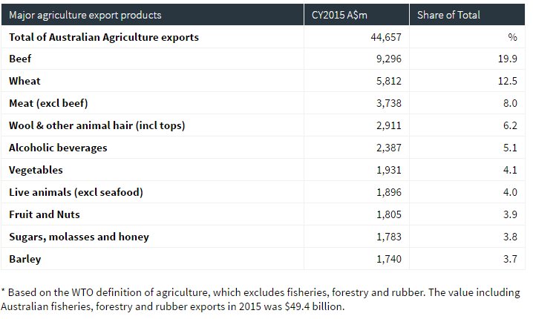

### Investment Sector: Digital Economy

#### Evidence

35% of Australian businesses have optimised their websites for mobiles, increasing from 3 % in 2011 and 31% of businesses had a social media presence, up from 18% in 2011. $6bn is also spent on online advertising. By 2019, online advertising is forecast to make up over half of all advertising spending in Australia. According to Harvard University for several years now “digital” has been an appendage to “business as usual.” But recently, digital transformations have reached the tipping point where digital has become “business as usual”; the tail has become the dog. Digital is not just part of the economy — it is the economy. It’s an economy of limitless opportunities for some and disruption and displacement for others. Many firms have been unable to adapt, while others are thriving. According to MIT Sloan research, the companies that are adapting to a digital world are 26% more profitable than their industry peers.

In the North Coast Region of NSW, with its proximity to major metropolitan areas, digital businesses servicing the “digital content” industry (e.g. advertising, online learning, film production and animation) are relocating their business operations as the rollout of the NBN reaches desired lifestyle locations. In the digital economy, distance—once a defining characteristic and barrier for regional Australia— becomes increasingly irrelevant. On average, a 10 % increase in connectivity raised regional output by 0.53% compared with only a 0.38 % increase in metropolitan areas. The NBN will enable all North Coast regional communities to have greater access to goods and services and education and employment opportunities. It will provide a reliable and ubiquitous network that supports the smart use of technology and improve the productivity and competitiveness of regional businesses and it will be a very attractive place for professionals in the digital support services sector to live.

#### Strategic priorities

The strategic priorities for this sector are to attract the relocation or the initiation of businesses that service the digital economy to the North Coast. A clear example of this type of business is the digital content development industry. As broadband capacity (nbn) reaches across the North Coast it is critical that businesses who employ high-income practitioners that service and develop content for the digital economy are attracted to the region. The priorities include:

* The application of technology to enable productivity gains and competitiveness
* Improved supply chain and freight infrastructure leading to product export competitiveness
* Necessary investment in skills development to drive workforce employability to support sectoral growth
* Improved digital connectivity that allows organisations to take advantage of new technologies
* Enhance the competitiveness of existing enterprises or facilitate the development of new and emerging enterprises

The Impact Statement below shows the effect of generating 100 additional jobs in this sector across the North Coast region. The economic output effect of $82m and the benefit cost multiplier of 1.5 to 2.037 is an indicator of how important the development of this industry to the region can be.

Source: Deloitte Access Economics “The Connected Continent – 2015”
REMPLAN ABS 2011 & 2015 Economic Impact Report on adding 100 Jobs.


Source: Deloitte Access Economics “The Connected Continent – 2015”

REMPLAN ABS 2011 & 2015 Economic Impact Report on adding 100 Jobs.

| Impact summary output ($M) | Direct effect $43.367 | Industrial effect $22.621 | Consumption effect $14.823 | Total effect $82.812 | Type 1 multiplier 1.499 | Type 2 multiplier 1.825 |
| --- | --- | --- | --- | --- | --- | --- |
| Employment (Jobs) | 108 | 58 | 54 | 220 | 1.537 | 2.037 |
| Wages and Salaries ($M) | $10.696 | $5.534 | $3.457 | $19.688 | 1.517 | 1.841 |
| Value-added ($M) | $20.075 | $9.767 | $8.334 | $38.176 | 1.487 | 1.902 |

### Investment Sector: Advanced Manufacturing

#### Evidence

Recent developments in robotics, cognitive programming and machine learning have put economies on the cusp of significant productivity gains and employment disruption. New or legacy Industries in regional Australia that can attract investments in these applied technologies will establish significant competitive advantages and cost leverage for both domestic and international markets. This will play a key role in any regional manufacturing initiatives. Driving, communicating and justifying investments in applied technologies for regional manufacturing will be a critical strategic initiative needed to convince new organisations and existing manufacturers to invest in these types of technologies.

For example, Defence Industries utilise a broad range of applied technologies and are a significant strategic employer in parts of the North Coast for both new manufacturing and ongoing maintenance. Regional manufacturers wanting to compete in defence contracts will need to be technologically aware and able to capitalise on technology to participate. The McKinsey Global Institute’s recent report on future work showed that about 47% of total US occupations are at high risk of automation perhaps over the next decade or two.

* Wages and educational attainment show a strong negative relationship with probability of computerization e.g. low skilled low wage = high probability
* Building on Frey and Osborne's original work, data from the World Bank suggests the risks vary across countries; in the OECD, on average 57% of jobs are susceptible to automation. This number rises to 69% in India and 77% in China
* On average, 9% of jobs across the 21 OECD countries are automatable
* There are notable differences across OECD countries when it comes to automation (e.g., the share of automatable jobs is 6% in Korea vs. 12% in Austria)
* Automation and technological advancements could lead to a net employment impact of more than 5.1 million jobs lost to disruptive labour market changes between 2015–20, with a total loss of 7.1 million jobs— two-thirds of which are concentrated in the office and administrative job family—and a total gain of 2 million jobs in several smaller job families
* Almost half of work activities globally have the potential to be automated using current technology.
* <5% of occupations can be automated entirely; about 60% have at least 30% of automatable activities
* Technically automatable activities touch 1.2 billion workers and $14.6 trillion in wages. China, India, Japan, and the United States constitute over half
* Automation’s boost to global productivity could be 0.8–1.4% annually over decades

McKinsey Global Institute 2017 - A FUTURE THAT WORKS: AUTOMATION, EMPLOYMENT, AND PRODUCTIVITY

In the North Coast Region, legacy industries such as food manufacturing and agriculture could drive their own adoption of advanced manufacturing technologies and therefore harness competitive advantages for export market growth. This would in turn allow the development of higher skilled pathways to be developed for the regions youth and contribute to increases in employment for highly skilled high income earning roles.

#### Strategic priorities

Identifying those organisations that could benefit from the application of advanced manufacturing or applied technologies is a key priority for the North Coast region. Promoting the use of advanced manufacturing techniques and the availability of technology to lift the awareness of how these applications would make organisations more competitive and profitable is also a key priority.

* The application of technology to enable productivity gains and competitiveness
* Improved supply chain and freight infrastructure leading to product export competitiveness
* Necessary investment in skills development to drive workforce employability to support sectoral growth
* Improved digital connectivity that allows organisations to take advantage of new technologies
* Enhance the competitiveness of existing enterprises or facilitate the development of new and emerging enterprises

**Evidence:** Australia’s ageing economy will result in a need for higher skilled individuals across industry sectors in a shrinking workforce.

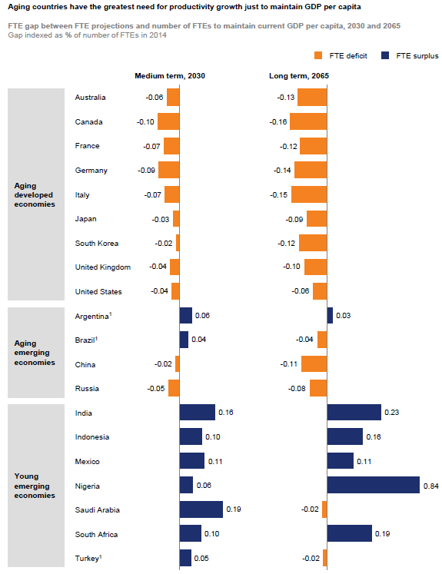

### Investment Sector: Visitor Economy

#### Evidence

The North Coast Region of New South Wales is the third most popular tourist destination by overnight stays in Australia. The region generates $3.7bn in economic benefit and counts 12.2m tourist visits annually. This tourism includes both domestic and international travellers, events, sports tourism and a range of emerging aspects to tourism. These emerging aspects that can be defined as “tourism” include wellness tourism (attending retreats or health resorts) and education tourism (attending short courses at University or Colleges as part of a holiday travel plan).

The NSW Government’s North Coast Regional Plan 2036 states that destination management plans or other tourism focused strategies will showcase existing tourism sites and activities, build relationships with the regional and international airports of Ballina-Byron, Coffs Harbour, Port Macquarie, Lismore, Newcastle and the Gold Coast, and capitalise on new and emerging trends such as the growing Asian tourism market. Opportunities associated with ports, harbours and Crown reserves should also be considered when developing these plans.

Considerable growth is expected in visitor numbers through regional airports with the Gold Coast Airport passenger numbers growing by 167% or 16m passengers by 2036. This will mean a significant increase in demand for visitor “products” that need to be developed and marketed to this demand. Accommodation and visitor support services will need specific focus to ensure that the economic impact on the region is managed. Traffic “hotspots” such as Byron Bay will need to prioritise strategies that manage demand with alternative destinations or attractions.

The NSW Government North Coast Regional Plan outlines a series of actions that reflect the tourism priorities for the region:

* Facilitate appropriate large-scale tourism developments in prime tourism development areas such as Tweed Heads, Tweed Coast, Ballina, Byron Bay, Coffs Harbour and Port Macquarie.
* Facilitate tourism and visitor accommodation and supporting land uses in coastal and rural hinterland locations through local growth management strategies and local environmental plans.
* Prepare destination management plans that: identify culturally appropriate Aboriginal tourism opportunities; encourage tourism development in natural areas that support conservation outcomes; and strategically plan for a growing international tourism market.
* Promote opportunities to expand visitation to regionally significant nature-based tourism places, such as Barrington Tops and Hat Head National Park, Ellenborough Falls, Dorrigo National Park, Wollumbin National Park,
* Preserve the region’s existing tourist and visitor accommodation by directing permanent residential accommodation away from tourism developments, except where it is ancillary to existing tourism developments or part of an area otherwise identified for urban expansion in an endorsed local growth management strategy.
* Use of technology that leads to productivity gains in managing and marketing to visitors including signage and visitor centers.

#### Strategic priorities

The strategic priorities for the Visitor Economy are:

* The application of technology to enable productivity gains and competitiveness
* Improved supply chain and freight infrastructure leading to product export competitiveness and freight infrastructure leading to product export competitiveness
* Necessary investment in skills development to drive workforce employability to support sectoral growth
* Improved digital connectivity that allows organisations to take advantage of new technologies
* Enhance the competitiveness of existing enterprises or facilitate the development of new and emerging enterprises

Evidence:

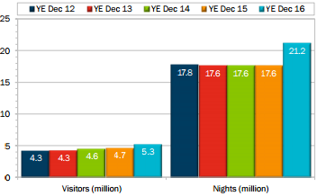

North Coast NSW received nearly 5.3 million domestic overnight visitors - up by 12.8%* on YE Dec 15. Visitors spent nearly 21.2 million nights in the region – up by 20.2%* on YE Dec 15. Note: The number of domestic overnight trips to regional New South Wales increased by 6.9 percent* on last year and by 18.2 percent* compared to four years ago.

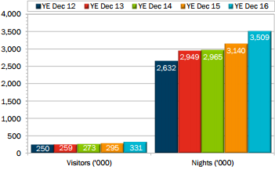

North Coast NSW received 330,900 international overnight visitors - up by 12.2%* on YE Dec 15. Visitors spent over 3.5 million nights in the region - up by 11.7% on YE Dec 15. Note: The number of overnight trips to regional New South Wales by international visitors increased by 11.5 percent* on last year and by 31.3 percent* compared to four years ago.

### Investment Sector: Education & Training Industry

#### Evidence

International education is Australia’s largest service export and the nation’s fourth largest export overall – after iron ore, coal and natural gas. In 2014/15, the sector’s measured export earnings stood at $18.8 billion, but unmeasured borderless activity suggests its size is even greater still. Public and Private education across the North Coast region has the potential to develop as a significant employer and regional revenue generator through the development of residential colleges, educational tourism packages and specialised skill development initiatives. Currently the region generates 16, 533 jobs which is 9.78% of the regional workforce. This includes university, primary and high school employees through the public education system. The Education and Training sector in the North Coast Region contributes $2.2bn in output or 4.33% of total output for the region.

Australia has historically demonstrated strong performance in the provision of onshore international education, consistently ranking as a destination of choice across many of the major source markets. Looking ahead, Deloitte Access Economics projects increased (from today’s market position) onshore commencements and enrolments over the next decade. Deloitte Access Economics projections for the 29 key source markets show that Australia’s onshore international education sector is capable of increasing from 650,000 enrolments today to 940,000 by 2025 (which equates to a compounding annual growth rate of 3.8%).

According to Deloitte Australia, the Australian technical and vocational education sector consists of 3,700 businesses with annual revenue of $8.9bn, which is expected to increase at 2.2% p.a. over the next five years to $9.9bn. The sector is made up of public and private providers. A key source of funding for private providers is tuition fees charged to students eligible for the VET FEE-HELP scheme and in 2014 this was $1.8bn.

#### Strategic Priorities

The Education sector in the North Coast region of NSW can increase the revenue generating potential of existing Universities, Technical Education Colleges and overall private providers for education services. Key elements that would need to be considered are the investment in residential accommodation, the “marketing” of locations to domestic and international students across various markets and the physical attractiveness of the region as a destination. Education Tourism is a key marketing initiative that would underpin this priority.

* The application of technology to enable productivity gains and competitiveness
* Improved supply chain and freight infrastructure leading to product export competitiveness
* Necessary investment in skills development to drive workforce employability to support sectoral growth
* Improved digital connectivity that allows organisations to take advantage of new technologies
* Enhance the competitiveness of existing enterprises or facilitate the development of new and emerging enterprises

Strategic assistance with regional universities and private colleges applying for funding to improve and increase residential accommodation would need to be coupled with marketplace analysis on demand and potential partnerships to drive education business success in the region.

Increasing the potential for online learning opportunities originating in the North Coast Region would allow higher income digital industry practitioners to reside in the North Coast region and practice their professions in a global marketplace. Subject matter experts, learning development professionals and the broader range of digital content developers can be a critical part of a success online learning and subsequently successful education business.

Overall the opportunity for Australia to grow a significant export market for educational services has become self-evident. The opportunity for the North Coast Region to take advantage of this growth is apparent and can be marketed as an **attractive place to learn**.

**Evidence:** Deloitte Access Economics’ report on International Education outlined that while the composition of enrolments from each sector remains stable, the fastest growing markets within each sector vary, as outlined below (2025 compared to 2015):

* Higher education growth is expected to be concentrated from China (additional 32,000 enrolments) and India (additional 15,800 enrolments);
* Vocational education and training (VET) is projected to experience the greatest growth from the Philippines (additional 10,200 enrolments) and India (additional 8,500 enrolments);
* Schooling growth will be driven by China (additional 2,000 enrolments) and Vietnam (additional 700 enrolments); and
* English language intensive courses for overseas students (ELICOS) is projected to experience the greatest growth from Thailand (additional 2,100 enrolments), India (additional 1,900 enrolments) and Vietnam (additional 1,700 enrolments).

With this growth expected to comprise a large volume of relatively higher yield segments, the sector’s contribution to export earnings is expected to almost double to in excess of $33 billion.

Source: Growth and opportunity in Australian International Education – 2016

### Investment Sector: Ageing Economy

#### Evidence

The Commonwealth Treasury Intergenerational Report 2015 states that the number of Australians aged 65 and over is projected to more than double by 2054-55, with 1 in 1,000 people projected to be aged over 100. In 1975, this was 1 in 10,000. Australians will live longer and continue to have one of the longest life expectancies in the world. In 2054-55, life expectancy at birth is projected to be 95.1 years for men and 96.6 years for women, compared with 91.5 and 93.6 years today. The average annual rate of growth in the population is projected to be 1.3 per cent, compared with 1.4 per cent over the past 40 years. By 2054-55, the participation rate for people aged over 15 years is projected to fall to 62.4 per cent, compared to 64.6 per cent in 2014-15. The number of people aged 15 to 64 for every person aged 65 and over has fallen from 7.3 people in 1975 to an estimated 4.5 people today. By 2054-55, this is projected to nearly halve again to 2.7 people. In New South Wales the ageing population median age is up from 29 in 1976 to 37 in 2015 and will rise to 41 in 2056. As the NSW population ages, workforce participation declines and the rate of economic growth naturally slows. An ageing population also causes the demand for services and infrastructure to grow and is expected to drive growth on government expenditures - particularly for health services.

However, the North Coast Region with its proximity to larger metropolitan areas (Brisbane & Sydney) is well positioned as a retirement hub for aged care facilities. The sea/tree change trend is expected to continue on the east coast and regions like the North Coast of NSW will continue to attract investment in retirement properties and investment and expansion of support services for this part of the economy.

As part of its economic activities, the aged care sector produces output, employs labour and pays wages, and generates returns to capital. Deloitte Access Economics estimates that the direct economic contribution resulting from this economic activity was $13.5 billion in value added in 2014-15. This represents the value of production or the ‘economic footprint’ attributable directly to the aged care sector in the Australian economy. The direct contribution of the sector is approaching that of other important Australian industries such as residential building construction and the sheep, grains, beef and dairy cattle industry. In addition to this direct economic contribution, the aged care sector utilises inputs from other industries in the Australian economy, such as food, accommodation and medical services. This indirectly generates economic activity by facilitating production and paying wages and returns in these other industries, with estimates suggesting that the total value of this indirect economic contribution was a further $4.1 billion in 2014-15.

#### Strategic priorities

The North Coast Region is an attractive location for many retirees to move to once they decide to leave the city. It is also a strategic location for aged care investments and related Allied Health projects. Many of the industries supporting tourism in the North Coast also support aged care or retirement living. One key strategic priority is to attract retirement living project investments that fit within the North Coast Regional Plan, specifically targeting those project proponents that will consider the North Coast region as a potential location for these types of projects (retirement villages, aged care facilities, private medical centres and support services organisations). Aged care skills and training programs both at a TAFE level and at a University level are also a key priority for this industry in the North Coast region.

Strategic Priorities are:

* The application of technology to enable productivity gains and competitiveness
* Improved supply chain and freight infrastructure leading to product export competitiveness
* Necessary investment in skills development to drive workforce employability to support sectoral growth
* Improved digital connectivity that allows organisations to take advantage of new technologies
* Enhance the competitiveness of existing enterprises or facilitate the development of new and emerging enterprises

**Evidence:** Using this methodology, Deloitte Access Economics estimates that in financial year 2014-15 the aged care sector directly contributed $13.5 billion in value added to the Australian economy and supported approximately 238,000 full-time equivalent (FTE) jobs. Given the labour-intensive nature of the sector, 87% of this direct contribution (equivalent to $11.7 billion) represents payments to labour.

Combining the direct and indirect contributions yields the total economic contribution. In 2014-15, the aged care sector’s total economic contribution to Australia was $17.6 billion, equal to approximately 1.1% of gross domestic product (GDP), and 277,500 FTE jobs, equal to 2.8% of the labour force. The average dollar of revenue from the aged care sector contributes $0.98 to value added in the Australian economy, and every one million dollars of revenue supports 15 FTE jobs. The results, broken down by aged care service type, are shown in Table 3.4. Residential care contributes 81% of the sector’s total value added ($14.2 billion) and 59% of total employment (162,600 FTE jobs). This is followed by HACC, with 11% of value added and 24% of employment; and home care, with the remaining 8% of value added and 17% of employment. The residential sector contributes relatively less to employment compared with its contribution to value added since it is more capital intensive than home care services.

